Stratigraphic Analysis

Sampling Design and Excavation Methods
In designing our selection of areas to excavate we had three objectives: 1) To determine the depth of deposits and the extent of the site so that as a second stage of our research we could estimate the total volume of occupations to be sampled – and from this judge the likely accuracy of our conclusions; 2) To secure enough excavated materials to make preliminary estimates of the variability and density of floral, faunal, artifactual, and architectural remains; and 3) To sample sufficiently the margins and core areas of the settlement to determine the outlines of both the settlement areas and the non-cultural, Pleistocene sand-gravel formation (gezira) on which the settlement was located.

Given these objectives, our strategy was to locate some of our units by means of a stratified random sampling design, and to select other areas on the basis of specific questions about topography, stratigraphy, etc. Excavation units, unless otherwise noted (especially in 1988), are designated by the southwest corner of the square.

In the 1984 season we excavated mainly in 2x1m units, because this relatively small size permitted precise stratigraphic control and also allowed us to excavate many units in different areas of the site. A stratified random sampling design was used to locate six units within the central area of the site (see Wenke and Redding 1985:6). Three additional areas were also chosen for excavation based on features of interest: A small step trench (ST-1) was excavated in the southwest near the modern village where sebakhin had cut away a portion of the mound allowing us to expose a fairly deep stratigraphic section; an area where a wall was exposed by (Hamada and Farid 1950) in their excavations (“Test Square “); and a third – 1203S/1070E – a 1x2m unit adjacent to unit 1202S/1070E excavated to expose a large hearth located in 1202S/1070E.

In 1986 we excavated in larger units, some of them 2x2m areas, again most placed according to a stratified random sampling design. In addition, two more step trenches were excavated (ST-1 and ST-2) to determine if a depression between the main area of our excavations and a modern village was formed by excavation or perhaps by a water course. A 2x4m unit was also excavated to the west of the main settlement mound in an area of newly discovered Old Kingdom occupations. Finally, a 72 m² trench was excavated in an area where well-preserved architectural remains were very near the surface. This area, named the “Block Area”, was not excavated to great depth in 1986, but portions were more deeply excavated in the 1988 season.

The 1988 season concentrated on deepening and extending the Block Area excavations and also investigating other areas of interest revealed in previous seasons. Excavation methods changed somewhat for the 1988 season: spatial control was still maintained using the original grid system but excavation was generally carried out within boundaries defined by architectural features, usually 3-4 intact walls. These were named by “room” in sequential order (Room 1, Room 2, etc.). In some cases where walls were not present an arbitrary square (designated by its southwest corner) was used for unit boundaries. Two other areas were also cleared to reveal the architectural features, one a few meters northwest of the main block area (containing Rooms 17, 19, and 20) and another in the far western portion of the site abutting agricultural fields (Rooms 22 and 23).

Excavations were carried out by natural stratigraphy to varying depths. The basic excavation unit over all three seasons was the “sedimentary unit” or SU. The SU was defined to be a sedimentary structure that differed from the surrounding sediments in compositional characteristics (color, content, structure, texture, etc.) and extent. Ideally, each SU could be considered a separate depositional event; in practice, the excavator often noted that what initially appeared to be separate units were actually variable portions of larger units. SUs can thus represent either cultural (e.g., a wall) or natural (e.g., sheetwash) depositional events. Thus, the SU represents the basic unit of analysis for all of our subsequent work.

The scale profile drawings included below for the 1984 and 1986 excavation units are based on stratigraphic analysis carried out in the field by Paul Buck:

The individual deposits were distinguished in the field based on examination of the stratigraphy in the excavation squares, and boundaries are based on color, dominant particle size, composition, and texture, all field observable attributes. The resultant analytical units are called “profile units” and are assigned roman numerals. . .profile units are not always equivalent analytical units to SUs (Buck 1990:113.

Thus, for the 1984 and 1986 season profiles the strata shown are profile units, not SUs. Buck (1990) provides extensive discussion of many of the 1986 units, and the remainder are described herein.

In 1988 we were more interested in recovering as much artifactual material as possible from secure architectural contexts rather than building up a depositional history of the site. Consequently, excavators tended to favor “lumping” as opposed to “splitting” in the creation of SUs. Also, profile units were not specifically defined and drawn on profiles in the field since most often walls defined the unit boundaries and thus contained no interior deposits in the section. The profile units for 1988 excavations are based on the Depositional Units (DUs) created by (Cagle 2001, 2003) but are referred to here as Strata following the nomenclature of earlier excavations.

Depositional history and chronology

Much of the first two seasons at Kom el-Hisn were devoted to understanding the overall depositional history of the site. Such an analysis offers insight into not only general site formation processes, but also places Kom el-Hisn in the larger context of Egyptian history and contributes to our understanding of its function within the political and economic structure of the Egyptian state. Was the site continuously occupied from pre-Dynastic times onward with little or no break in occupation? Was it only occupied at certain times when the central government was strong enough to maintain specialized communities in the Delta? How did its occupation change during times of upheaval, such as the First and Second Intermediate Periods? The timing of various occupational units and the manner in which space was utilized over time can offer important clues as to how Kom el-Hisn functioned at different times. Thus, our analyses have revolved around the creation of depositional meta-units that allow us to build a depositional history of the site that bears on these questions with some degree of specificity.

Both Buck (1990) and Cagle (2001, 2003) defined individual deposit types on the basis of paradigmatic classifications of field-observable characteristics and on general observations regarding the context and character of each deposit. Several fairly general categories of deposits were defined based on the nature of the matrix, the kind and amount of artifacts present, and an interpretation of the mode of deposition of the deposit. The main deposit types were floors, dumps (in situ or redeposited), wall collapse (in situ or redeposited, and also decomposed), intact walls, pits, fluvial deposits, and the Upper Pottery Layer (UPL), a layer of coarse salt-encrusted sediment with abundant ceramics covering most of the site and which is thought to be a lag deposit resulting from sebakh (fertilizer) digging. Together, these deposit types structure our interpretations of the depositional sequences observed within this context of a fairly densely packed array of mud brick structures: the types of sediments available, the mechanisms by which sediment was transported within the site, and the processes by which structures collapse and are reused over time. From this, we developed the basic chronology of each structure’s depositional history and also make some generalizations about how the site as a whole was occupied over time.

Floors and standing walls were generally built on top of collapsed walls or heavily decomposed wall collapse, not often on brick platforms or redeposited wall collapse, and in only one case on top of dump material. This indicates that foundation deposits were generally carried out by knocking down and leveling existing walls, some of which had lain undisturbed for some time and been allowed to decompose, much as (Giddy 1987) described at Ayn Asil. The general sequence of deposits, then, followed the pattern Floor-Wall Collapse, followed either by dumped material, UPL, or further sequences of Floor-Wall Collapse; only rarely did dumps lie directly on top of floors. This pattern suggests that refuse was deposited primarily in either natural topographic depressions -- such as 1192/1035 and 1204/1060 -- or in abandoned room structures that had already begun to collapse (Hoffman 1974). Since the majority of dump deposits in the main excavated portion of the site occurred on top of wall collapse deposits, this suggests that this part of the site was left abandoned for some period of time with limited refuse disposal occurring within the existing structures.

In terms of developing a coherent chronology placing each deposit in correct relation to all other deposits, given the nature of the excavation, there were very few cases outside of the Block Area where deposits in separate excavation units could be linked to create a sitewide stratigraphic chronology. However, Cagle (2001, 2003) analyzed the stratigraphy and artifact contents of most 1986 and 1988 units and created a general chronology for those deposits. Since our main focus was the Old Kingdom, deposits demonstrably later than that were lumped into a single chronological category, while Old Kingdom deposits were separated into various categories.

The topmost level, designated as Level 0, comprises all material later than Old Kingdom date, including most of the Upper Pottery Layer, and those excavation units containing First Intermediate Period and later ceramics. Beneath this, Level 1, are the dumps deposited after abandonment of this area and after it was used as a cemetery. Level 2 deposits are those directly associated with the burials (Chapter 10). Level 3 deposits are those directly associated with the uppermost habitation structures, but excluding the intrusive burials and other deposits (mostly dumps) that were deposited after abandonment and partial collapse of the structures (comprising Levels 1 and 2). Below these main Old Kingdom occupation deposits are any older deposits, numbered sequentially down from Level 3; most units with lower deposits have only one lower level that was excavated (designated Level 4), and only one (Room 18) has more than one level below the main Level 3 deposits, designated Level 5.

These level designations are based on the chronostratigraphic units described by Stein (1987, 1990) in that the definition of a level is based on the time of the initial formation of the deposit rather than simply the last movement of the set of particles defining a deposit. Levels are used to clarify the relationship of the deposits within a structure to the history of that structure rather than their simple depositional sequence and thus represent more closely the idea of “occupation”. For example, wall collapse deposits are tightly associated with a room's structure regardless of when the sediment moved from the intact walls of the room to collapse into the room. Other deposits, such as dumps, may only be associated with a particular room when they are deposited there which may be during the period the room was in use (i.e., the same chronostratigraphic unit) or at some later date and different chronostratigraphic period.

The following are general summaries for a sample of excavation units, with more detailed descriptions for those units not treated in more detail in Buck (1990) and Cagle (2001, 2003). Several of the 1986 excavation units were excavated to shallow depths that year and were subsequently continued in 1988 as part of a room structure; these are combined using the room designations from the latter year. These units are fully described by their 1988 designations. Level information is provided for those deposits included in the stratigraphic analysis described above.

1984

Unit 1156S-1000E was excavated by Paul Buck and Janet Long between 14 July and 5 August, 1984. It was chosen as part of our random sample and was 2 X 1 meters in dimensions. Excavations ceased when apparently non-cultural gezira sands and gravels were reached at a depth of approximately 1.6 m. Profiles are shown for all four walls of this unit (Figures 4.1-4.4).

The surface of this unit was heavily vegetated. Just below the surface was the "crust" of UPL found in varying concentrations over much of the surface of Kom el-Hisn.

Stratum I is a silty sand with numerous rounded quartz granules and many small sherds. Its boundary with SU II is abrupt and clearly marks the bottom of this pit feature.

Stratum II is a well-sorted silty sand containing only a few sherds and small amounts of charcoal. Its boundary with Stratum III is quite abrupt and distinct. Stratum III is a greasy sandy silt containing numerous pottery sherds, charcoal, and what appears to be burned pottery or brick.

Stratum IV is a very dark silty sand with relatively few artifacts and many mud brick fragments. Stratum V is similar to Stratum IV but lighter in color and apparently containing more brick fragments.

Stratum VI is a mud brick wall (Figures E2 and E4) of bricks that range in color from dark brown to light yellow. The homogeneity of some of these bricks, their lack of artifactual contents, the presence of small whole shells in some of them, and their general appearance led us to consider the rather unlikely possibility that some of these bricks had been cut from sediments rather than molded. The wall had been deeply charred near its base.
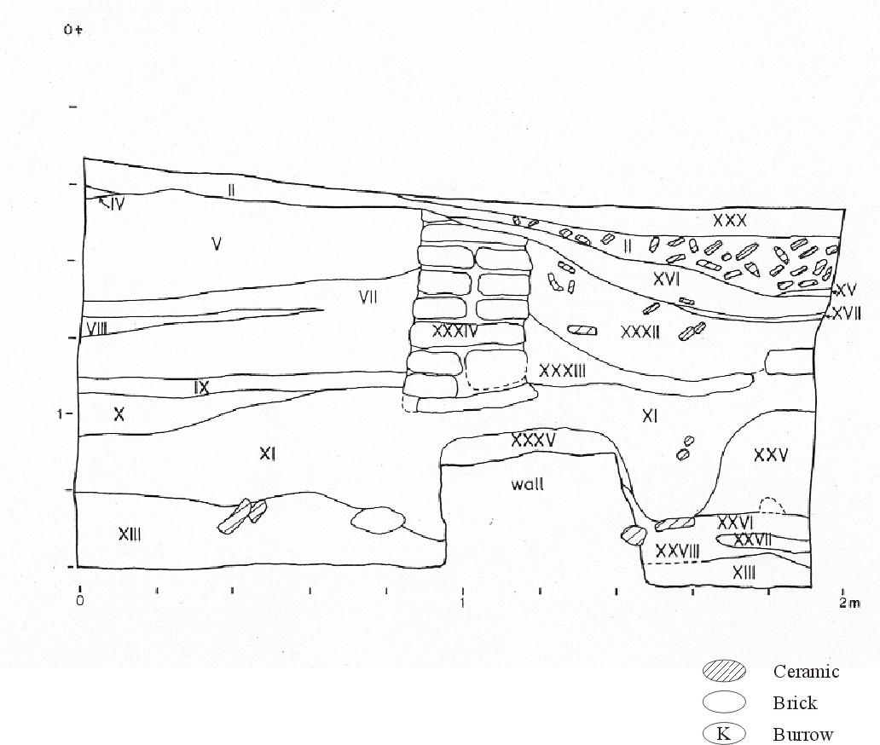
Figure 4.1 Unit 1156/1000 North profile.
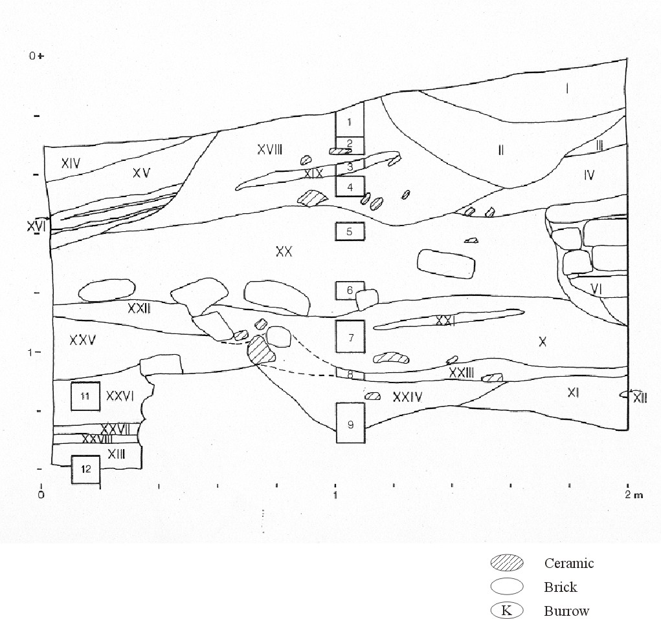
Figure 4.2 Unit 1156/1000 South profile
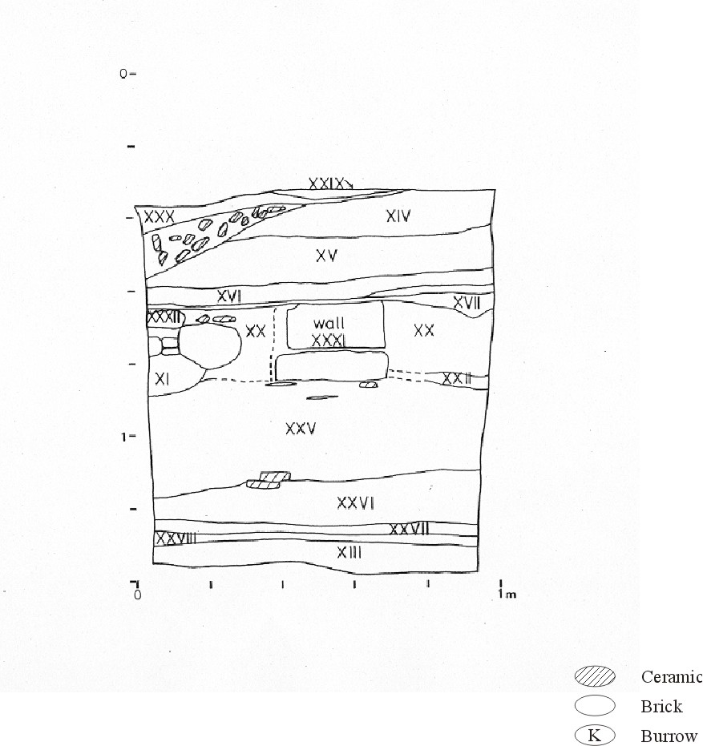
Figure 4.3 Unit 1156/1000 East profile
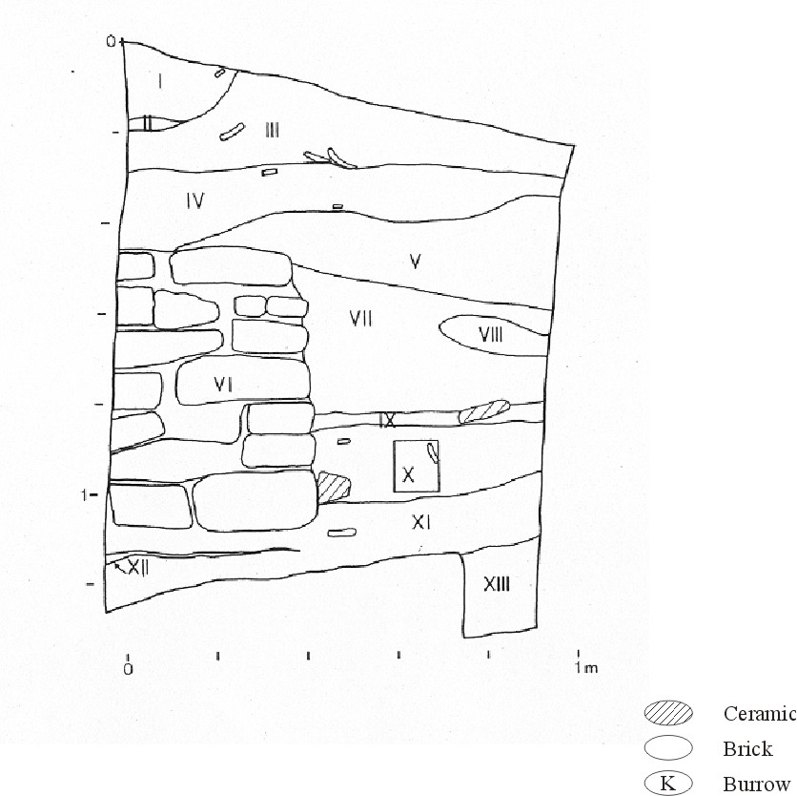
Figure 4.4 Unit 1156/1000 West profile
Stratum VII is a dark sandy silt containing few artifacts or charcoal. It has been badly disturbed by roots. Stratum VIII is similar to VII but somewhat darker. Strata VII and VIII appear to represent periods of infilling of a small abandoned mud brick building. Stratum IX is a very dark layer comprising lenses of varying thicknesses and colors. It contains some larger pot sherds and charcoal and may be an occupational surface associated with these walls. Stratum X is also very dark and contains numerous carbonized sherds as well as mud brick fragments. It too has been disturbed by roots, but the lower boundary is clear and quite linear. This layer, too, may represent an interior occupation surface connected with these walls.

Stratum XI forms the foundation for the mud brick building in this unit. It is a dark, wet, sandy silt containing some carbonized seeds and a few large sherds. It too has an obvious and rather linear lower boundary.

Stratum XII is a thin patchy lens of sticky plastic clay.

Stratum XIII appears to be a non-cultural deposit of sands and gravels--the gezira formation that apparently underlies all or most of the ancient settlement at Kom el-Hisn.

Stratum XIV (Figure 4.2), in the south profile is part of an apparent pit filled with medium to fine sand deposited in thin laminations and containing few artifacts.

Stratum XV is a darker silty sand containing unconsolidated pebbles, quartz granules, and pottery. Stratum XVI is similar to XV but darker and contains burned pottery sherds. Like XIV and XV, its lower boundary is abrupt and smooth.

Stratum XVII is a very dark silty sand containing numerous fragments of burned and unburned pottery. Stratum XVIII is quite similar and contains numerous flecks of charcoal, some bone, and considerable amounts of burned and unburned ceramics.

Stratum XIX is a slightly greasy, silty sand with some mud brick fragments, rounded pebbles, and quartz granules.

Stratum XX is a silty sand containing numerous mud brick fragments, a few sherds, and no apparent charcoal. It appears to have been deposited as wall fall or from the leveling of mud-brick buildings, possibly of the wall evident in the southwest corner of this excavation unit. It contains numerous rounded pebbles and quartz granules, and here, too, it seems evident that the density of pebbles and quartz granules is a direct function of the density of decomposed mud bricks.

Stratum XXI is a small lens of silty sand that is slightly darker than Stratum XX, within which it is located.

Stratum XXII is a poorly sorted, laminated series of fine sand, silt, and clay, which appears to have been deposited as slope wash, though it contains some brick fragments and a single piece of burned pottery.

Stratum XXIII is a lens of well-sorted clay and brick fragments.

Stratum XXIV is a wet, well-sorted fine sand mixed with fragments of relatively hard brick. Excavations ceased before the bottom of this stratum was revealed.

Stratum XXV appears to be a layer of brick collapse, containing the usual combination of pebbles, quartz granules, clay, etc. Its lower boundary is abrupt and smooth.

Stratum XXVI is a very greasy, sandy silt in which are mixed numerous fragments of burned and unburned ceramics, charcoal flecks, quartz granules, and pebbles. Its lower boundary is sharply defined and smooth. It may correspond to an occupational surface associated with the nearby wall, but this is not certain.

Stratum XXVII is a wet, well-sorted sand and contains few ceramics but some brick fragments. Portions of this stratum extending into the north profile appear to be deeply burned.

Stratum XXVIII is quite similar to XXVI.

Stratum XIII, which lies below XXVII and is identified in the west profile, is burned in its exposure in the south profile.

Stratum XXIX is in the east profile and appears to be a small pit. It contains the salt crust found over most of the site.

Stratum XXX is a well-sorted silt with some clay and appears to be the result of slope wash from the high point in the southwest corner.

Stratum XXXI (Figure 4.3) is a wall of olive-colored bricks. Because of the limited size of this unit it was not possible to demonstrate the articulation of this wall with the other structures in the excavation.

Stratum XXXII is a silty sand with few quartz granules but many large pottery sherds and animal bones, as well as some small burned sherds.

Stratum XXXIII is similar to XXXI, with a clean silty sand mixed with some clay.

Stratum XXXIV (Figure 4.2) is similar to VI and contains few quartz granules.

Stratum XXXV (Figure 4.2) is the lowest wall formation in the unit. The bricks appear to be the clean gezira bricks that contain few or no artifacts but moderate numbers of gastropod shells--often intact.

Summary of 1156S-1000E
This unit is important for several reasons: it has two distinct superimposed occupation levels--both above the water table; the shells placed under the corners of walls represent one of the few known decorative aspects of Old Kingdom Kom el-Hisn; the distinction in brick types, between the yellow-brown variety that contains considerable temper and heavy clays and silts, as opposed to the gezira bricks containing relatively little evident tempering and composed mainly of sands and gravels, is particularly distinct here.

In summary, nothing in the artifacts or faunal remains from this unit contrasts with what the mud brick suggests these deposits to be, the residues of domestic activities involving food preparation, storage, cooking, and consumption, and perhaps some minor stone tool working.

Unit 1200S-1088E was excavated between 11 and 27 July, 1984 (the high water period), by Lech Krzyzaniak and Karla Kroeper. It was selected as part of the stratified random sample. Profiles for the south and west walls of this unit are shown in Figures E5 and E6, respectively.

This unit is on the higher portions of the main occupational mound. Like most of these higher areas, the surface of 1200S-1088E was only lightly vegetated, mainly with cattle-thorn, and surface salts are clearly evident in the UPL layer. The water-table was encountered at about 1.34 m; but, by means of rapid bailing, samples of ceramics and other cultural materials were retrieved to a depth of about 1.7 m. Cultural sediments clearly extend below 1.7 m.

No architecture was encountered in these excavations. The stratigraphic profile of the south wall of the excavations (Figure 4.5) suggests that the cultural debris excavated in this unit was deposited as series of many different depositional events, including what appears to have been household waste disposal, water erosion and redeposition of cultural debris, and, perhaps, leveling of the site surface during periods of rebuilding or reoccupation.

Excavations of first level, Stratum I, began with the removal of the salt crust and disturbed surface deposits. Removal of these materials revealed a variegated surface incorporating pottery sherds, bones, and other materials. Strata II, III, and IV were defined mainly on the basis of color differences. Stratum IV contains a dense concentration of pot sherds, as well as an animal tooth, a lithic, and other debris, and it seems to represent an event contemporary with or slightly later than that represented by Stratum II. Stratum IV comprises all of the 2 X 1 m area of the unit except for about .30 square meters of the western half of the unit, which was darker in color than the beige to brown sediments of Stratum V.

Strata VII, VIII, and IX are a mixture of silts, clays, artifacts, biological remains, carbon, and other materials suggestive of household debris.
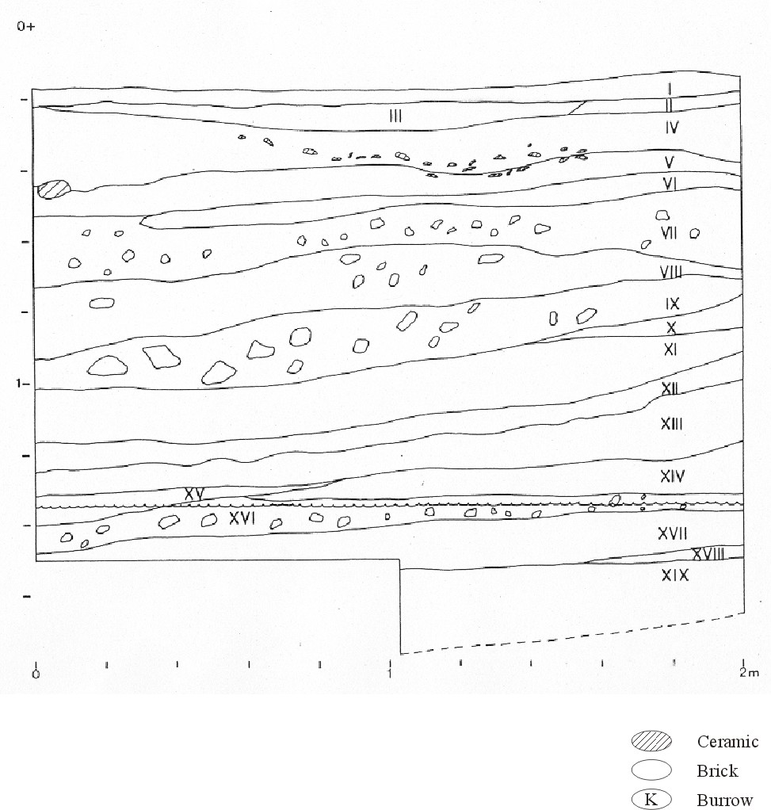
Figure 4.5 Unit 1200/1088 South profile
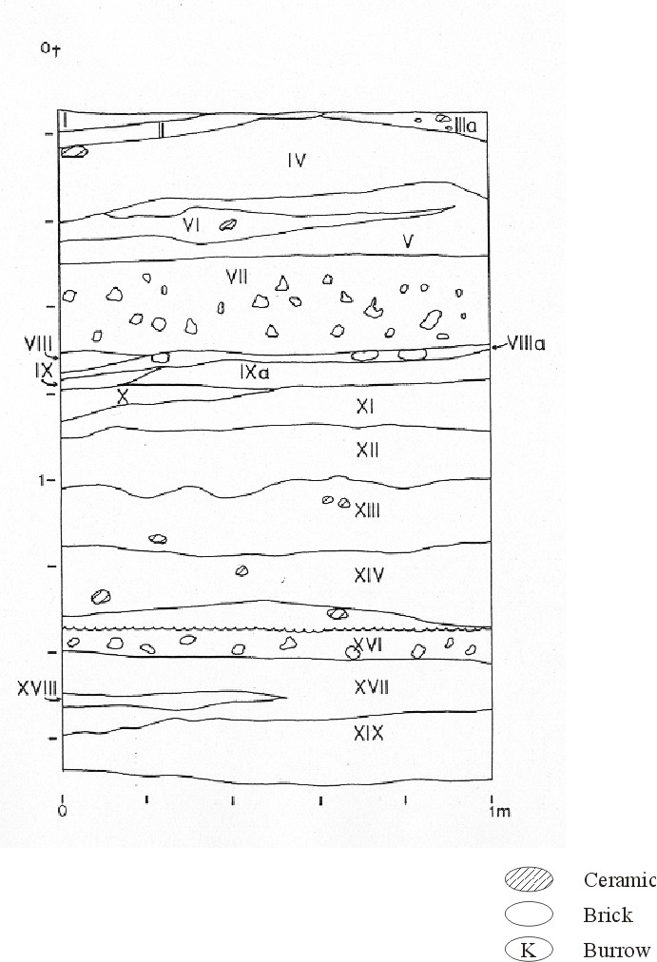
Figure 4.6 Unit 1200/1088 West profile

Strata X, XI, and XIII resemble the previous levels in general range of colors, textures, and cultural materials, but they contain numerous fragments of mud bricks. These show no consistent orientation and appear to be the residue of redeposited building debris.

Strata XV, XVI, and XVII, in contrast, contained few brick fragments but numerous sherds, bones, and dense concentrations of small flecks of charcoal. In the northwest corner Stratum XVII contained one heavy concentration of bones and artifacts that seemed intact and deposited as the result of food-processing, with little subsequent disturbance.

The water-table was encountered in Stratum XVIII, and with Stratum XIX the analyses of remains were affected by our inability to sieve these deposits. In general appearance and contents, however, it resembles Stratum XVIII. Stratum XIX, in contrast, contained dense concentrations of mud brick fragments. Stratum XX was a hard-packed layer of sand that directly overlays Stratum XX, which contained large quantities of pottery, charcoal, bones, and other materials.

Excavations ceased with SU-21, which resembled SU-20 in color and contents but which could not be fully excavated because of the water-table.

Summary of 1200S-1088E
This unit is comparable to the nearby unit of 1192S-1035E, which is also a complex superpositioning of strata that seems to reflect different episodes of trash disposal. One striking difference between these units, however, is that the strata of 1192S-1035E seem to slope sharply, even though the present ground surface in this area is relatively horizontal. In 1200S-1088E, in contrast, the ground surface is horizontal and the strata for the most part are parallel to the ground surface. This may indicate that the size of the built-up area of the community was smaller at one time, so that 1192S-1035E was near the edge of the main areas of residence. If so, the area represented by 1200S-1088E may have been an open area within the main residential area--a corral, perhaps, or courtyard. The presence of dense concentrations of mud brick fragments in various levels of both these units may indicate substantial regrading of the community during periods of rebuilding.

An examination of the animal bones found in this excavation unit suggests no significant difference from the other excavation units. Pigs, sheep, goats, and fish were the mainstays throughout the period represented by these strata. The ceramics and lithics, too, suggest the ordinary domestic refuse encountered all over the site.

Unit 1229S-1029E was excavated by Kim Honor between July 17 and 26, 1984. There are no profiles for this unit. It was chosen on the basis of the random design. We had hoped that 1229S-1029E would elucidate the relationship between the depression that runs between the main areas of our excavations and the mound underlying the modern village. We considered the possibility that this depression was an ancient watercourse, was created by sediment removal for agricultural purposes, or was part of the natural topography of the sand-gravel mound on which the settlement at Kom el-Hisn was constructed.

But the water-table was encountered at only 50 cm below the surface of this unit, and thus the nature of occupations here are largely unknown. One mud brick wall was revealed, however, and the distribution of sherds and other debris in the areas between this unit and the main areas of excavation and extending to the area of the step-trench (ST-1, below) and the modern village strongly suggests that all of this area was at one time occupied.

The extreme disturbance of sediments in this area by vegetation and the high water-table was such that no meaningful profiles could be drawn. Insofar as they were evident in the course of excavations, these sediments were quite similar to those from other excavations.

Unit 1192S-1060E was primarily excavated by Osama el-Sayed el-Katafany and Janet Long between July 31 and August 15, 1984. There are four profiles for this unit (Figures E7-E10).

Stratum I is composed of a dark brown sandy silt with some clay and both large chunks and smaller flecks of pottery. The boundary with the underlying Stratum II is very distinct and has a wavy appearance.
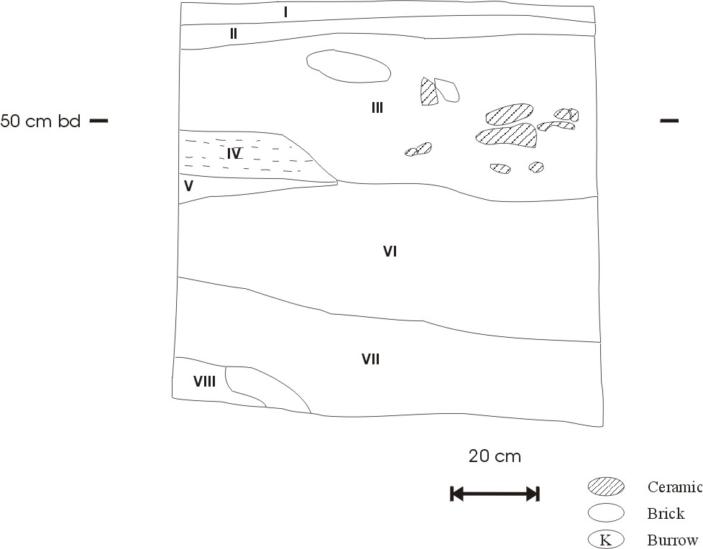
Figure 4.7 Unit 1192/1060 East profile
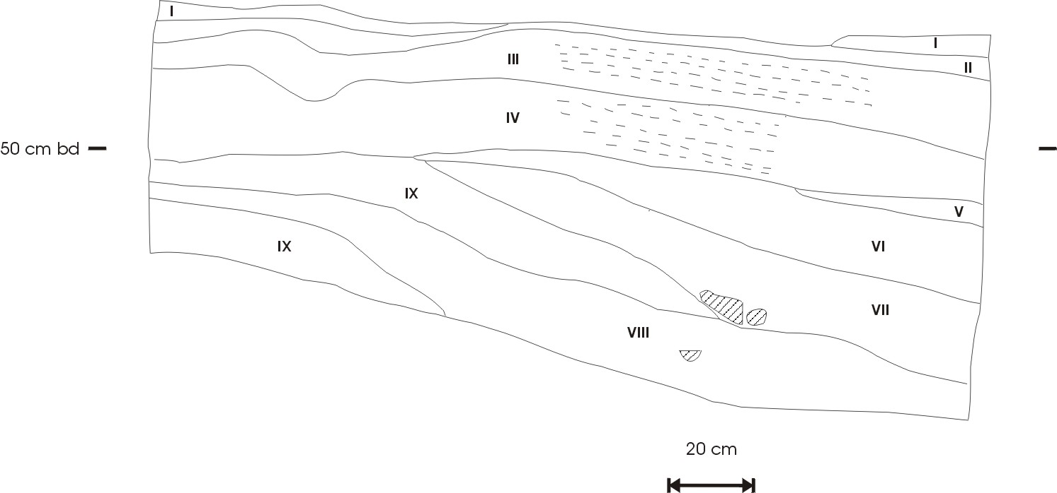
Figure 4.8 Unit 1192/1060 North profile
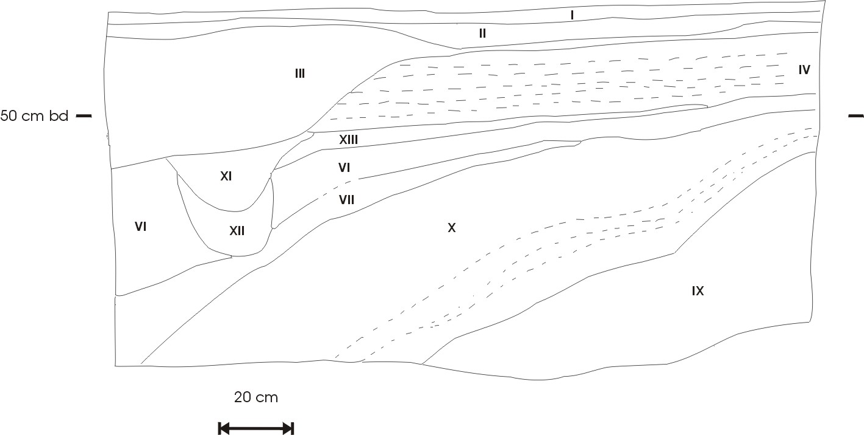
Figure 4.9 Unit 1192/1060 South profile
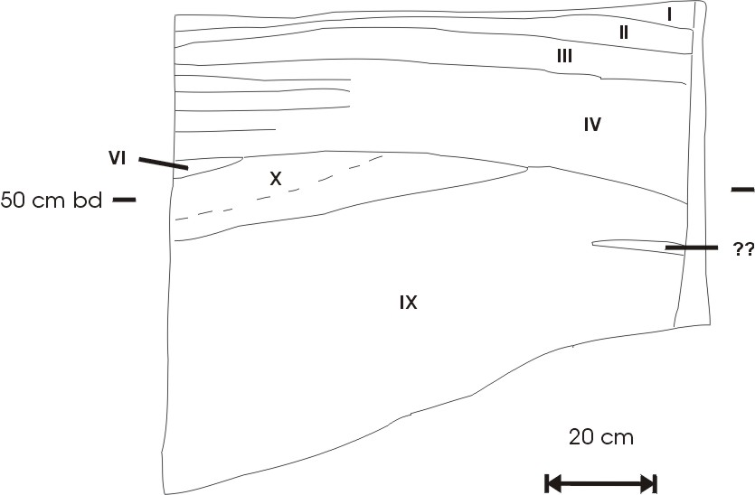
Figure 4.10 Unit 1192/1060 West profile
Stratum II is also a well-sorted dark grayish brown silty sand with abundant ceramics. It also has a well-defined boundary with Stratum III. The latter Stratum is a greasy, very dark gray silty sand with small pieces of pottery. The deposit is continuous with the pit feature in the southeast corner of the excavation unit which contains abundant large sherds and bone. The pit itself has abrupt boundaries and fine laminations in the northern section.

Stratum IV consists of dark to very dark grayish brown silty sand with lenses of yellowish brown fine sand that is clean and well sorted. Larger pieces of pottery appear near the bottom of the unit.

Stratum V consists of brown to dark brown medium moderately well sorted fine sand containing small pebbles and granules. It is similar to the fine sand lenses noted in Stratum IV. The lower boundary of this stratum varies from abrupt and smooth to rough and wavy.

Stratum VI is a dark grayish brown sandy silt with a clear and smooth lower boundary, some pottery, and flecks of charcoal throughout, as well as yellowish brown small mottles up to 5 cm in diameter.

Stratum VII is a greasy sandy silt with some admixture of clay. Rounded quartz pebbles are also present. Stratum VIII is similar, a dark grayish brown sandy silt with quartz granules, but is less greasy than Stratum VII. Similarly, Stratum IX is a dark grayish brown to black sandy silt also containing rounded quartz pebbles up to 1 cm in diameter. Stratum IX also contains frequent small mottles less than 1 cm in diameter.

Stratum X is very dark brown to black and contains small mottles. It is a silty sand with some laminations dipping to the east. The lower boundary is clear and wavy.

Strata XI and XII make up the deeper portion of the pit feature visible in the south profile (Figure 4.9). Stratum XI is a dark grayish brown sandy silt with a clay component and a few mottles. It also contains some rounded quartz grains and small pottery bits. The lower boundary with Stratum XII is abrupt and smooth. Stratum XII is an olive colored clay, very sticky and plastic.

Summary of 1192S-1060E
This unit is largely composed of gently sloping sediments with varying abundances of artifactual material. Most of the deposits seem to be composed largely of dissolved mud brick wall material with some minor dumping events. The pit feature, composed of Strata III, XI, and XII, seems to be an excavated pit structure of unknown function. The upper portions contain some large pottery and bone fragments but not in abundance to suggest a dump. The lower deposits also do not contain a large amount of artifacts further arguing against a garbage dump for this feature. Overall, this may represent a depression outside of habitation areas to which collapsing wall and household debris flowed into, with the addition of a pit feature of unknown function.

Test Square 1 (TS-1) was excavated by Michael Kobusiewicz between July 17 and August 10, 1984. This 2 X 2 m unit was not chosen as part of our sampling design, rather it was laid out on what we have surmised is the edge of excavations by Hamada and Farid (1947, 1950) in an area they described as having considerable architecture and numerous burials. Indeed, just to the south of this unit truncated mud brick walls protrude from a water-filled pit. Maps published by Hamada et al. are inexact, and precise delineation of their excavation units is difficult. Some of the disturbances of the area between TS-1 and the village to the east may be the result of the removal of sediments for agricultural purposes. The north, east, and west profiles for this unit are shown in Figures E11-E13.

Excavations began with removal of heavy vegetative cover and UPL.

Stratum I is a fine-grained silty sand, may be the residue of an early removal of surface sediments. It included a very dense concentration of ceramics in the northwest corner.

Stratum II is a fine-grained sand heavily mixed with organic materials. Excavation of Stratum II revealed a substantial mud brick wall that ran from the west balk, at an angle, toward the northeast corner. (Note: Stratum III was combined with Stratum II.)
Stratum IV is a fine-grained sand slightly mixed with organic material, as well as with some gravel up to 1.5 cm in diameter. Its lower boundary is abrupt and smooth.

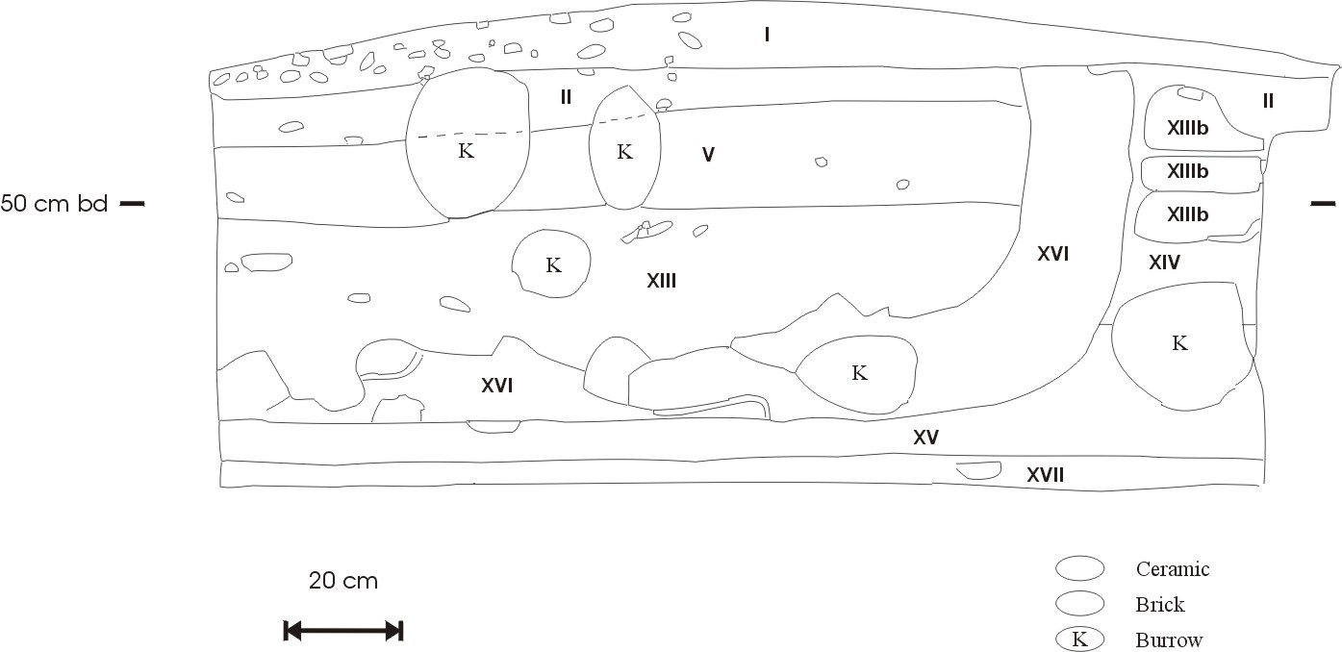
Figure 4.11 Test Square 1 North profile
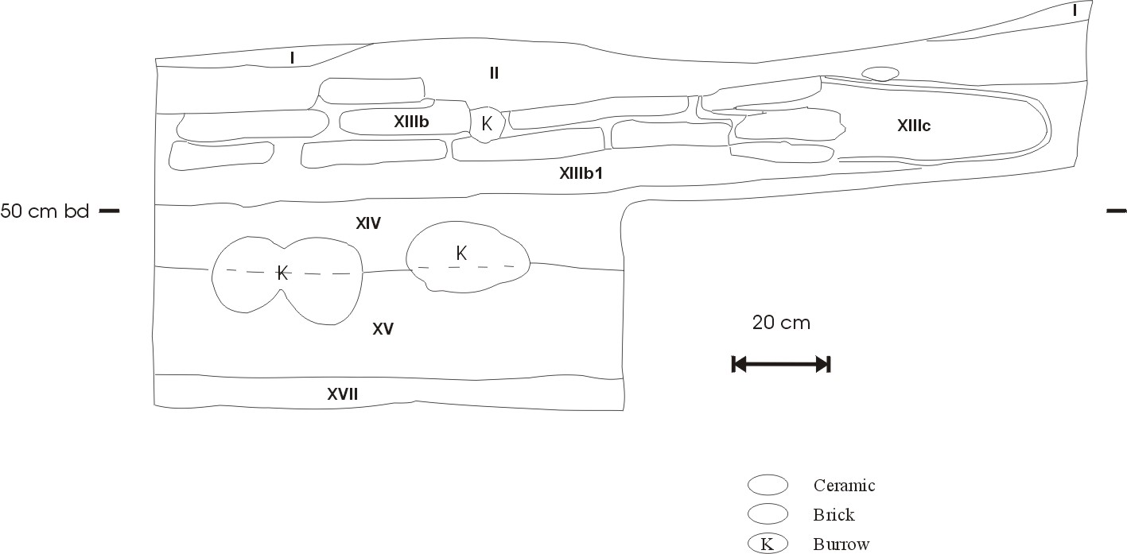
Figure 4.12 Test Square 1 East profile
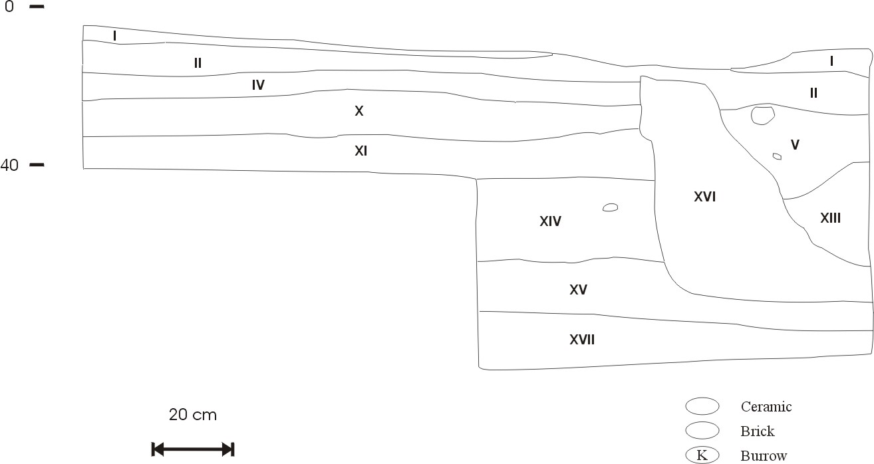
Figure 4.13 Test Square 1 West profile
Stratum V is a greasy fine-grained sand with some traces of silt; its lower boundary is smooth and abrupt. Stratum V and Stratum IV represent mainly fill in a mud brick building of unknown dimensions. (Note: Strata VI-IX were combined into Stratum V.)

Stratum X is a fine- and medium-grained sand slightly mixed with organic materials. Its boundaries are very indistinct.

Stratum XI is fine-grained sand with some organic materials. Its lower boundary is distinct and smooth. Strata X and XI appear to comprise sediments deposited outside of and against the walls illustrated in Figure 4.13. (Note: Stratum XII was combined with Stratum XIII.)

Stratum XIII is a greasy clay mixed with small amounts of fine-grained sand with small concentrations of silt. Its lower boundary is clear and smooth. This stratum may represent occupational remains associated with the walls in Figure 4.12, but the nature of this structure is uncertain. The animal remains and artifacts suggest domestic use, but most of these remains could have been deposited in these structures as refuse after their abandonment and partial leveling.

Stratum XIIIb is the lower three courses of a mud brick wall illustrated in Figures E11 and E12.

Stratum XIIIc is the plaster coffin of the burial from this room.

Stratum XIV is a mixture of clays, silts, sands, and organic materials whose boundary with Stratum II is quite indistinct.

Stratum XV is a medium- and fine-grained sand lightly mixed with silt and organic material. Its boundary with Stratum XI is hardly visible.

Stratum XVI is a mixture of medium coarse sands and brick fragments with no apparent organic materials--although it lies on the bottom of the mud brick structure illustrated in Figures E11 and E12.

Stratum XVII is a silt and clay mixture that contains concentrations of gravels and sands strongly suggestive of decomposed mud bricks. Strata XVII and XVI are particularly significant stratigraphically because they are underlie and are obviously earlier than the structure illustrated in Figures E11 and E12.

In general interpretation of this unit, it was evident that the dense concentration of ceramics in the northwest corner was deposited after the various walls in this unit were abandoned. They may be useful for seriation but, given the frequent use of older midden deposits in the construction of mud brick walls and other redepositing of cultural debris, these sherds may actually be older than the walls that they overlay.

The walls themselves suggest a rather complex building history. The burial was placed in what seems to be a purposefully constructed crypt, between two mud brick walls that appear to have been built at the same time and articulated with the wall running east to west (Figure 4.12). But the wall running east to west actually cut off the head of this burial--there were not even any small cranial bone fragments left in the plastered coffin. We found most of the bones of a human head in a pot below the level of this wall, and we surmise that the builders of the east-west wall cut through the two north-south walls, discovered the burial, and then reburied the head as they finished their construction. This interpretation seems the most probable, despite the obvious articulation of all these walls, which suggests a unified building design and a short building period, if not a single event.

Two other aspects of this architectural complex are somewhat puzzling. First, one of the walls in this complex (Figure 4.12) contained an exceptional number of large grinding stone fragments and large pot sherds. Even though mining of midden deposits for building materials seems to have been common at Kom el-Hisn, the size and the density of the artifacts in this construction were impressive. Second, when seen in profile, part of this complex of walls (Figure 4.12) was curved in a most unusual fashion: regular bricks appeared in the upper and some lower courses, but the lower portions of these walls were composed of a mixture of yellow sands and grayish-brown silts and clays, with only a few small sherds. These lower courses may simply have deteriorated to the point that brick outlines were no longer evident, but this did not seem to be the case.

Some of the ceramics of this area--such as the pot in which the human skull was buried--seem suggestive of First Intermediate or Early Middle Kingdom forms, and it may be that this area is related to the large cemetery excavated by Hamada et al. (1947, 1948, 1950). Yet the density of animal remains and the ordinary domestic pottery and lithics recovered here suggest that if this were indeed a cemetery area, it was constructed out of older domestic debris.

Step-trench 1 (ST-1) was excavated in the eastern slope of the mound that underlies the modern village to the west of the main areas of our excavations. Excavations (by Richard Redding and Kim Honor) began on July 11, 1984, and terminated on August 18th of that season. There are no profiles for this unit.

This step-trench was not part of our random sample of excavation units. We suspected that, if Kom el-Hisn was occupied before the Old Kingdom, the area of the step-trench, near the highest elevation of the site, might be where these early occupations would be located. The stone-lined tomb of Khesu-wer -- a local notable of what seems to have been the early Middle Kingdom (Silverman in press) -- is situated about half-way on the slope formed by this mound, suggesting that considerable earlier occupational debris lies beneath this tomb. Also, we had hoped that, if this mound were mainly of stratified Old Kingdom materials, we would then be able to use the artifact sequence in these strata to establish relative seriations.

In any case, this mound is the only area of the evident site of Kom el-Hisn that seems different, both in elevation and topography, from the other areas, and thus we suspected that Old Kingdom occupations contained in this mound might provide some clue as to the functional differentiation of this community.

Excavations began in a 2 X 2 m area near the highest elevations of the mound (the highest areas are under the contemporary village and rise about 1-2 m above the surface of the step-trench). The surface of ST-1 was covered with village trash. The excavation was eventually extended to a 2 X 4 meter area and eventually reached the water-table before excavations ceased.

It became evident during the first phase of excavation that most of the slope of the mound in the area of the step-trench was composed of redeposited occupational debris of the Coptic era -- of perhaps the 3rd or 4th centuries A.D. The ceramics of this period are poorly known, but we found painted pottery sherds that seem to match those found in association with textiles, coins, architecture, and other artifacts of this period. All of the materials in these levels of our step-trench were unstratified mixtures, however, and we found no architecture or other features.

The ceramics and other materials relating to these early first millennium A.D. occupations will be reported in full in our final publication. For purposes of the present report, however, it is only with Stratum XIII that we encountered Old Kingdom deposits -- and this stratum and successive ones were to a greater or lesser degree truncated or disturbed by later occupations. For these reasons, our report of these excavations and the materials recovered is somewhat more condensed than those for our other excavations.

As illustrated in Figure 4.14, the step-trench disclosed in its lower levels two parallel mud brick walls. One wall runs approximately north to south, but the small portion revealed suggests that this structure may actually circumvallate the entire mound. Its width of more than 1.5 meters seems too great for ordinary residential functions. The relationship of this wall to the section of the mud brick wall revealed in the west profile is somewhat unclear, however. The space between them--less than 1.5 meters--and the disparity between the elevations of their respective lowest courses (Figure 4.14) raise the possibility that these are not contemporary features.

In their ceramic associations and general architectural details these walls are both clearly Old Kingdom in origin. It is possible that the wall revealed in the west profile is a residential or other domestic structure within an area circumscribed by the other wall, whose lower elevation may simply reflect its greater size and slightly earlier construction than that of the wall in the west profile. Other relationships between these features are, of course, possible, and none can be eliminated without additional excavations.

Augering of the area of SU 30 (Figure 4.14 if applicable), however, revealed that there remains at least 50 cm of occupational deposit below the level of this SU.
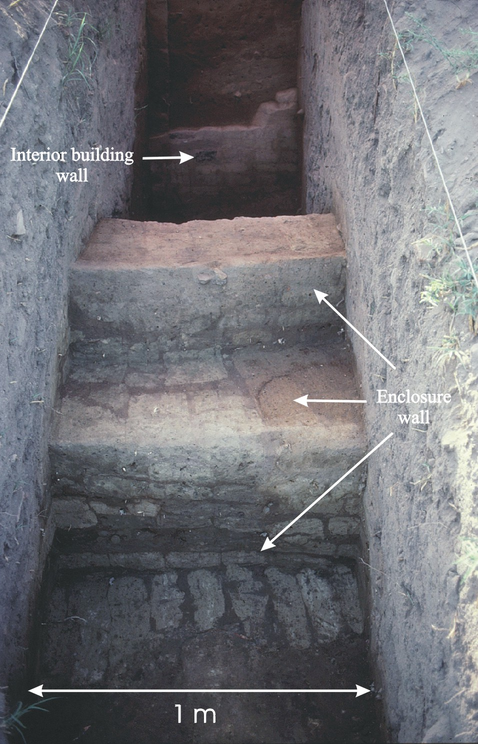
Figure 4.14 Step Trench 1 (ST-1) showing the large enclosure wall and a smaller interior building wall.

In analyzing the stratigraphy exposed by this step-trench, it became evident that unmixed Old Kingdom materials were only encountered only at about 1.9 m below the datum point, and only in the area between the two mud brick walls. This level corresponds to SU XXII, and the relationships between this SU and subsequent ones and the strata in this excavation are described below.

The faunal remains from ST-1 are very much what one would expect, based on the rest of the site, although the ST-1 samples are small. The absence of any lithics from Old Kingdom levels also may simply reflect the small sample sizes resulting from the large volume of this excavation occupied by the mud brick wall that is its main feature. The ceramics from the occupational surface associated with these walls (Strata below Stratum XIV) indicate that these walls were built in the Old Kingdom.

In summary of this step-trench, although the artifacts and faunal remains are very much like those of other units, here too the width of the exposed wall suggests that this is the only area of the site that is not primarily residential in nature.

1986

Unit 1235S/1056E was excavated between June 28 August 19, 1986 by Maureen King and Emilia Zartman. Profiles for all four walls are shown in Figures E15-E18.

The stratigraphy in this unit is extremely complex, with substantial mud brick walls, floors, pits and other features. Most of the volume of 1235/1056 was occupied by mud brick walls that traversed the unit from approximately north to south and east to west. These walls were substantially rebuilt at various times and are associated with long-term continuous occupations. In the lowest levels we found courses of brick that may be remnants of a phase of construction unrelated to the other exposed mud brick walls in this unit.

Strata I-III (all Level 0) comprises a silty sand intermixed with numerous decomposing fragments of pottery, especially in the salt crust toward the upper portions of the unit (the
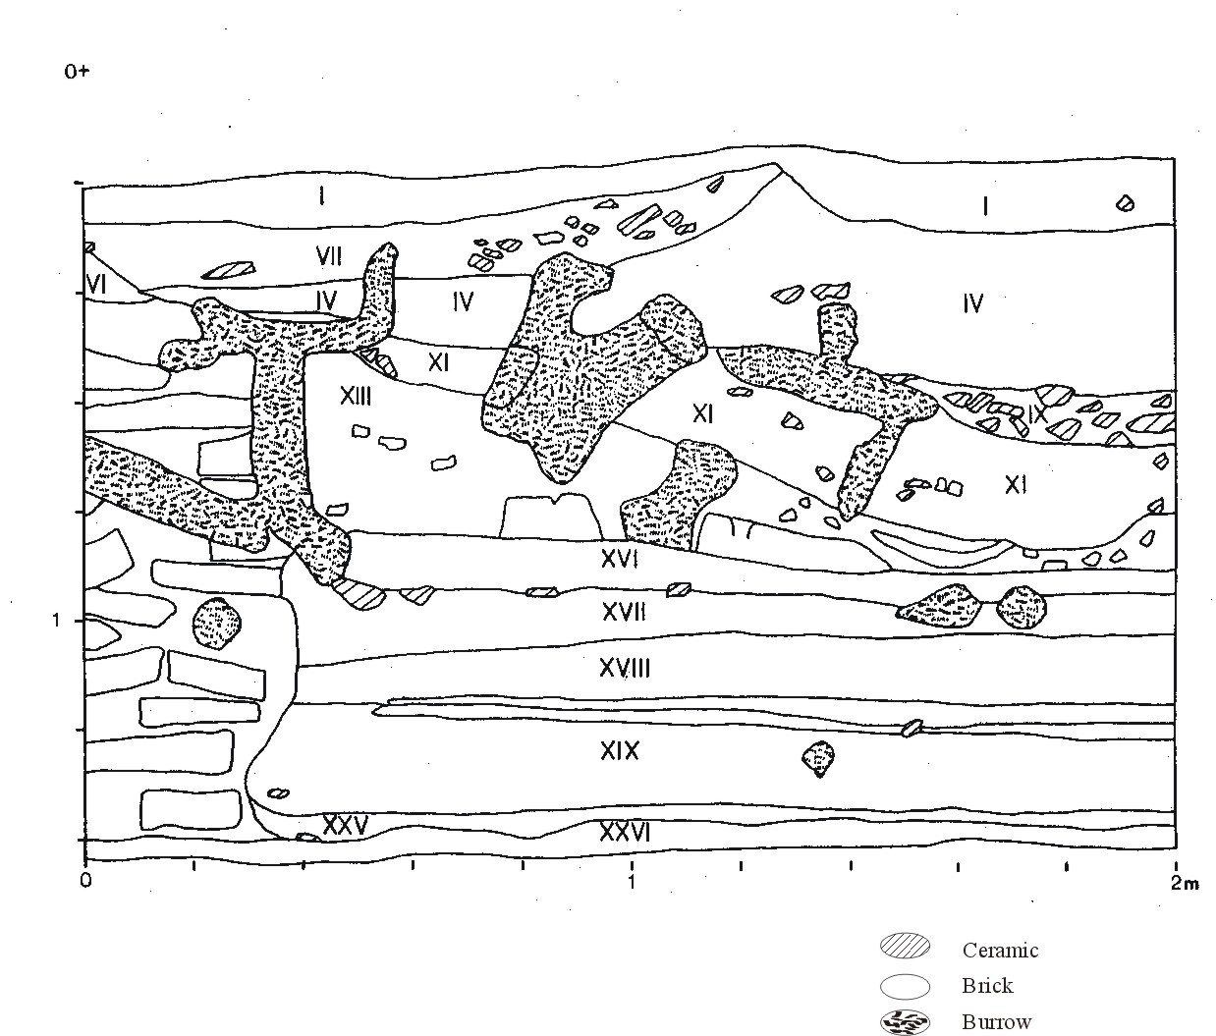
Figure 4.15 Unit 1235/1056 East profile
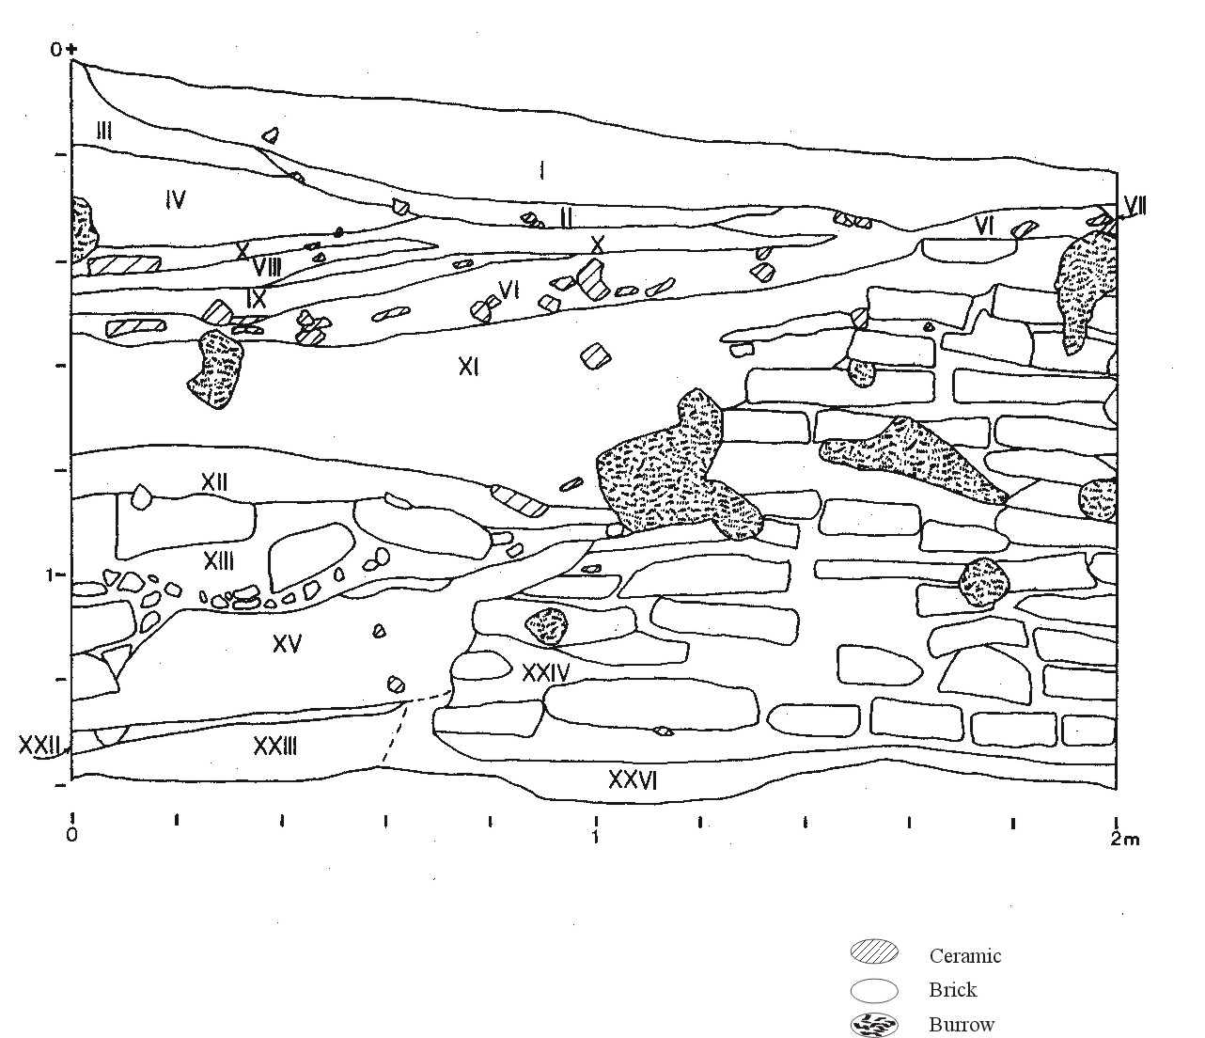
Figure 4.16 Unit 1235/1056 North profile
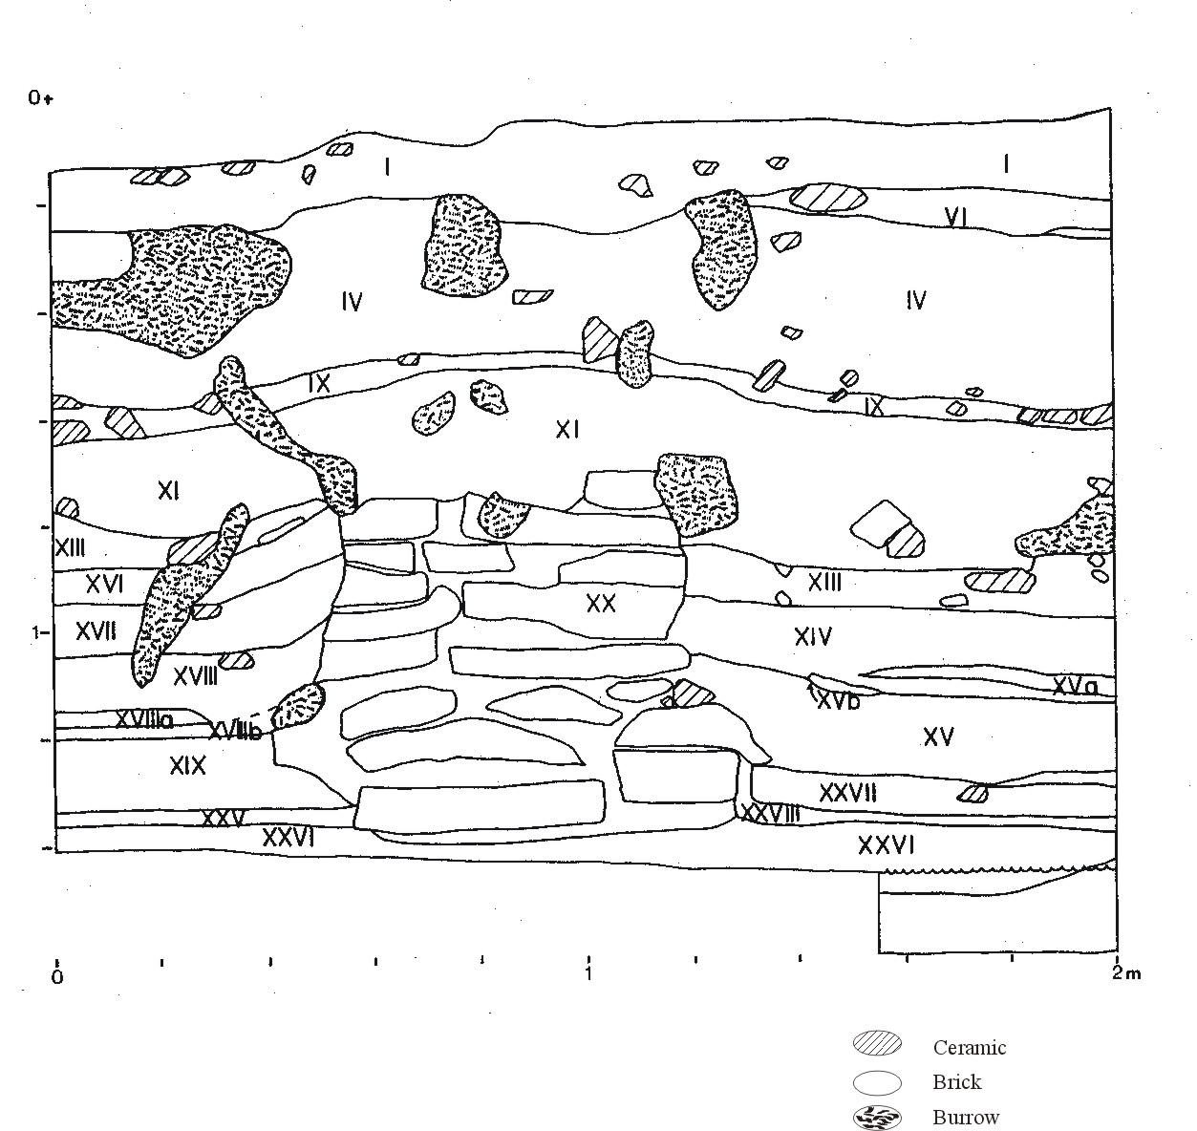
Figure 4.17 Unit 1235/1056 South profile
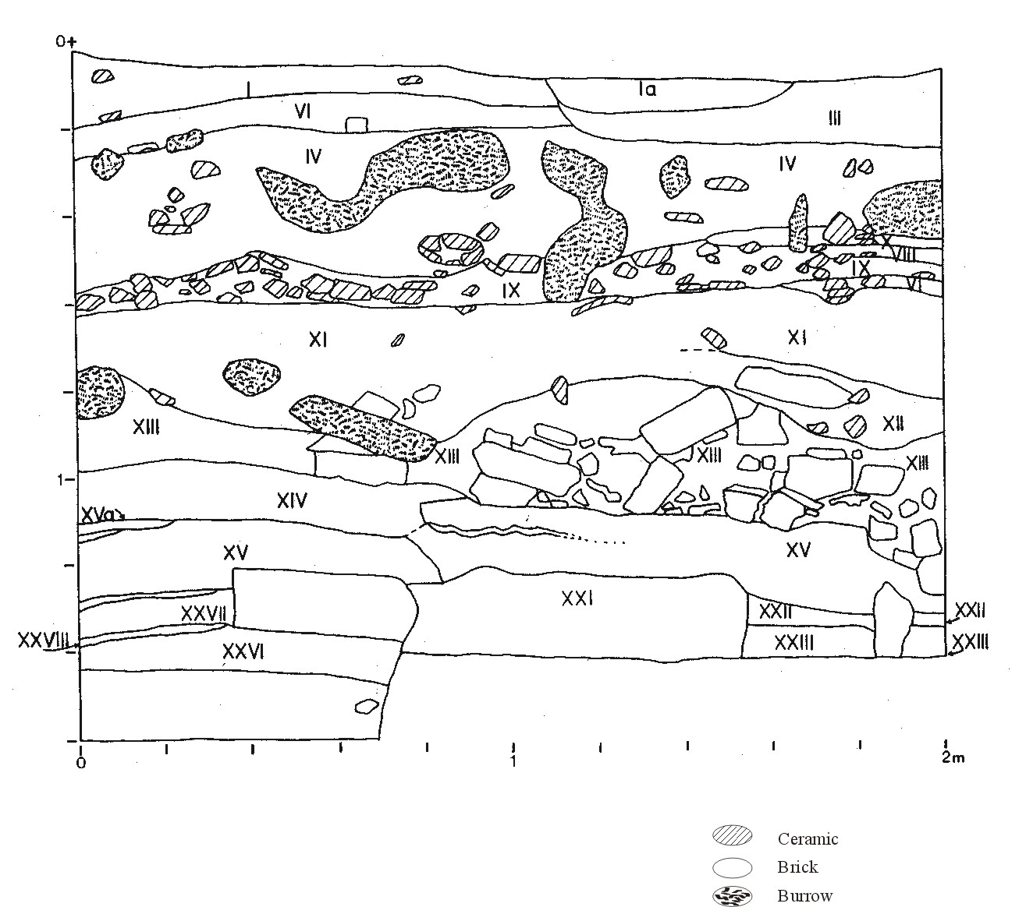
Figure 4.18 Unit 1235/1056 West profile
Upper Pottery Layer, or UPL). The boundary of Stratum I and Stratum II is quite distinct in that Stratum II has a much higher clay content. Stratum II also contains some areas of apparently water-laid clays. Stratum III, in contrast, is mainly sand and contains almost no silt or clay.

Stratum IV (Level 0) is a very dark brown medium sand with quartz granules containing numerous sherds, charcoal bits, and mottles identified as mud brick fragments. Stratum IV is a major unit that is evident in all four walls of the excavations. This is a very thick unit (up to 30 cm in places) and seems to represent a combination of wall collapse and dump deposits. Several of the larger sherds are horizontally bedded and some minor laminations are present as well.

Stratum VII (Level 0) is a silty sand with little silt or clay containing many dark grayish brown (2.5Y 4/2) brick fragments and abundant large sherds. The excavator described this as being a well-defined pit structure that sloped slightly to the southeast. Based on the presence of brick fragments, charcoal fragments, and relatively abundant ceramics and bone, its contents may be wall collapse along with some redeposited building debris. Its boundary with Stratum IV is clear and distinct. Stratum VI (Level 0) contains mainly sand, little silt or clay, and many large sherds. Stratum X (Level 0) is a layer of silty sand and large sherds and is found in the north and west walls only. It may be a subunit of Stratum IV. Stratum VIII (Level 0) is similar in composition to Stratum X in that it was mainly silty sand containing large sherds.

Stratum IX (Level 0) is a substantial layer of silty sand with large sherds in locally dense concentrations, as well as brick fragments indicative of wall collapse and some dark areas suggestive of organic refuse. This unit forms a capping deposit between the dark fill from above and stratigraphically older wall collapse and rubble below.

Stratum XI (Level 4) is composed mainly of decomposed bricks all of fairly small size and rounded, and having little apparent internal stratification. It is distinguished from Stratum XII (Level 4) only by the latter’s slightly darker color. Stratum XIII (Level 4) seems to be mainly decomposed mud brick, primarily of the gezira bricks – those made of light-colored, homogeneous sands and gravels – as well as some of the more clayey brown bricks. There are few sherds in this stratum, and it probably represents wall collapse or redeposited building debris.

Stratum XIII represents the final capping deposit covering the entire square. Below this the deposits are differentiated into two main areas on opposite sides of two walls defined as SUs 18 and 39. These two sequences are both directly associated with this large wall and can be, roughly, divided into eastern and western portions (Cagle 2003:62).

West portion (Area B in Buck (1990); Strata XIV, XV, XI, XXII, XXIII, XXVII, XXVIII, all Level 4)

Stratum XIV is a small deposit in the southwest corner of the square and is mostly clean sand with few artifacts or brick pieces. Stratum XV is probably the occupation surface associated with the major room walls in this area of the square and corresponds to SUs 34 and 35 (Cagle 2003 interpreted SUs 28, 32, 34, 35, 38, 40 as all belonging to the occupation surface). It is composed of a dark grayish brown silty sand with rare laminated patches and substantial clay, rare sherds, and no brick pieces. The laminations consist of alternating bands of dark brown and lighter yellow layers with the darker layers containing some charcoal flecks. This series is interpreted as several occupation surfaces separated by clean sand. The deposits in this Stratum are separated by a small partition wall (SU-39) but the lower deposits connect underneath it.

Below this are five additional strata (XXI-XXIII, XXVII, and XXVIII) that are interpreted as various forms of wall collapse deposits (see Buck 1990: 151-152 and Cagle 2003:62-63). The lowest portion of Stratum XXVII (SU-48) was described by the excavator as a prepared plaster surface as it curved up to com in contact with the base of the Stratum XV wall.

East portion (Strata XVI-XIX, XXIV-XXVI, all Level 4, except XXVI which is Level 5):
Stratum XXVIII represents the floor surface for this room and is covered by Strata XVI and XVII that may represent either a prepared floor with some dump material within it, or some form of one or the other. Structurally, Stratum XXVIII is very similar to Stratum XV on the other side of the wall: laminated layers of dark brown material separated by lighter clean sand layers.

The remaining strata are a combination of wall collapses, with the exception of Stratum XXVI which makes up the basal deposit of the entire square and is composed of unstratified silty sand and is either some sort of fluvial deposit or more probably a prepared sand surface (see Buck 1990:152 and Cagle 2003:63).

In sum, 1235/1056 contains the following basic sequence: a set of capping deposits composed of a combination of UPL, wall collapse, and small dump deposits, some contained within a shallow excavated pit; two sets of fairly thick, stratified floor deposits (Strata XV and XXVIII) resting at about the same elevation and relation to the wall; and a set of basal deposits of largely wall collapse and a prepared sand surface.

Two building episodes are represented in this square, the later one represented by the floor deposits associated with the walls visible in the profile drawings. The floors of these occupations are 40-50 cm thick and probably represent fairly continuous occupation of the structure(s). An earlier building episode is visible underneath the prepared sand floor but this was not excavated due to the high water table.

Regarding the distribution of artifacts and biological remains in 1235/1056, there is little apparent contrast with the remains found in other units. A relatively large number of fish remains were found in SUs 7 and 8, Strata IV, V, VI, and VII. These fish remains are part of redeposited materials not directly associated with the in situ architecture in this unit, and these could come mainly from just a few individual fish since the number of identified specimens (NISP) is the measure used. The ceramics included numerous examples of Types 3 and 11 – both of which are crude vessels that appear to have been the mainstays of domestic food storage, preparation, and cooking. The lithics also are of the same types and distribution as in most of the other excavation units.

In short, 1235/1056 is probably an area of the site in which two or perhaps three occupational periods there were small mud brick buildings of the type common in Egyptian villages for many millennia.

Unit 1192S-1035E was excavated between June 29 and July 26, 1986 by Richard Redding. No architecture as found; the water table was encountered at about 1.37m. Profiles are shown in Figures E19 and E20.

Excavations began by clearing a surface that was largely unvegetated. Small sherd fragments and pebbles were lightly distributed through the top five cm. Just beneath the UPL the surface appeared somewhat mottled, with apparent mud brick fragments, sherds, and some darker areas.

Stratum I (Level 0) was removed largely intact but included some materials from Stratum II (Figure 4.19). The sloping strata in this unit were recognized within the first 15 cm of excavation, however, and most of the sediments were removed in sedimentary units that correspond to the strata depicted in Figure 4.20. Stratum I is a silty sand with abundant decomposing ceramics in the upper levels – typical UPL. It was generally horizontally bedded and the boundary with Stratum II is clear but wavy and irregular.

Stratum II (Level 3) is a massive layer of sandy silt with faint parallel striations. It contains many large sherds lying flat on this surface and aligned on their long axes parallel with the bedding planes and in association with what appear to be small mud brick fragments and flecks of charcoal. Strata IIa, IIb, IIc, and IId are lenses and are very similar to Stratum II but are slightly blacker – apparently because of greater charcoal concentrations.

Stratum III (Level 3) is also silty sand but slightly darker than Stratum II. It also contains large sherd and mud brick fragments. Stratum IIIa is a lens of silty sand, slightly lighter brown in color than either II or III. It contains numerous sherds and charcoal flecks. Stratum IV (Level 3) is much like Stratum II, though the boundary with III and IIIa is quite distinct and smooth and wavy like that between Strata I and II. Stratum IVa is distinguished from IV by its lighter color and is a thin lens conformable with Stratum V below it. Stratum V (Level 3) is distinguished from the strata above it mainly by a greater number of mud brick fragments. Stratum VI is a massive concentration of sherds in a fine silt or clay matrix mixed with abundant charcoal and mud brick fragments. In some areas the sherds are horizontally bedded, but elsewhere they are jumbled in a manner that may suggest rapid deposition.
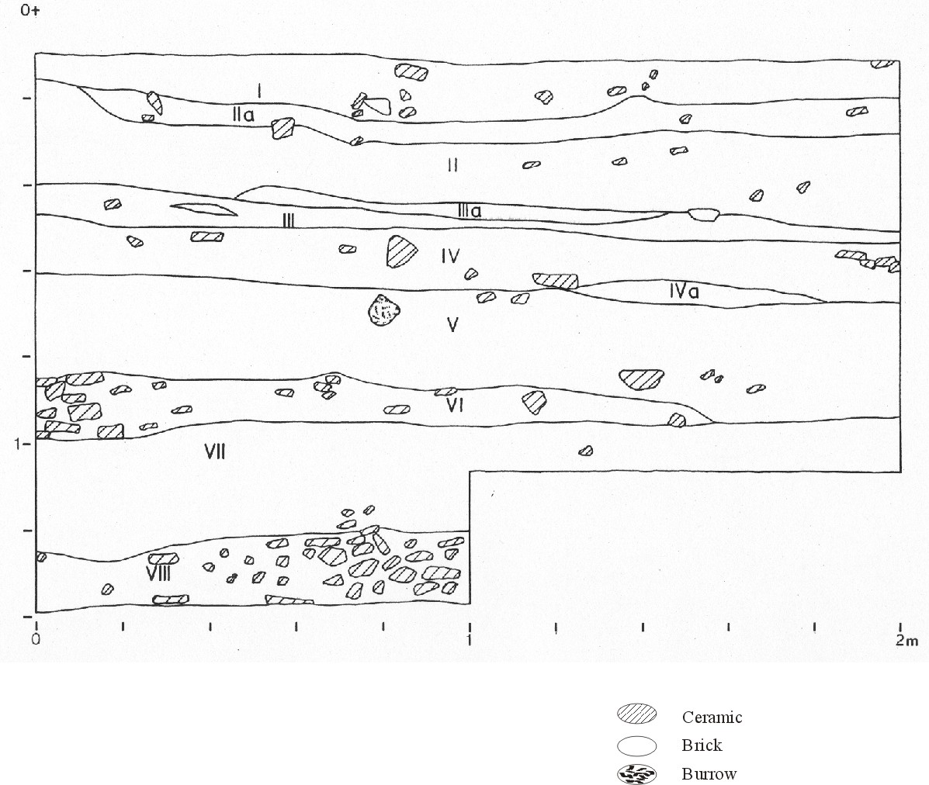
Figure 4.19 Unit 1192/1035 North profile
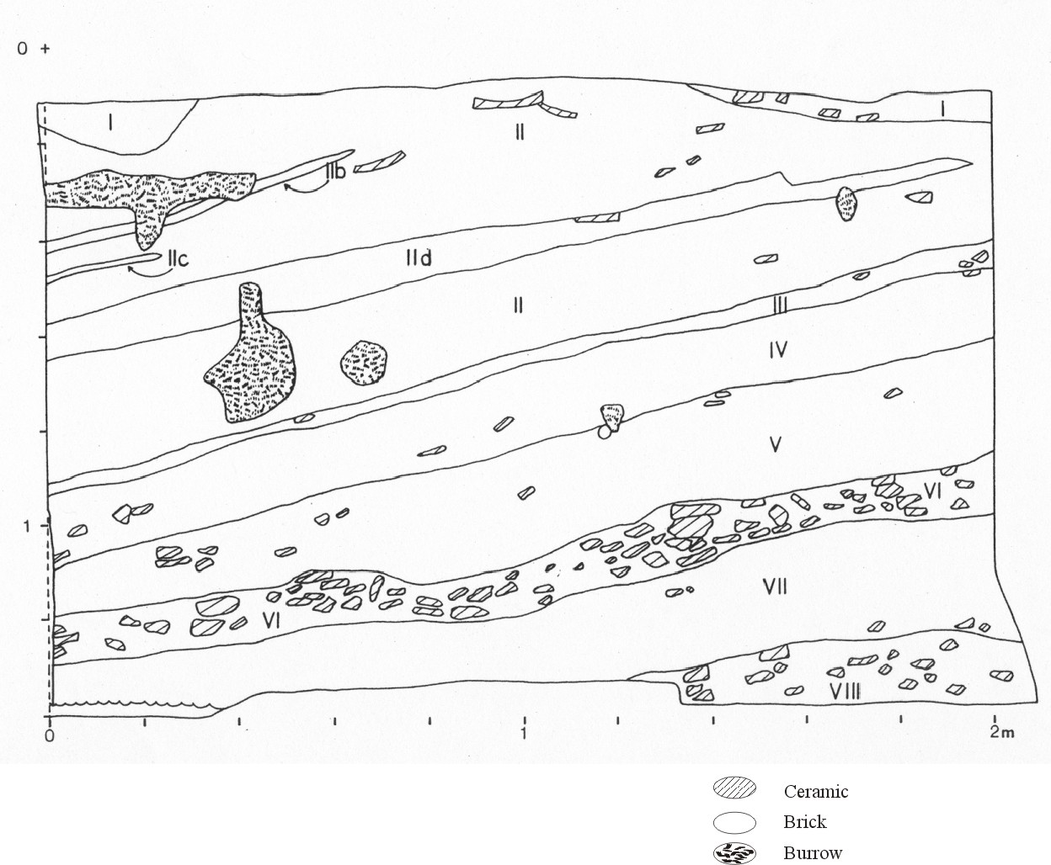
Figure 4.20 Unit 1192/1035 West profile

Stratum VII (Level 3) is a fairly clean sandy silt with few large sherds and occasional small bits of charcoal, brick pieces, and sherds. It is massive with no apparent stratification but darkens somewhat toward the bottom as charcoal concentrations increase. The upper surface of Stratum VII is wavy and irregular indicating an unconformity with the overlying Stratum VI (Buck 1990:276). Below is Stratum VIII (Level 3), a massive sherd concentration within a sand matrix. Sherds of all size are common as is burned and unburned bone.

In summary, Strata II, IIa-d, III, IV, and V reflect periods of continuous dumping of household debris but with changes in the manner of deposition. Stratum VI, for example, represented a short period of concentrated dumping of large quantities of sherds and other debris, whereas Stratum VII seems to reflect a slow accumulation of materials notable for the low density of ceramics and other preserved remains. Stratum VIII, however, derives from another episode of massive sherd dumping.

The sloping strata of this unit probably reflect a typical Middle Eastern architectural history, with a small settlement in the middle of the mound as the original occupation, but then periods of rebuilding in which old buildings and other debris were leveled off and pushed over the sides of the slightly higher community center. Stratum VIII may represent the first of such rebuilding periods, with Stratum VI reflecting another. The other periods may have been similar periods of deposition and releveling, but of deposits that contained fewer ceramics. These deposits of ceramics, it should be noted, were not isolated, so that they appeared in the balk but not in the rest of the unit; these layers of sherds covered most of the area of the 2-meter excavation unit.

Unit 1219S/1095E was excavated between June 28 and July 21, 1986. All of the walls in this unit were heavily disturbed by roots and rodent burrowing. Profiles are shown in Figures E21 and E22.

Strata I (Level 0) and Ia are both massive deposits of relatively loose silty sand; typical UPL. Stratum Ia contains fewer large ceramics and is a somewhat more compact sediment, containing relatively more silt and clay components. The boundary between the two is unclear and they are probably slightly differing UPL deposits.
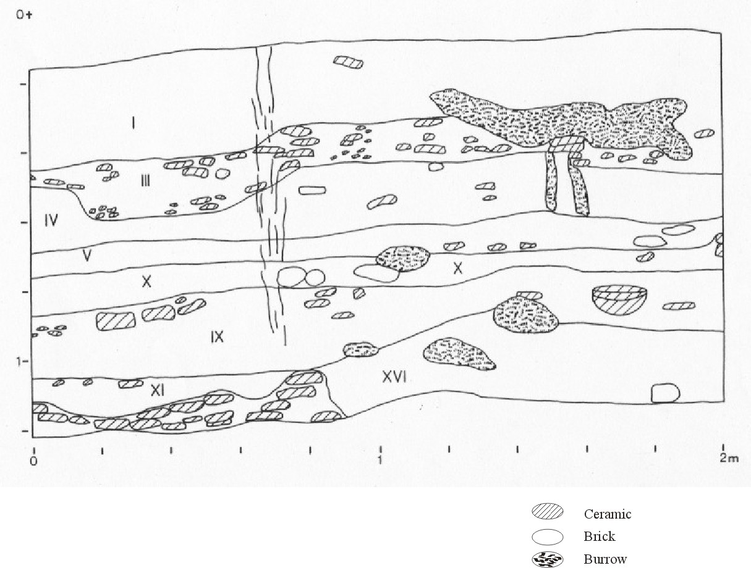
Figure 4.21 Unit 1219/1095 North profile
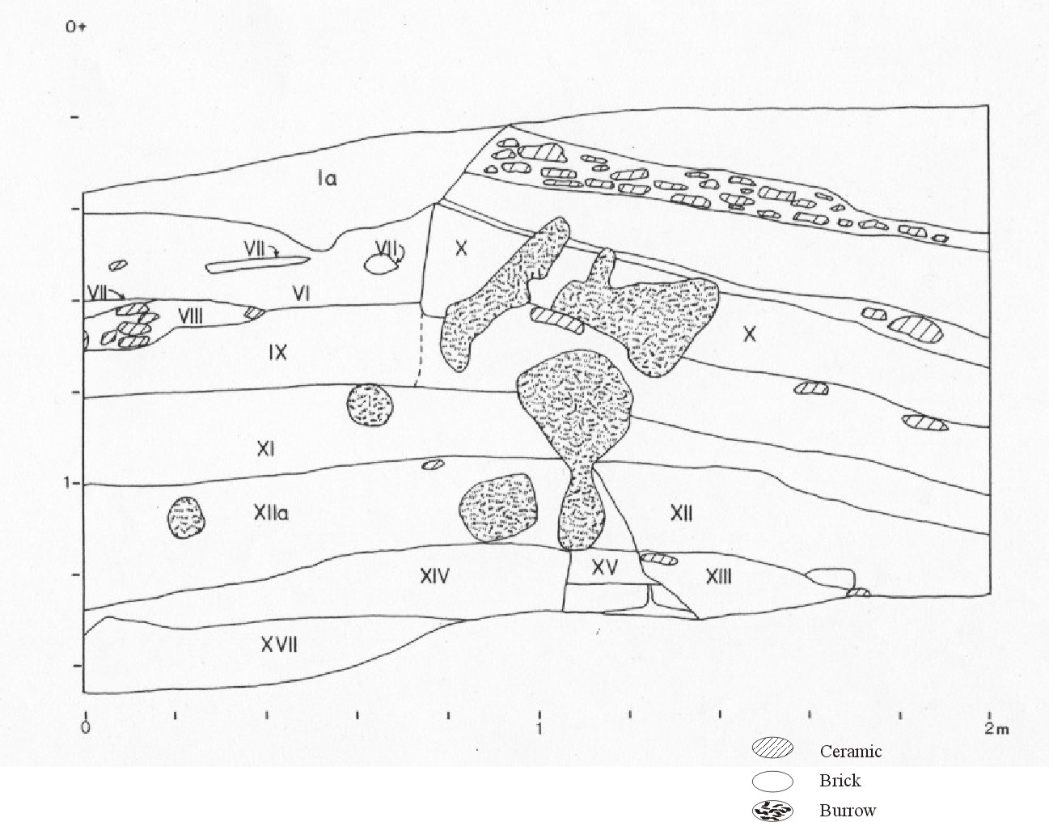
Figure 4.22 Unit 1219/1095 West profile

Stratum III (Level 0; there is no Stratum II) consists of layers of grayish brown compact sandy silt with some charcoal and heavy concentrations of sherds in places as seen in the north profile (Figure 4.21). Stratum IV (Level 0) is a relatively clean silty sand with only occasional sherds, bone, and charcoal. Strata I-IV were considered by Cagle (2001:54) to be a single deposit representing UPL and lower deposits of heavier (III) and lighter (IV) dumping mixed through rodent action.

Stratum V (Level 0) is a silty sand with common sherds and charcoal and some mottles (presumably brick pieces) at the east end of the north wall. Stratum VI is a massive unit without apparent stratification. Stratum VII is contained within Stratum VI (Figure 4.22) and appears to be debris dumps containing ‘chunks’ of some other deposit: stratified brown mud and white sand.

Stratum VIII (Level 0) is a silty sand containing lots of pottery and is similar to Strata III and V. Strata IX and X are both sandy silt and were combined by (Cagle 2003:54) into a single unit representing wall collapse. Both contain a few large sherd pieces (Stratum IX in its upper portion only) and the center of the west wall here is greatly disturbed by rodents (see Figure 4.22).

Everything above Stratum XI (Level 0; SUs 1-4) is later than the underlying structure that is defined by the Stratum XV wall (below) and not related to it. Below this, the strata split into two sides of the Stratum XV wall, visible in Figure 4.22.

Stratum XI (Level 0) is a sandy silt with occasional sherds and charcoal and slight stratification. Below this are Strata XII and XII (both Level 0) which are similar, but distinct; the boundary between them (see Figure 4.22) is heavily disturbed by rodent burrowings. They are both sandy silts but XII contains abundant large sherds while XIIa contains rare large sherds and charcoal. These are interpreted to be dump deposits by both (Buck 1990:142 and (Cagle 2003:57).

Stratum XIII (Level 0) is similar to XII, a sandy silt with common sherds and some charcoal with no apparent stratification. Stratum XIV (Level 0) contains charcoal flecks and occasional sherds and directly abuts the brick wall of Stratum XV. It reflects moderate intensity of use and may be an occupation surface but is probably dumped material from another location.

Stratum XV (Level 0) is an intact brick wall or platform including decomposed and collapsed brick material from higher in the stratigraphic column than the intact bricks. It trends in a NW to SE direction across most of the middle of the square, ending just as it enters the west wall. The bricks themselves are yellow-green and sandy (2.5Y4/2).

Stratum XVI (Level 0) is a mottled sandy silt with grayish and yellow brick pieces, occasional sherds and charcoal flecking; probably wall collapse. Stratum XVII (Level 0) is a silty sand and was described by (Buck 1990:142) as a possible occupation surface. While no direct correspondence information is available, this is probably SU-15 and/or SU-16 that (Cagle 2003:57) identified as a floor deposit.

Summary of 1219/1095 This unit contains part of one structure represented by the Stratum XV (SU-5) wall. This wall runs roughly NNW from about the middle of the east baulk and continues to within 20 cm of the west wall. At this point, it does not end abruptly but seems to be collapsed. The wall was first defined at 30 cm below datum and extended through the bottom of the excavated deposits.

The upper strata were heavily disturbed by rodent burrowing and roots and this continued throughout the unit. Though not apparent in the profile, the excavator noted that a great deal of mixing had occurred in these upper levels and probably in the entire sequence.

Overall, the deposits in 1219/1095 can be divided into two sequences. The upper sequence is a heavily disturbed set of deposits (Strata I-X) representing some combination of UPL, dumped debris, and wall collapse all heavily mixed by rodent burrows and root systems. Below this are the strata directly associated with the Stratum XV wall. These also represent some dumped material and collapsed wall material of Stratum XV. The possible occupation surface is composed of SUs 15 and 16, and is composed of an upper layer of dark, sticky matrix with abundant charcoal, bone, and ceramics, and a foundation deposit of relatively clean brown sand. This foundation deposit seems to have been laid down to cover a previous floor surface (unexcavated) whose association with the Stratum XV wall is unknown (Cagle 2003:57.

Because of the large number of Middle Kingdom bread molds and later ceramics in the upper strata and other Middle Kingdom ceramics in the lower strata (especially in the occupation floor itself), and because of the degree of mixing throughout this unit, it is difficult to assign the deposits in this unit to a particular age (Cagle 2003:58). Buck argued that all of the upper strata were unrelated to the lower deposits (Buck 1990:282) but the presence of Middle Kingdom ceramics throughout muddies this interpretation. It is possible that the Stratum XV wall is of Old Kingdom age but the extensive post-depositional disturbance mixed the deposits to a degree that makes interpretation tenuous at best.

Because a large number of the ceramics from all of these deposits were of Middle Kingdom age) and because of the heavy disturbance it is difficult to assign these deposits to a particular age range. It is possible that the Stratum XV wall is of Old Kingdom date with later deposits.

Unit 1166S/1066E was excavated between June 28 and July 21, 1986 by Paul Buck and Osama el-Sayed el-Katafany between July 7 and 23, 1986. It was selected for excavation on the basis of our random sampling design. Excavations were abandoned at a relatively short depth because the water-table was encountered. Profiles are shown in Figures E23 and E24.

The surface of the unit was covered with camelthorn and a heavy mat of vegetation--probably reflecting the nearness of the water-table.

Stratum I (Level 3) contained the salt-crust found in most excavations here just below the land surface -- UPL. The matrix was a series of finely laminated silt and sand mixture with some pottery, and the salt- crust was associated with decomposing pottery. Numerous flecks of a white mineral--probably a precipitate--were evident beneath the salt-crust.

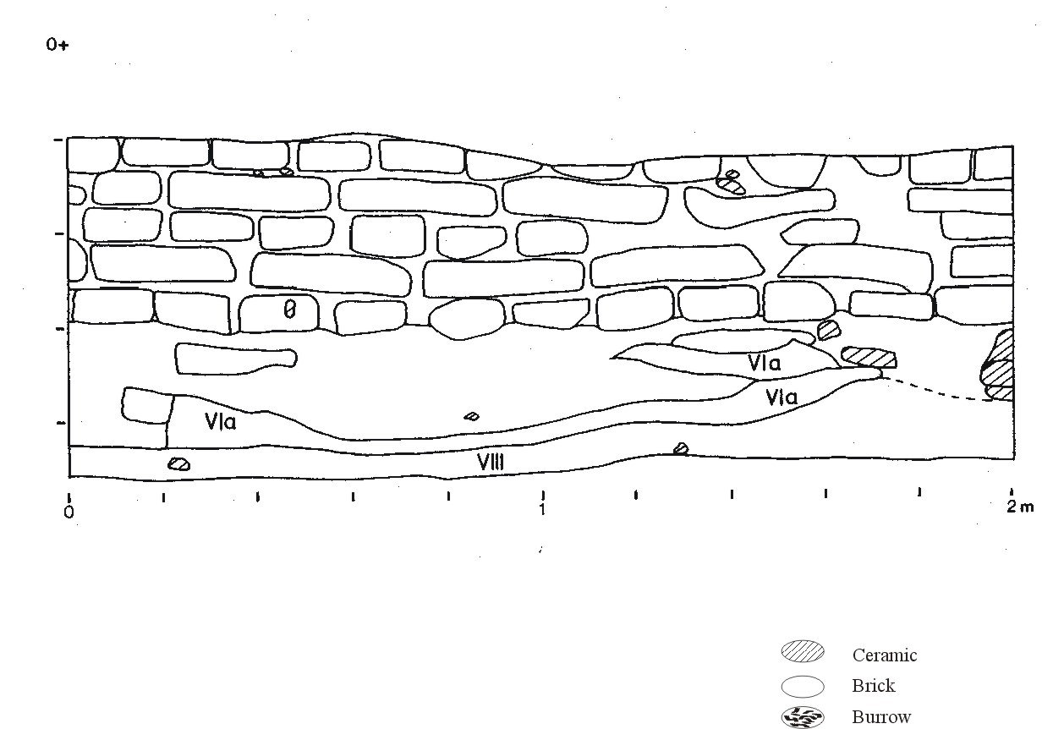
Figure 4.23 Unit 1166/1066 North profile
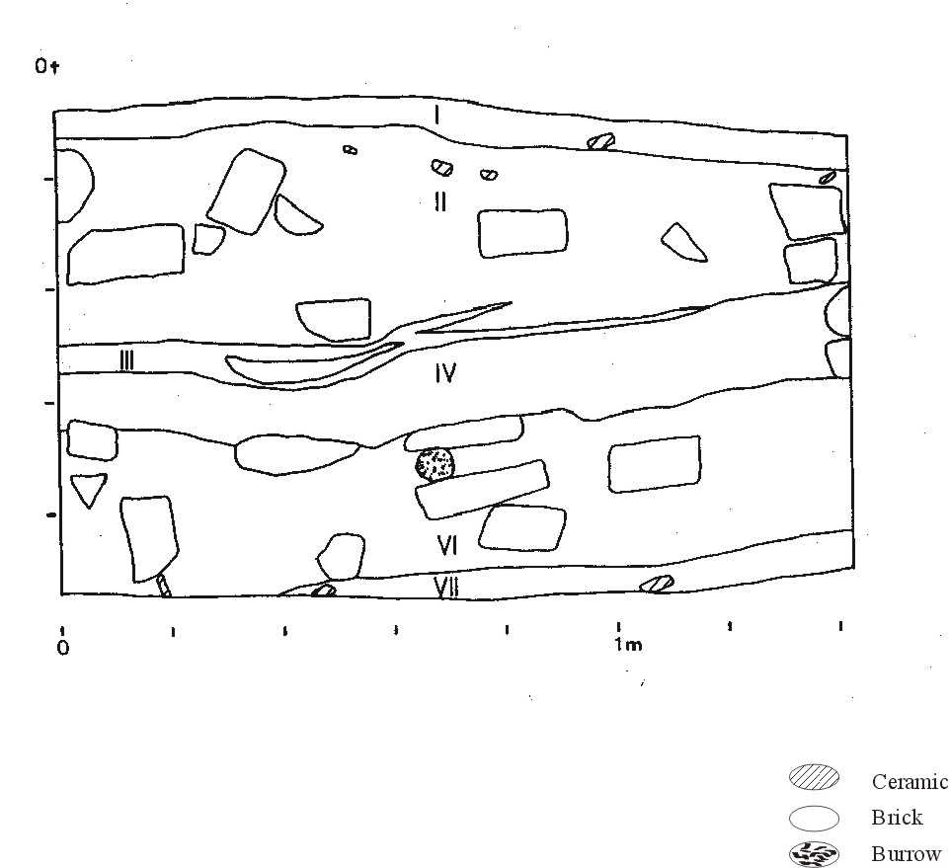
Figure 4.24 Unit 1166/1066 West profile
Stratum II (Level 3) appears to have been a layer of wall collapse. It contained whole bricks and brick fragments in a silty sand matrix. The mud brick wall at a slight angle to the North balk was already evident 20 cm below the datum, toward the top of this Stratum. It is located just above the basal course of the brick walls in this unit and on the floor surface.

Stratum III (Level 3) is a layer of sandy silt with numerous lenses of white sand, "greasy" gray deposits that contained charcoal and what appeared to be ash, and coarse reddish sand. It is about 2-3 cm thick and slopes slightly from the south where it abuts the SU-3 (unexcavated) intact wall to the north (see Figure 4.23). In several areas the sediment was yellow-orange, apparently a result of in situ burning; in addition, a small shallow pit (Figure 4.9) contained material burned in situ. The apparent hearths, laminated structure, and position at the base of the SU-3 wall indicate this as a floor/occupation deposit.

Stratum IV (Level 4) is a relatively clean sandy silt containing few sherds or other cultural materials. It may have been deposited as foundation material for the mud brick building in this unit. Stratum V (Level 4) is similar to Stratum IV in color and contents and both may represent heavily decomposed brick wall material.

Stratum VI (Level 4) is similar to Stratum II, in that it contains bricks and brick fragments that may have been deposited as wall collapse or from the leveling of wall debris. The bricks seem to be the gezira variant, in that they contain no obvious sherds and are made of coarse white sand, as opposed to the brown, chaff-tempered bricks that often contain sherds. In fact Stratum VI seems to be in the same architectural pattern as some of the other excavation units, in which the lowest levels of occupation were apparently made predominantly with the gezira bricks, whereas the upper levels are usually made with the ordinary brown mud bricks. The matrix is a silty sand.

Stratum VIA (Level 4) is made up of discontinuous lenses of silty sand containing fragments of gezira bricks.

Stratum VII (Level 4) is a sandy silt with some brick fragments, sherds, and occasional flecks of charcoal. It may well have been a floor of a structure whose walls are not in the excavation unit. The circular unfired clay features at 107 cm and 111 cm depth may well have been storage features like that in Stratum II and observed elsewhere on the site.

In general summary of this unit, it is important to our stratigraphic analyses because it shows two clear levels of occupation separated by a floor. This floor is only about 3 cm thick but is well preserved. The superpositioning of the two apparent floors in this unit may indicate a continuous occupation over a relatively short period, with one episode of rebuilding. But this interpretation is tentative. In the next season of occupation this unit will be extended horizontally to reveal the rest of the walls of this structure.

Summary of 1166/1066
Two distinct occupations are represented in this unit. The upper deposits, Strata I-III including the SU-3 wall seen in Figure 4.23 (North wall), contain one distinct occupation surface (Stratum III) which is associated with the intact wall in the north end of the square. The occupation surface is overlain by collapsed wall material (Stratum II) and the unit is capped by the UPL of Stratum I.

Directly below the Stratum III occupation surface and representing an earlier occupation are two probably collapsed wall deposits, the upper one (Stratum IV) apparently made up of heavily decomposed bricks such that no intact bricks are observed and is probably the foundation deposit for the upper units. This may indicate that a substantial amount of time passed between the two occupations or that lower was purposefully knocked down and leveled. Below the wall collapse deposits is another possible floor (Stratum VII) though this deposit was into the water table at the time of excavation making a determination of structure difficult.

Unit 1204S-1060E was excavated by Emilia Zartman between July 22 and August 10, 1986. It was not part of the stratified random sample of units, having been selected for excavation to determine the extent of the architecture in the 1200/1213S-1070/1074E complex. The west profile is shown in Figure 4.25.

The unit proved to be a finely stratified series of deposits without in situ architecture. These strata contain relatively few ceramics, though the density of faunal remains is moderately high.
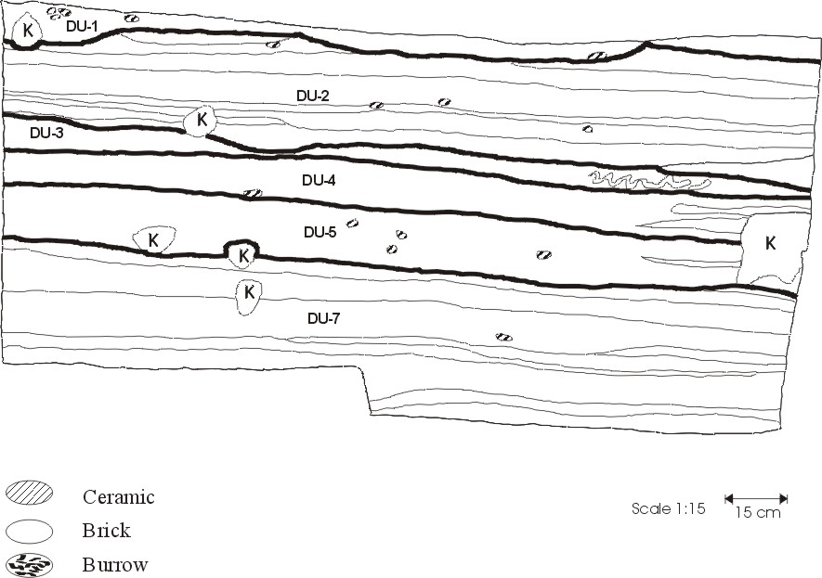
Figure 4.25 Unit 1204/1060 West profile

Stratum I (Level 0) is fairly typical UPL with moderate amounts of both ceramics ad lithics, but with little or no bone. Stratum II (Level 3) is a laminated deposit consisting of alternating layers of brownish-gray sandy clay with black lenses and two tan sand lenses (SU-5) within it. Ceramic densities are rather moderate and bone density is high with cattle bone (including 18 bovid tooth fragments) making up part of the faunal remains, one of the few units to actually contain any Bos remains; the remainder of the identified faunal remains were sheep/goat and pig, and a variety of unidentified body part fragments. Lithic density is also moderate consisting of four pieces of debitage and a flake of unknown material. The presence of bone indicates some kind of habitation debris as a source, but the presence of brick fragments also suggest wall material was included. At least some deposition due to water flow is indicated by the laminated structure, but the patchiness could also result from some small individual dumping events.

Stratum III (Level 3) is a small area of redeposited wall collapse in the eastern section of the square. The types of bricks noted seem to be typical gezira bricks of yellow color with occasional snail shells. Very few ceramics were present and no lithics and some bone was present, mostly from a few unidentified limb fragments. The massive structure of this deposit indicates slumping from a nearby structure rather than fluvial movement.

Stratum IV (Level 3) is similar to that of Stratum II and may in fact be a continuation of it: brown sand with lenses of black and tan material. The tan sandy lenses in this unit and in Stratum II may represent decomposed gezira brick similar to that noted in Stratum III. Otherwise, the artifact densities of Strata II and IV are very similar except that Stratum IV has a lower frequency of bone

Stratum V (Level 3) is a massive unstratified layer of brown sandy silt and higher, though still low, densities of ceramics than Stratum IV. Occasional brick pieces were noted, and these seemed to be more prevalent in the northeast corner and tapered off to the southwest as if they were originally dumped in that corner and slumped away. The excavator noted that SU-12 contained a great deal of fish bone. No laminations are present, so the mode of deposition may be dumped and/or slumped building debris (decomposed mud brick) with some habitation debris mixed in.

Stratum VI (Level 3) is differentiated from the others by its high content of brick fragments. It contains no bone or ceramics and one prepared core. Stratum VII (Level 3) consists of numerous alternating layers of different sediments, ranging from brown sand to gray clay. Ceramics are rare as were all other types of artifacts. The highly laminated structure of this deposit, along with the low artifact densities indicate numerous sheet wash events.

Summary of 1204S-1060E The initial interpretation of this unit was that of a single stratified deposit with the same sources and transport mechanisms for all of the strata. This is probably largely true though with some modifications. Strata III, V, and VI appear to have been transported more by slumping or some deliberate dumping of wall material rather than fluvial movement since none of these deposits show evidence of laminations due to water movement. The remaining strata (except Stratum I) are all more characteristic of sheet wash events carrying in a variety of wall collapse and habitation debris. In many places, the laminations show a deformity of structure (convolutions) directly indicating running water as a transport mechanism. The overall interpretation is of an unoccupied sedimentary basin into which debris from nearby habitations flowed along with some individual dumping events. The apparently slumped wall collapse in places suggests a nearby structure.

The deposits in this unit are assigned to Level 3 because it is likely that the debris washed into this unit is from structures and their associated habitation debris whether or not the actual transport and deposition took place at this time. Much of the actual deposition probably took place after the area was abandoned and the nearby structures were allowed to decompose.

Units 1261S/1074E and 1263S/1074E
These two contiguous 2 X 2 m areas were excavated by Janet Long and A.C. D’Andrea between June 28 and August 17, 1986. A mud brick wall was exposed near the surface in 1263/1074, and at that point excavations shifted to concentrate in 1261S/1074E in the hopes of discovering a floor and perhaps other walls in association with the wall in 1263/1074. Profiles for the south and west walls of both 1261/1074 and 1263/1074 are shown in Figures E26 through E29.
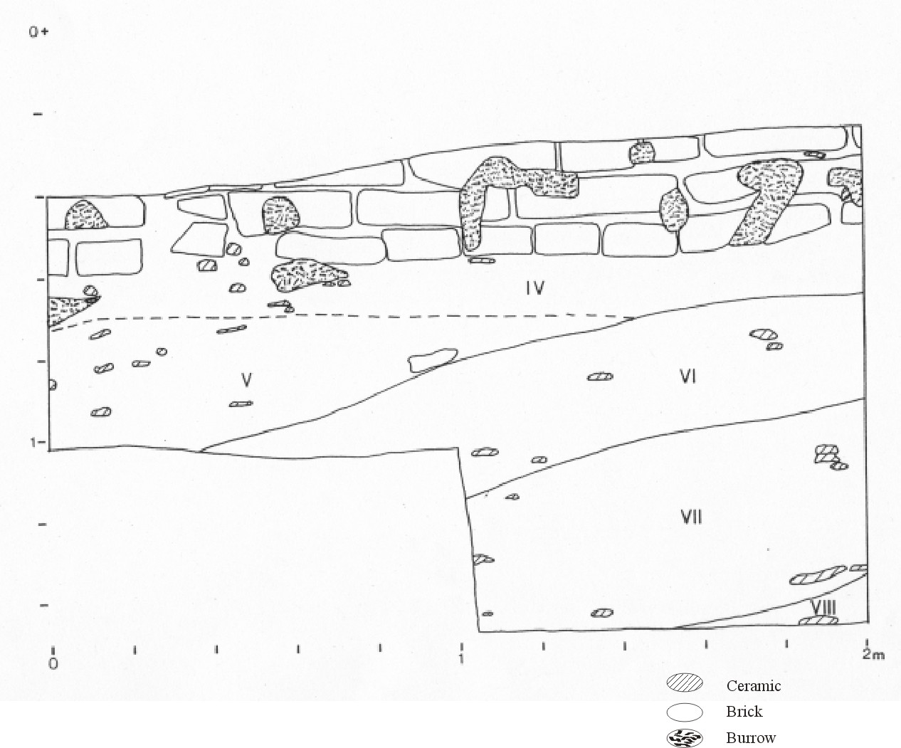
Figure 4.26 Unit 1261/1074 South profile
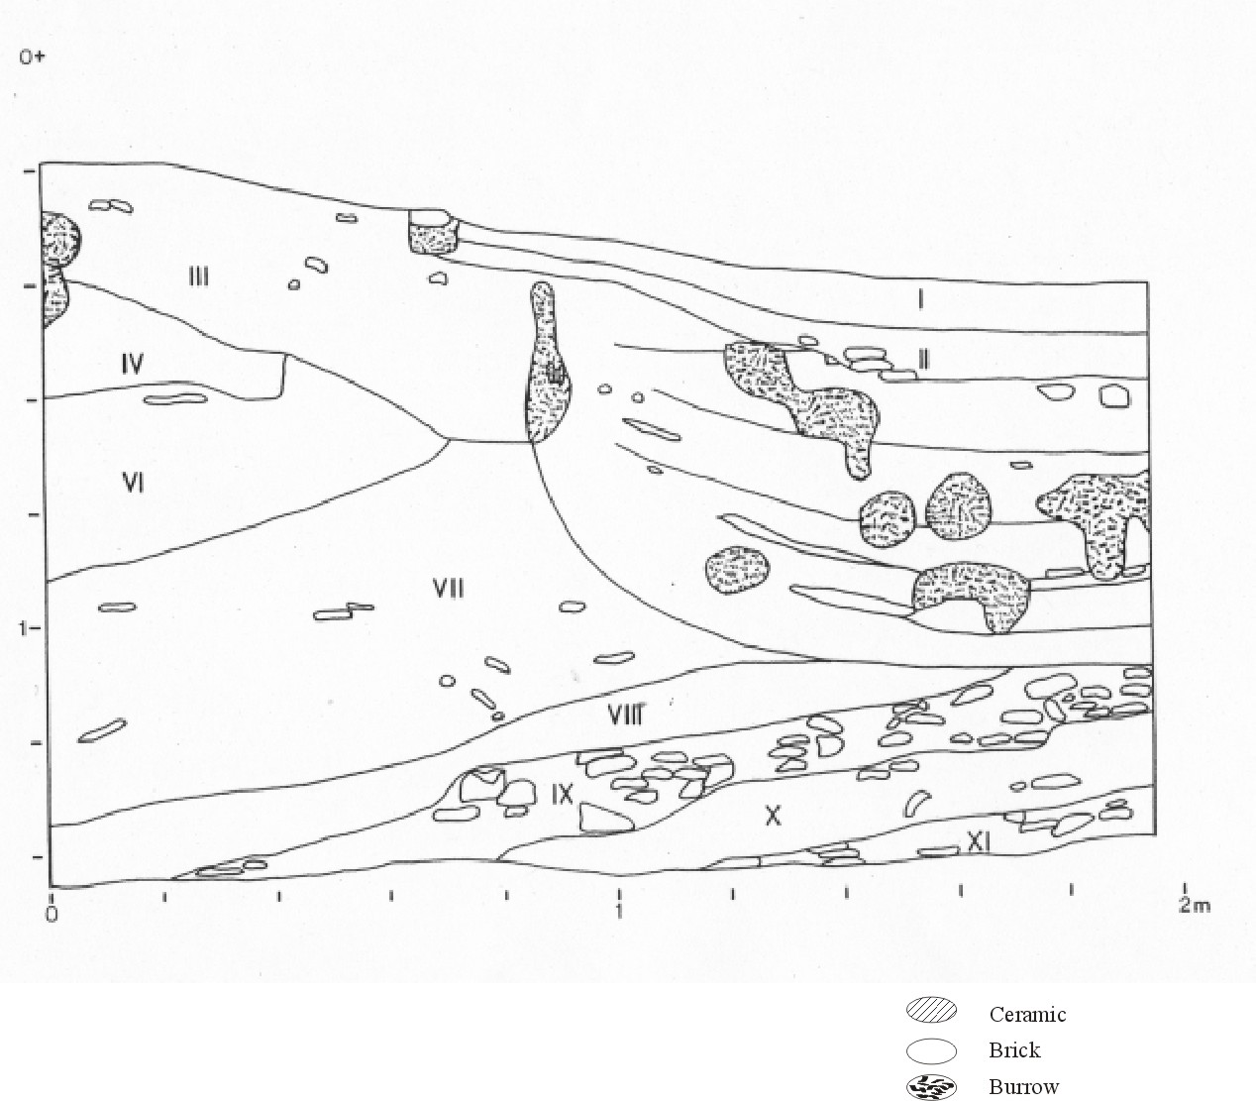
Figure 4.27 Unit 1261/1074 West profile
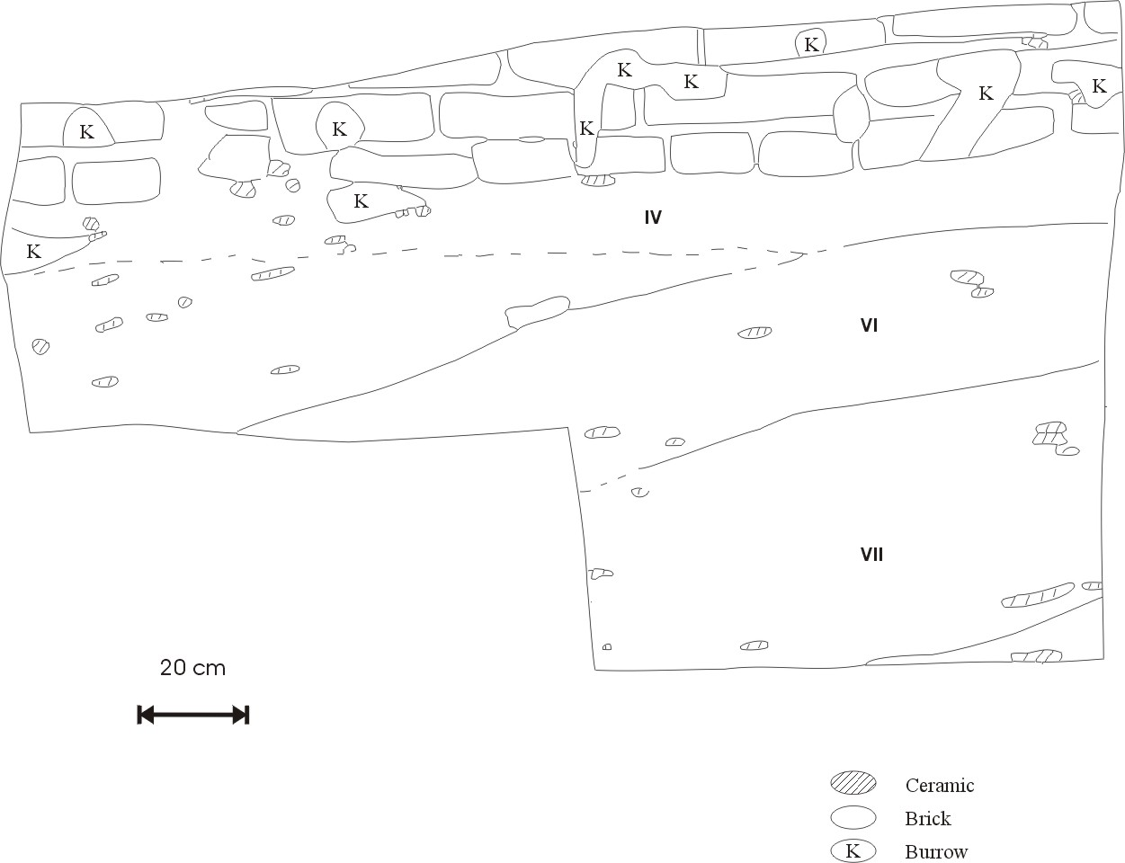
Figure 4.28 Unit 1263/1074 South profile
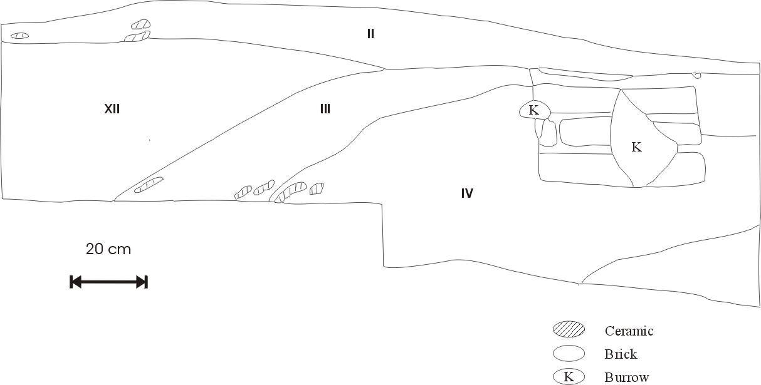
Figure 4.29 Unit 1263/1074 West profile

From the first strata in both these units it was evident that the ceramics were somewhat different from those in other excavation units, particularly in the large numbers of sherds from thin, straight-walled cups, many of which had a faint red line near the lip, as well as numerous fragments of "bread-molds".

Our suspicions that we were dealing with Middle Kingdom occupations in this unit were confirmed when we found several seal fragments that to date to the reign of Amenemhet I, of the 12th Dynasty.

Stratum I (Level 0) in 1261/1074 was a very sticky, plastic, clayey silt with some faint laminations apparently filling in a shallow depression. This is probably a small water-laid deposit washing in UPL material. Stratum II (Level 0) was also sticky and plastic, redder than Stratum I and also with some faint laminations. It contained relatively more decomposed red pottery fragments and is also probably UPL with some water-laid component.

Stratum III (Level 0) is a large, complex unit composed of numerous interfingered layers or lenses of yellow sand, darker brown silt or clay, and occasional thick black lenses of burned, ashy material. Ceramics, which are low in density, are generally conformable to bedding planes. (Buck 1990:188) suggested two possible interpretations of this unit: a small channel deposit in which water flowed into a small gully; or a depression filled with colluvium from the habitation structure immediately to the south. (Cagle 2003:66) favored the second interpretation as the deposits making up this Stratum seem to cut into the underlying deposits as if active erosion was taking place. The arrangement of strata in this unit appears quite similar to those in some levels of Unit 1204S-1060E.

Stratum IV (Level 0) is a very loose, unconsolidated silty sand containing numerous sherds and very disturbed by roots and rodents. The sherds are at different orientations, and the boundaries of the stratum are rather diffuse. The unit underlies the south wall between 1261/1074 and 1263/1074 and may represent a builder's trench or some other redeposition resulting from construction projects.

Stratum V (Level 0) is a compact consolidated silty sand with some concentrations of sherds, in which the larger sherds commonly conform with the bedding plane. It contains little charcoal or other organic matter and few mud brick fragments.

Stratum VI (Level 0) is a greasy, non-plastic, dark sand that appears to contains considerable charcoal and concentrations of pottery. It may represent redeposition of materials burned elsewhere -- the sherds, in particular, show signs of having been burned. The lower boundary of the stratum (with Stratum VIII) is diffuse, and Stratum VI continues under the brick wall and into 1263/1074.

Stratum VII (Level 0) is a slightly greasy sand containing a great deal of charcoal and ceramics. It is similar to Stratum VI but the sherds have no apparent orientation and has less organic content.

Stratum VIII (Level 0) is almost identical to Stratum VI and is truncated by Stratum III. Its boundary with Stratum IX is clear and wavy largely because of the number of large sherds in Stratum IX, which is almost equally composed of sand and sherds. Larger sherds are especially abundant and no orientation. The sherd cores tend to be bright red.

Stratum X (Level 0) is a massive silty sand with no apparent internal stratification and contains moderate densities of sherds and some pebbles ca. 2-3cm in diameter. Stratum XI is quite similar to Stratum X, but with greater sherd densities.

Stratum XII (Level 0) is a massive, unstratified deposit of silty sand with rare flecks of charcoal but abundant pottery. It is also found in unit 1263/1074.

Stratum XIII is the brick wall illustrated in Figures E26 and E28 (south walls).

Two sets of deposits are represented in this unit. The lower deposits, Strata IV-XII, are a set of dump deposits of variable composition and character. These lower units were cut through by an erosional (or excavated?) basin which was then filled in with later materials making up a distinct upper layer. The bulk of the upper layer (Stratum III) consists of a complex series of redeposited material cut through by extensive rodent burrowing. The character of the deposits suggests a series of alluvial deposits transporting dump and/or household debris into the basin after the site was abandoned. These deposits appear to be directly associated with an adjacent wall. The wall appears to be a remnant of a small structure, but in the absence of a clear floor deposit in association with it or of other walls articulated with it, the nature of this structure is not clear. Capping these deposits are two layers of UPL, the lower of which was apparently redeposited by running water.

The artifacts found within the lower and upper units differ markedly in some respects. The higher of these, mostly Stratum III, are characterized by high densities of ground stone and fragments of sedimentary stone objects, perhaps waste products from the production of ground stone tools (Cagle 2003: 66). These are also some of the few deposits where cattle (Bos) and wild game or draft animals (hartebeest and ass) remains were found. These upper units were deposited after the brick wall in the south of the square and may contain material derived from this structure. This relatively distinctive complement of faunal remains is intriguing, but as a sample the materials excavated from this unit are far too small to infer significant differences between these Middle Kingdom deposits and the Old Kingdom remains. The relatively large numbers of equid remains may derive from just one or two animals, and equids are certainly evident in other, Old Kingdom deposits. Bird remains in these upper deposits seems particularly numerous, but overall the density of faunal material in these deposits is quite high. The lower units, in contrast, are generally much poorer in ground stone debris, little cattle or wild game, and much higher ceramic densities.

It should be noted, however, that the only grape seeds found at Kom el-Hisn come from this unit (Chapter 7)--which may indicate a substantial difference between the Old Kingdom and Middle Kingdom economies of the inhabitants of Kom el-Hisn.

Most of the seal impressions from this unit appear to come from Strata IX, X, and XI, in levels containing considerable pottery. Finally, the relatively high frequency of stamp seal impressions from this unit raises the possibility of a significant difference in the external relations of the Middle Kingdom community, compared to the Old Kingdom period.

Unit 1159S-1040E was excavated by Melinda Hartwig and Jo Ann Kris between 23 July and 20 August, 1986. It was selected as part of the stratified random sample. The south and east profiles are shown in Figures E30 and E31.

This unit was heavily vegetated with camel thorn, which was removed along with the salt crust and the underlying few centimeters of deposits as Stratum I. Removal of Stratum I exposed a multicolored surface with substantial numbers of sherds.

Stratum II is a silty sand and represents the reddish layer of salt-eroded and decomposing sherds noted over most of the site, particularly in depressions such as this unit represents.

Stratum III is a dark, thin layer of what appeared to be organic remains mixed with charcoal. It truncates the levels immediately beneath it, and it appears to be the first of three strata that overlay the large pit feature comprising the lower strata.

Stratum IV is a larger mostly unstratified unit with a reddish color that may be the result of burned or eroded sherds. The matrix is largely sand and contains numerous flecks of charcoal. Stratum IVa is similar to V but appears to contain less charcoal and is lighter in color.

Stratum V is a silty sand with numerous quartz granules and some sherds. It is somewhat mottled with barely discernible laminations.

Strata VI and VII are very much like Stratum IV, comprising a largely sand matrix in which sherds, charcoal, and other cultural debris are mixed, and with a reddish color that is the result of decomposed sherds or, possibly, of fire.

Stratum VIII is similar to IV but contains less charcoal and is lighter in color.

Stratum IX is a silty sand containing numerous potsherds as well as brick-fragments, including those of the gezira-brick variety--which are a light, almost greenish white and incorporate no apparent cultural materials. Unlike some of the other strata, this unit does
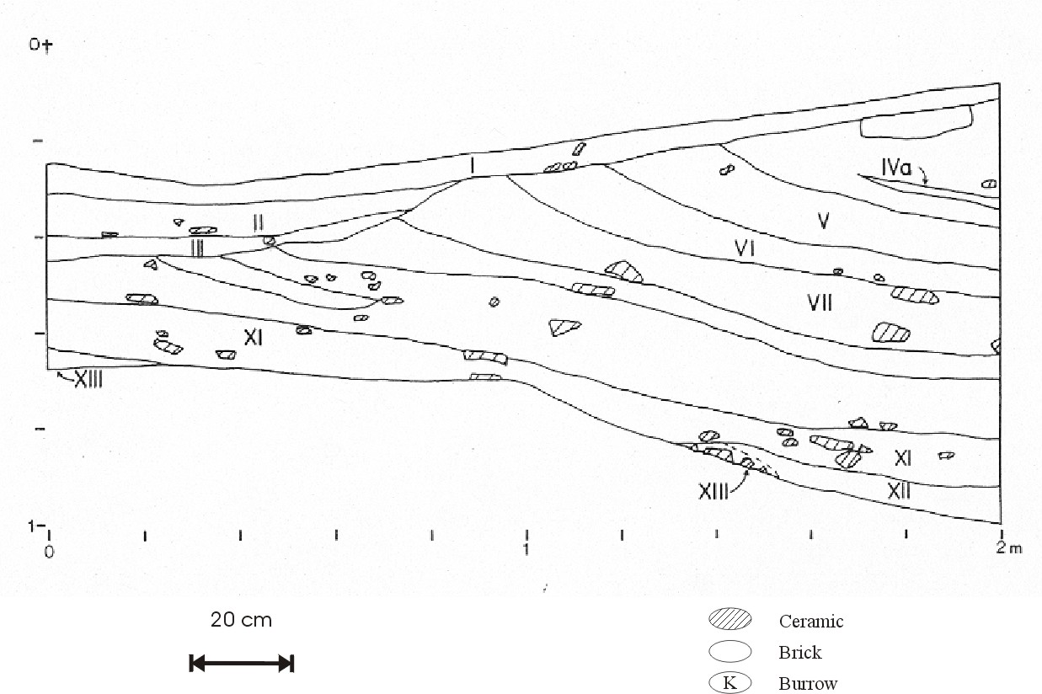
Figure 4.30 Unit 1159/1040 East profile
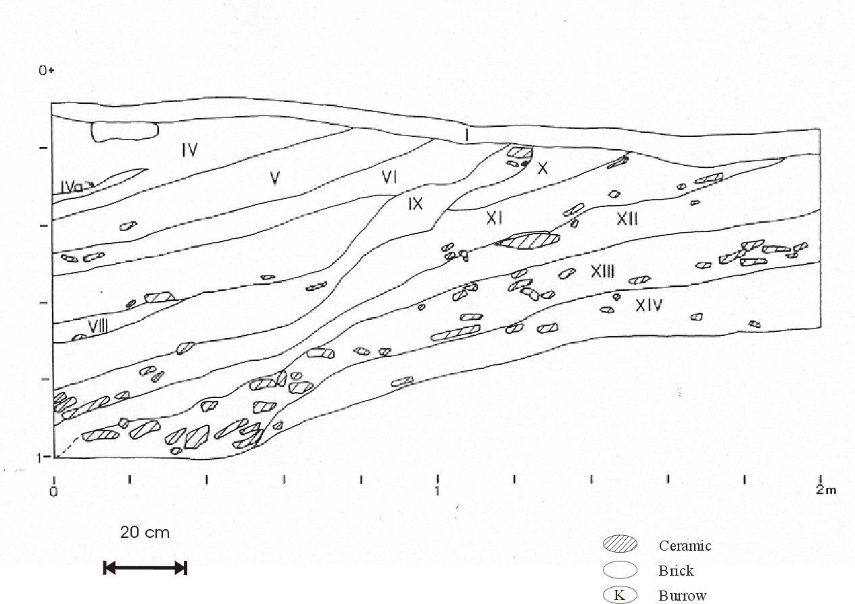
Figure 4.31 Unit 1159/1040 South profile
not appear to be composed of common kitchen debris. It may be largely composed of redeposited or in situ wall fall.

Stratum X is a layer of silty sand with a slightly greasy texture and moderate densities of charcoal, sherds, and brick fragments.

Stratum XI is also a silty sand intermixed with sherds, brick fragments, and quartz granules.

Stratum XII, in contrast, is a relatively clean silty sand with only a few sherds other artifacts.

Stratum XIII is a silty sand layer with dense concentrations of large pot sherds and numerous fragments of yellow-brown and gray brick fragments.

Stratum XIV is quite similar to Stratum XIII except that it contained fewer sherds.

Excavations ceased in this unit before the water table was reached.

In general summary of 1159E-1040S, most of the materials excavated from this unit appeared to be successive deposits of household garbage and building debris. The slope to the strata indicates a pit feature of considerable size. The fact that the present surface is highest over the bottom of the pit feature may be of some significance. It appears that garbage and other debris were deposited over a long period and continued to be deposited even after the surface of the pit rose above the level of the surrounding portions of the community.

The stratigraphic complexity of this unit and the subtle differences of texture and color that distinguish what likely were successive depositions of very similar kinds of debris resulted in a removal of materials in SUs that do not correspond well to the strata defined in the profiles after excavations were complete.

Step Trench 2 (ST-2) was excavated on the slope of a depression bordering the site on the southwest. It was excavated by Michael Kobusiewicz between 20 and 24 July, 1986. No profile drawings are available for this unit, and no level data is available.

Stratum I (SU-1) covers the entire 1x2 meter unit and is composed of grayish-brown sandy silts with various lighter patches of probably broken and decomposed bricks, and some small gravel. Pottery and lithics are both plentiful, and some bone is also observed.

Stratum II (SUs 2 and 4) is first observed in the southeast corner along the southern edge of the trench and was eventually found to cover the entire unit. It was described as a very soft sediment composed of dark brown or blackish-gray silty sand mixed with ash. This stratum was excavated to a depth of 85 cm when excavation ceased.

Stratum III (SU-3) is a lens of silt mixed with sand with a large component of fine, almost powdered ash. It is located along the northeast wall and is approximately 7 cm thick. It is contained within Stratum II.

Summary of Step trench 2. The upper stratum (I) is probably an admixture of UPL and some collapsed and decomposed wall, underlain by a massive undifferentiated sediment of unknown origin. The Stratum III lens may be a dump containing primarily ash contained within Stratum II. The excavator described this as “backdirt” which may indicate that it is associated with prior excavations.

Step Trench 3 (ST-3) was excavated between 26 July and 17 August 1986 by Michael Kobusiewicz. The unit was placed on the western-sloping embankment to the south of the main excavation area. ST-3 was excavated first as a 1x2-meter square (designated ST-3/A) and then was extended with another 1x2-meter square directly to the east and excavated as ST-3/B. There are no profile drawings for this unit. The various strata are composed of sedimentary units from both squares. No level data is available.

Stratum I (3/A SU-1) covers only the eastern half of the 3/A square and is composed of a sandy silt with large fragments of broken sand brick and a moderate amount of pottery.

Stratum II (3/B SUs 1-3) consists primarily of coarse sand with a heavy component of silt and contains some component of UPL indicated by reddish matrix and a portion (SU-3) which is somewhat lenticular in shape and contains a large amount of crushed pottery typical of UPL.

Stratum III (3/A SUs 2-4, 3/B SUs 4 and 6) was partially covered by a thin crust of burned clay in the center part of unit 3/A but largely consists of a light gray coarse sand with some silt. Numerous brick pieces are common and the character of the sediment is probably partially to wholly dissolved mud brick wall. Most of this stratum was spare in ceramics but certain areas in 3/B contained large amounts of very thick pottery fragments indicating at least some dumping events within what is otherwise typical wall collapse.

Stratum IV (3/A SUs 5 and 6, 3/B SU-7) is a dark gray fine-grained sand with little silt. In some areas, notably 3/A SU-5 it is composed of numerous interfingered lenses somewhat more brown sand and silt. Few ceramics are present except in restricted locations.

Stratum V (3/A SUs 7 and 8, 3/B SU-8) is a brownish-gray later of fine-grained sand a relatively more silt than the overlying Stratum IV. Again, pottery and other artifacts are rather sparse except in a few concentrated areas.

Summary of Step-Trench 3 (ST-3) The upper strata of this unit seem to represent a mixture of some wall collapse and UPL material; rodent burrowing was noted by the excavator (and see North profile) throughout the upper portions. Overall, the lower strata seem to be composed primarily of largely decomposed wall collapse with some instances of slumping or fluvial deposition of the same material into discrete lenses at certain times. Pockets of ashy material and concentrations of ceramics point to the occasional dumping event as well. No structures were evident in the excavation unit itself, so the source of the wall material is unknown.

1988
Based on the results of previous seasons, especially the Block Area excavations of 1986, the 1988 season was dedicated to expanding the Block Area to expose more architecture, open up other areas in a search for more Old Kingdom architectural elements, and widen our spatial coverage to other areas of the site.

Our strategy in 1988 involved scraping off the top 10-20cm of UPL covering to expose the underlying mud brick architecture. Excavation units were then defined by any mud brick walls that seemed to form coherent structures; these were designated as ‘rooms’ and numbered sequentially as excavation proceeded. Each room was further defined by the grid point closest to its southwest corner.

Sedimentary units differed somewhat from previous seasons. Natural stratigraphy was still used, but our intent was to uncover floor surfaces and continue deeper to expose earlier habitations; we purposely began work in early spring when the water table was low for this latter reason. We also had far better knowledge of the overall site formation processes. Consequently, SU definitions were somewhat less stringent; differences in sediments judged to be minor were noted as excavation progressed, with possible sediment and/or flotation samples taken as deemed appropriate.

The same general criteria are used here to define larger depositional units from the individual SUs as in previous years. These were developed by (Cagle 2001, Cagle 2003) and the resulting strata -- designated as ‘depositional units’ or DUs -- were based on similar deposit characteristics as in previous years. Each Stratum herein corresponds with the same number DU from (Cagle 2001, Cagle 2003). Again, any 1986 units that correlate with 1988 room structures are added to the 1988 room deposit sequences. Fewer profile drawings are available for these units as excavations tended to be bounded by mud brick walls rather than baulks.

Room 1 (1202S/1070E)
This is a 2x4 meter test pit at location 1202S/1070E was excavated in 1984 but these deposits are unrelated to that square. Room 1 deposits are more fully described in (Cagle 2003:67). There are no profile drawings for this unit. This room was excavated by Janet Long and Alicia Wise between 6 and 10 April 1988 and also by Paul Buck between 19 and 21 April 1988.

Stratum I (SU-1, Level 3) is a brick rubble fill with mottled gray-orange brick fragments with burned edges, apparently collapse from the walls that make up the room. Large areas are disturbed by rodent burrows and roots.

Stratum II (SU-4, Level 3) is a pit feature originating in the 'occupation surface' of Stratum III (SU-2). The outside of the pit is not apparently a brick structure, though the bottom was lined with at least three bricks and brick fragments which appear to have been low-fired. He bricks themselves are made of coarse sand of reddish-brown color. These are covered with a thin layer (approx. 0.5 cm) of gray clay. There is no evidence of any burning apart from the low-fired bricks.

Stratum III (SU-2, Level 3) was referred to by the excavator as the occupation surface of the room and is a horizontally bedded dark gray compact sediment. The horizontal bedding is due to a series of lenses that do not form a continuous layer, some of which contain pockets filled with ash, burned bone and blackened ceramics. Bone density is very high, with pig comprising the majority of the identified faunal remains (N=10) along with some sheep/goat; the majority of the unidentified fragments were from either ribs or limbs.

Stratum IV (SUs 3, 5 and 6, Level 4) lies under the brick walls making up the room and is stratigraphically unrelated to the overlying deposits. The matrix consisted of reddish brown to brown loosely compact sand with no evidence of burning and in interpreted as a dump.

Stratum V (SU-7, Level 4) i s a semi-continuous paving of mud bricks. The plan drawing suggests that this was not a paving but a wall that fell over largely intact.

Summary of Room 1 The room boundaries are defined by brick walls on the west and south and a less well-defined wall to the east.

The upper deposits (Strata I, II and III) are associated with the walls making up the room boundaries and are assumed to be contemporary with the block area architecture to the south of the room. The pit feature did not contain burned material and probably functioned as storage rather than as a hearth.

Beneath the occupation surface of Stratum III is a dump that in stratigraphically beneath the walls making up the room and therefore not associated with it. Beneath this dump, which acts as a foundation deposit for the room, lies a largely intact wall from a previous structure that had fallen over.

There are more detailed plan maps available. I have copies. Need either original drawings (Burke? Michael?) or scans (Michael?).

Room 2 (1208S/1074E)
There is no profile drawing available for this unit. Room 2 was partially excavated in 1986 as parts of squares 1207/1074 and 1209/1074. Unit 1207/1074 was excavated by Melinda Hartwig between 11 August and 19 August, 1986; unit 1209/1074 was excavated by Lech Krzyzaniak and Karla Kroeper between 6 August and 19 August, 1986; Room 2 was excavated between Paul Buck and Anthony Cagle between 7 April and 12 April, 1988. The SUs from the 1986 units that are within the confines of Room 2 are described here; the remainder are described in their respective units.

Stratum I (1207/1074 SUs 1 and 2, Level 0) are typical UPL. Artifact densities were moderate. The lithics found (n=9) were almost entirely composed of sickle blades or blade blanks (n=8) and the identified faunal remains were predominantly sheep/goat and pig.

Stratum II (1207/1074 SU-3, 1209/1074 SU-3, Level 3) is composed of a tumble of beige-colored bricks together with charred pottery fragments and can be considered part of a collapsed wall. Stratum III (SU-1, Level 3) is probably a continuation of Stratum II except that it contains higher ceramic densities and lacks the burned sediments.

Stratum IV (SU-2, Level 3) was described by the excavators as "a dark brown clay material with a series of fine laminations with in a fining upwards sequence" which suggests that this deposit may be a simple water-laid deposit. However, the matrix is also very similar to the underlying stratum (V) which is securely interpreted as an occupation surface. Artifact densities are not indicative of either as the values for Stratum IV lie in the middle of the range of both floors and fluvial deposits (Cagle 2003: 70). In fact, Cagle (2003:70) suggested that this stratum may represent a period of abandonment with some fluvial deposition.

Stratum V (SU-3, Level 3), as noted above, has a similar matrix to that of Stratum IV: a dark clayey material but without the laminated structure of Stratum IV. Both of these strata intersect the base of the walls making up the room and have artifact densities typical of other occupation surfaces.

Stratum VI (SU-4, Level 3) is the topmost deposit making up the interior floor of the pit structure in the northwest corner of Room 2 which is associated with the occupation surfaces (see PLAN MAP). It consists of a reddish matrix containing a great deal of bone, especially fish bone. The burning appeared to the excavator to be in situ. This is probably a dump deposit and was excavated as a single sediment sample and the only available artifact densities were calculated from the microscopically sorted heavy fraction of this sample (see Cagle 1991).

Strata VII (SU-5, Level 3) and VIII (SU-6, Level 3) are both hard clay layers lining the bottom of the pit and pressed into the mud bricks making up the bottom of the pit structure (photo?). Both were excavated as single sediment samples and contained little to no artifacts.

Summary of Room 2 Part of this room was excavated in 1986 as parts of units 1207/1074 and 1209/1074. Only four SUs from these two units were included in the Room 2 descriptions; the remainder are found in their respective unit sections.

This room is defined by three walls to the north, west, and south and al seem directly related to the other structures in this area. The room contains a mud brick pit structure and at least one occupation surface (Stratum V) directly associated with the each other and the structure. The topmost deposit within the pit may be slightly later than the others and represent a small dump deposit; (Cagle 1991) noted that it contained a great deal of fish crania and vertebrae suggesting food waste. Capping the deposits in this room are two strata (II and III) of collapsed wall material and one (I) of UPL.

Room 3 (1212S/1074E)
No profile drawing is available for this unit. It was excavated in 1988 by Delores Ward between April 9-10, 1988. Parts were also excavated in 1986 in units 1211/1074 – excavated by Lech Krzyzaniak and Karla Kroeper between 11 and 17 August, 1986 – and 1213/1074 – also excavated by Lech Krzyzaniak and Karla Kroeper between 10 and 11 August, 1986. Only two SUs were used from the 1986 excavations; the remaining SUS are described in their respective unit sections.

There is only a single stratum for this room, Stratum I (Level 3). It is composed of SU-1 from the 1988 excavations and SU-3 from both 1211/1074 and 1213/1074. All excavators described the sediment in similar terms: dark brown to black matrix with abundant mottles, probably decomposed mud brick. Like the adjacent Room 2, the lithic component (n=5 total) is composed of a sickle blade and four blade blanks. Besides the lithics it also contains a moderate density of bone so there is probably some dumped material mixed in with the wall collapse.

Summary of Room 3 The deposits n this room contain only a single stratum composed mostly of collapsed wall material, probably from the north, south, and east walls that define the room boundaries. The north wall separates it from Room 2 and the western wall is less defined and may have only a small partition jutting out from the south to separate it from the deposits further west and defined as Room 5.

Room 4 (1216S/1072E)
The south profile drawing for this unit is shown in Figure 4.32. It was excavated in 1988 by Janet Long and Genny Stone between April 10-28, 1988.

Some small amount of surface material (probably UPL) was removed prior to excavation. Also, SU-1 was described as a small (<0.015m³) mottled gray-orange sandy material, perhaps some wall collapse mixed with UPL. SU-1 is not part of any Stratum analyzed here.

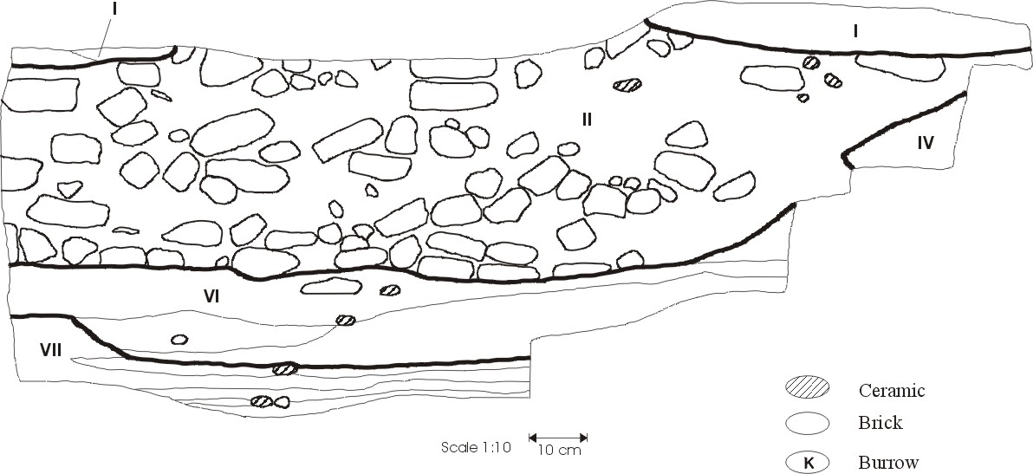
Figure 4.32 Room 4 (1216/1072) West profile
Stratum I (SU-2, Level 1) is a dark gray to black loosely compacted material, probably a dump. It lies above the infant burial (Stratum IV) dug into the occupation deposits of the room.

Stratum II (SUs 3 and 7, Level 3) is a black to brown mottled matrix sloping towards the southeast. The upper portion (SU-3) contains more brick than the lower layer and the brick fragments become larger with more evidence of burning towards the bottom of SU-3. Several large ceramic pieces were present on the surface of SU-7 indicating an unconformity with the overlying deposit, but both seem to be part of the same overall wal collapse deposit.

Stratum III (SU-4, Level 3) is a section of the (intact) north wall that was removed to gain access to the infant burial beneath it. Stratum IV (Level 2), an infant burial, is described in greater detail in section X.XX. The artifacts associated with this deposit are probably intrusive. The burial is that of an infant and seems to have been cut partially into the north wall of the room. Sex of the skeleton is undetermined and was placed in the fetal position with the head facing east and the back towards the north wall.

Stratum V (SU-8, Level 3) is a small mound of sediment in the northeast corner of the room. The deposit consists of a thin (approximately 4 cm) layer of compact gray-green material on top of another thin layer of blackened material. There were no artifacts in this deposit and it is difficult to determine precisely what it represents. The upper gray-green portion may be decomposed brick material while the lower portion may be a small dumping event consisting mostly of fine ash.

Stratum VI (SUs 9, 10, Level 4) underlies the walls of Room 4. It is a gray-green mottled clay and SU-9 contains three brick-shaped discolorations suggesting this is heavily decomposed wall collapse.

Stratum VII (SUs 11,12,13, Level 4) consists of mostly dark gray and tan mottled matrix with tan and black lenses within, the latter containing higher concentrations of bone and a high proportion of rim sherds. Bone density is very high in this deposit as are lithics; the latter consist of three sickle blade fragments, three blade blanks, and a small fragment of a coarse sandstone metate. It is interpreted as a floor deposit but did not appear to be associated with the Room 4 walls.

Summary of Room 4 The upper layer of this room, Stratum I, is apparently dumped material and covers the entire area enclosed by the room walls. Some time before this material was deposited, an infant burial (Stratum IV) was cut into the north wall through the underlying sediment of Stratum II.

Below the later Stratum I dump and the infant burial are two episodes of wall collapse deposits, Strata II and V, the latter a smaller mound of material in the northeast corner of the room. It was the excavator's opinion, and the profile seems to bear this out, that Stratum V was the lowest deposit directly associated with the room architecture meaning that no occupation surface was excavated as part of this room. It may be that any floor deposit was very thin and/or disturbed by the activities involving the burial.

Not associated with Room 4 are two deposits, the Stratum VI wall collapse and an occupation surface, Stratum VII, both clearly underneath the walls making up the room.

Room 5 (1212S/1072E)

There are no profile drawings for Room 5. The deposits for this room contain deposits excavated in 1986 and in 1988. All SUs that were excavated in 1986 in units 1211/1072 and 1213/1072 are included with this room. In 1986 both units were excavated by Lech Krzyzaniak and Karla Kroeper between 15 July and 22 July, 1986 and in 1988 it was excavated as Room 5 by Paul Buck and Delores Ward between 10 April 26 April, 1988.

Stratum I (1211/1072, SUs 1 and 2; 1213/1072, SUs 1 and 2, Level 0) is typical UPL but with some brick pieces within it. Artifact densities are typical of this type of deposit, and the lithics found (n=11) include a notched flake and a fragment of a biface, and several sickle blades and blade blanks.

Stratum II (1211/1072, SU-4, 1213/1072, SU-4, Level 2) is a burial. The grave is intrusive into the occupation surfaces of the room, and cuts into two pit structures (Strata VIII and IX). The grave itself was initially split between two 1986 excavation units: 1211/1072, which contained the head and torso, and 1213/1072, which contained the lower extremities. In addition to the adult burial, another infant burial was found in 1213/1072 west of the adult burial and just south of the pit structure (Stratum XI). The infant burial was also oriented with the head to the north, but there is no obvious relation between the two burials.

The stratigraphic relationship of Strata III (1213/1072 SU-5, Level 3) and IV (1211/1072 SU-3, Level 1) is unclear because of the intervening burial (Stratum I). Stratum III occurs in the southern (lower extremity) end of the burial and is interrupted by it. It consists of irregular patches of beige sand bricks and is derived from the walls making up the room. It contains moderate amounts of ceramics, and a fairly high density of bone; the bone consisted entirely of unidentified fragments. Stratum IV consists of four different patches of material: a black-brown gravelly sediment; a small patch of hard-packed gray clay; a patch of white loose sand; and a fourth patch of loose clay. All contained some evidence of burning in the form of what appeared to be decomposed charcoal. This material was apparently dumped before the burial was cut into the deposits.

Stratum V (SU-2, Level 3) underlies both Strata III and IV and consists of gray clay and loosely compacted light to dark brown sediment mixed with brick tumble. Two clusters of rough ceramics were also noted. Ceramic and bone density are high (Cagle 2003:74). The bone consists of a single large ovicaprid bone and a single pig bone (together, 57.3 g), and several unidentified fragments (18.6 g).

Stratum VI (SU-3, Level 3) is interpreted as a floor because it covers the entire room's surface and consists of several laminated layers of dark brown loamy sediment. It contains a light scattering of ceramics and moderate bone density with no identifiable specimens. Two lithics were found, a chunk of limestone and a globular piece of chert with rubbing visible on several faces.

Stratum VII (SU-4, Level 3) is also a floor and is differentiated from Stratum VI because it is a much lighter colored hard clay 'plastered' layer restricted to the northwest corner of the room, though clearly associated with Stratum VI. Artifact densities are similar to those of Stratum VI (Cagle 2003:74). The lithics found (N=9) consist of a single sickle blade fragment, a blade fragment, a lame a crete, a sandstone flake, a chunk of limestone, and four sandstone grinding stone fragments all of which were apparently part of a single saddle-shaped metate.

Stratum VIII (SU-6, Level 3) is a D-shaped structure just to the east of the adult burial. It is constructed of a thin, circular brick-like wall enclosed by 23 cm of heavy, thick gray clay. The interior contains tumbled brick pieces, some bone, and ceramics. According to the excavator the bottom of the pit appeared to go through the bottom of the Stratum VII floor. This suggests that the Stratum VIII pit was constructed before the Strata VI and VII floors were deposited but was probably cut into the floor surface making them contemporaneous. Ceramic density is moderate but bone density is high (Cagle 2003: 76) which may be a result of post-occupational use of the pit as a small dumping area before collapsing in on itself. A single sandstone flake was also found.

Stratum IX (SU-5, Level 3) is also a large brick-lined pit structure that is cut into by the northeast corner of the adult burial. The contents were only described as 'fill' material but the contents indicate use as a small dump (Cagle 2003: 76). All artifact categories have high densities and the lithic density is especially high.

Stratum X (SUs 7, 8, and 9, Level 3) is the second of two sets of floor deposits associated with this room and consists of three SU's representing a series of laminated layers. The layers tend to be loosely compacted brown sediment with thin (1 cm) blackened layers in between. There are also small blackened areas filled with charcoal and ceramics that could indicate small hearths. Depositionally, these deposits occur near the bottom of the enclosing walls. The faunal material consists of one Bos bone, and various ovicaprid and pig bones, together with a large number of unidentified remains, the majority (by weight) being limb fragments. There were a number of lithics (N=16). Three of these were blade fragments. The remainder were: a single limestone flake; five irregular chunks of chert, limestone, and silicified wood; two globular chunks of chert with rubbing apparent on several faces; and six sandstone metate fragments.

Stratum XI (1213/1072 SU-3, Level 3) is also a D-shaped structure similar to Stratum VIII. The sediments are burned sand and charred bone and ceramics indicating in situ burning. The only bones present were from fish which again suggests post-occupational trash dumping like the other two pit structures in this room.

Stratum XII (SU-10, Level 3) is also a floor surface and was originally differentiated from those above as being more of a compact clay sediment. This series of deposits is right at the base of the walls. On the north and south walls some of these bricks were angled as leveling courses. The deposit itself consists of three layers: a hardpacked clay floor, underlain by a brown sediments with a less consolidated clay running through it, all on a base of a black surface. Artifact densities are similar to those of Stratum X though without a lithic component. Faunal remains are predominantly unidentified fragments.

Summary of Room 5 This room is composed of two distinct sets of occupation surfaces both of which are associated with the room structure. The initial occupation is repre-sented by the Strata X and XII floors, the latter probably functioning as the foundation deposit of the room. Two of the pits, Strata VIII and IX, are directly associated with these floors. A second occupation surface, Strata VI and VII, leveled the underlying pit struc-tures and a third pit structure, Stratum XI, is associated with these two floors. After the occupation represented by Strata VI and VII, the structure was probably left open for a time, during which time some minor dumping occurred in the pit structures. The adult and infant burials were then cut into the occupation surfaces. Further collapse of the structure proceeded (Stratum III), followed by at least one episode of refuse dumping (Stratum IV).

Since both sets of occupation surfaces are directly associated with the room structure, (Cagle 2003: 76-77) assigned them both to the same stratigraphic level (3). Several factors militate in favor of interpreting both sets of occupation surfaces having the same general functions associated with them. A functional change may have occurred between the two occupations since the earlier floors, particularly Stratum X, contain far more ash and blackened sediments along with charred limb bones suggesting that some form of food preparation took place which did not apparently take place in the later floors. Thus, there may have been a short period of abandonment of this room at which time it was used for purposes other than storage (indicated by the pit structure).

Room 6 (1212S/1068E)
There is no profile drawing for this room. All SUs that were excavated in 1988 by Anthony Cagle between 12 April and 22 May, 1988.

Stratum I (SUs 1 and 2, Level 3) consists largely of typical wall collapse material in a brown matrix. The structure of the deposit is slightly humped up in the middle of the room and slopes down on all sides to the walls. The bricks also seem to be more patterned near the center as if the wall collapsed there. Ceramic density is moderate and the faunal material consists of approximately equal quantities of identified ovicaprid and pig remains and unidentified fragments. Lithic density is also moderate and consists of a blade and a limestone chunk.

Stratum II (SU-3, Level 1) is a black unit which follows the structural contours of DU-1: humped up in the middle and sloping to all sides with the deepest part in the center and southeast corner. The excavator noted that it seemed to be full of ash, charcoal, and burned bone that did not appear to be burned in situ. Ceramic density is moderate while faunal material is abundant and the identified portion consisted almost exclusively of pig (N=14). Lithics were also relatively abundant and consisted of two sickle blade fragments, a sandstone flake, and a saddle-shaped metate fragment.

Stratum III (SU-6, Level 3) is essentially the same deposit as Stratum I but interrupted by the dump of Stratum II, and is confined to the southeast corner of the room. Artifact densities are similar to those of Stratum I but with a higher ceramic content.

Stratum IV (SUs 4, 5, 7, and 9, Level 3) is a thick unit (ca. 40 cm deep) and is a brown sandy sediment with no visible brick fragments. However, its appearance and position un-derneath similarly colored brick fall indicates this is wall collapse where all brick fragments have decomposed. Its artifact frequencies are similar to that of Strata I and III except that Stratum IV has a higher frequency of lithics than the other two: two sickle blade fragments, two blade fragments, one limestone chunk, one ala-baster chunk, a quartzitic sandstone flake, and three sandstone metate fragments.

Stratum V (SU-8, Level 3) is a thin unit, no more than 3 cm thick, and is the occupation surface of the room. It consists of dark brown to black sediment with a great deal of ceramic and stone on the surface. It is underlain by a deposit (SU-10) that is similar to that in the adjacent Room 8. Ceramic and bone densities are moderate; the faunal material consists of two pig bones and several unidentified fragments. No lithics were present.

SU-10 (Level 3) is analyzed fully as part of Room 8, Stratum IV. This is a very black sediment with a great deal of burned bone. It connects under the south wall to Stratum IV DU-4 of Room 8 and is analyzed and described in more detail as part of that room's deposits.

Summary of Room 6 The occupation surface directly associated with the Room 6 walls is Stratum V, an apparently brief occupation based on the thinness of the deposit. Below this is another floor surface that connects to a floor in the adjacent Room 8. After Room 6 was abandoned the walls collapsed and decomposed to form Stratum IV indicating a substantial passage of time. This was followed by a period of further decomposition of the walls, perhaps some done intentionally as the material was humped up in the middle of the unit beginning with Stratum III indicates. A short dumping episode occurred with Stratum II, interrupting the wall decomposition, which continued with Stratum I. The connection and overall sequence of this and Room 8 is discussed more fully in the latter room's summary.

Room 7 (1218S/1072E)
There is no profile drawing for this room. All SUs that were excavated Janet Long and Alicia Wise between 14 and 16 April, 1988. This room is defined by a semi-circular formation of mud brick adjacent to the room in unit 1220/1072.

Stratum I (SUs 1 and 2, Level 3) largely follows the bricks on the surface and in toward the center of the structure. The upper portion is a dark brown to black sediment with brick fragments. Lower down (SU-2) it becomes more brown and sandy with only small spots of brick fragments. The excavator noted that the ceramics seemed to occur in clusters indicating that some small sherd dumps or perhaps broken whole pots may have been incorporated into the matrix. Overall the unit is probably wall collapse with some minor dumping events.

Stratum II (SU-3, Level 3) is a thin layer of gray clay with charcoal flecks and abundant artifacts. Structurally, it curves upward to meet the bricks of the eastern portion of the wall and the underlying sediment clearly goes beneath the walls; this stratum is thus considered to be the floor of this structure.

Summary of Room 7 The function of this structure and its relation to the adjacent room (north) in unit 1220/1072 or to Room 4 to the south is unclear. The upper wall collapse deposit, Stratum I, contains several (N-12) sandstone flakes and two flint blades and a variety of ceramic types. The charcoal in the matrix of the DU-2 floor may indicate some form of cooking nearby, but no hearth or oven features are within the room or nearby.

Unit 1220/1072E
There is no profile drawing for this room. All SUs that were excavated Janet Long and Alicia Wise between 10 and 13 April, 1988. This is a 2-meter unit with no definable walls. It was excavated to determine if any structures were present to the east of a wall along the western boundary of the square that was cleared earlier.

Stratum I (SU-1, Level 3) consists of two small areas of mud brick with no definable structure to them. Stratum II (SU-2) is a think, dark brown layer with some small mottles. The northeast portion has a massive structure while towards the south it has fine laminations present. Portions of this deposit had visible brick fragments but the remainder is likely decomposed and fluvially redeposited due to the presence of the fine laminations.

Stratum III (SU-3, Level 3) is a mottled tan sand covering the northeast half of the square and also a small area in the southwest corner; though spatially distinct, both of these areas were excavated as the same SU as they appeared very similar in their sediment characteristics and both were directly on top of the underlying Stratum IV material. Both are probably collapsed and dissolved brick wall material from adjacent structures, Room 7 to the north and an unexcavated brick wall along the southern portion of the west wall.

Stratum IV (SU-4, Level 3) is a thin layer of moderately compact laminated dark gray-brown sand that covers the entire square. The laminated structure of the deposit suggests at least some fluvial deposition.

Stratum V (SU-5, Level 3) consists of several thin alternating layers of mottled brown sand and tan sand with a few thin lenses of dark gray clay and very few artifacts. It is possible that this represents redeposited wall collapse (because of the mottles) but seems to be predominantly fine-grained material with no identifiable brick fragments visible. Artifact densities are high compared to other fluvial deposits, perhaps because of the inclusion of some wall collapse material.

Stratum VI (SU-6, Level 3) is described only as a massive homogeneous brown sand. Artifact densities are in line with other types of wall collapse deposits. This may be a prepared foundation deposit but its overall structure is unclear as it extends to, and presumably past, the edges of the excavation square and especially under the brick wall found along the west side of the square.

Summary of Unit 1220/1072 This unit probably represents an unoccupied depositional basin that accepted slumped or washed in material from the adjacent structures to the north (Room 7) and west. The wall along the west boundary of the square has no connecting members within this unit. As the excavator noted, much of this material seems to have been fluvially redeposited material with its main source being the deposits to the north in Room 7 as the slope of the deposits is down to the south of the square.

Room 8 (1216/1068)
The profile drawing for the east wall of this room is shown in Figure 4.33. This room was excavated by Janet Long and Alicia Wise between 17 and 26 April, 1988. As noted earlier in the Room 6 description, SU-10 from Room 6 is included in the deposits associated with this room.

Stratum I (SUs 1 and 2, Level 3) consists of typical burned wall collapse in the upper portion (SU-1) and unburned, more fragmentary bricks in the lower portion (SU-2), in a
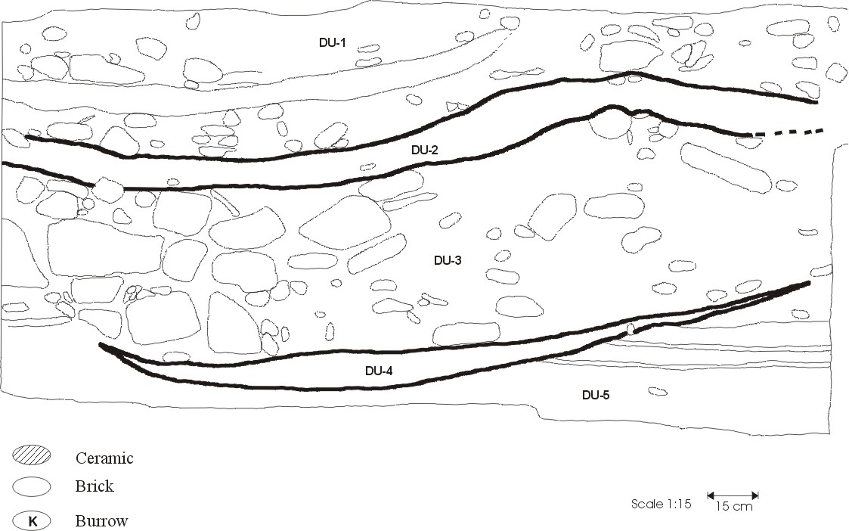
Figure 4.33 Room 8 (1216/1068) East profile
brown to dark brown matrix. The excavator noted several large ceramic pieces and bone indicating some dumped material may be included in this deposit. Indeed, ceramic and bone density is high for wall collapse deposits and moderate compared to all deposits (Cagle 2003: 82).

Stratum II (SU-3, Level 3) is differentiated from the one above it by being predominantly decomposed brick material and no burning evident. The majority of this deposit is a dark brown sand with little or no brick “staining” or mottling present, except in the northeast corner where brick fragments and mottles are visible. Structurally, the deposits slope downward becoming deeper in the north end. This is probably collapsed and mostly dissolved brick wall material with its source to the north in the boundary wall between Rooms 6 and 8.

Stratum III (SU-4, Level 3) is dark brown containing a great deal of brick fall contrasting it with the higher units. In several areas the edges of exposed brick fragments were burned, though not in situ as the burning did not extend to the surrounding matrix. Since some of the intact bricks in the walls were obviously burned, much of this unit's bricks were probably burned while they were part of the surrounding walls before collapsing. The brick fall is especially heavy near the bottom of the unit. A largely intact ceramic vessel was found in this stratum along with a concentration of sherds representing several vessels.

Stratum IV (Level 3) is composed of SU-5 from Room 8 and SU-10 of Room 6. The upper portions of SU-5 are in direct association with the Room 8 walls but the lower portion also connects with SU-10 in Room 6 underneath the wall separating the two rooms. Consequently, there may be two separate but related occupations evident in this deposit. The surface of the deposit is flat but curves up to meet the north and south walls. It consists of a dark brown mottled layer above and a dark gray compact layer further down with thin laminations suggesting that this was a floor surface or a series of floor surfaces. The faunal remains are predominantly pig (N=3) and ovicaprid (N=1) with several unidentified fragments. Lithic density is relatively high and consist of a fragment of a bifacial knife, four blade blanks, and five sandstone chips.

Stratum V (SUs 6 and 7, Level 4) is unrelated to the walls making up the room and is a tan or brown mottled sediment thicker along the outer edges than in the center suggesting wall collapse. This same deposit was also noted as lying under Room 6 SU-10 though the deposit in Room 6 was not excavated. The upper portion (SU-6) is more decomposed showing fewer actual brick pieces while the lower portion had many more identifiable bricks.

Summary of Room 8 Three walls make up the boundaries of this room on the north, east, and west. The north wall is shared with Room 6 and the west wall is shared with the larger structure surrounding Rooms 15 and 10. The eastern wall is a large, perhaps outer, wall separating many of the units excavated in 1986 from those excavated in 1988.

The upper deposits consist of wall collapse of varied composition. The top two deposits, Strata I and II, have less brick content than the lower one, Stratum III. Stratum I also contains burned material and the higher than expected densities of ceramic and bone indicate some dumping may have occurred within this deposit. Much of the brick in Stratum III was burned, apparently while the brick was still part of the structure from which it came which suggests active destruction of the structure.

The occupation surface is Stratum IV and is shared in part with Room 6. As noted above, the lower portion of the floor surface seems to extend into Room 6, but the upper part seems to be restricted to Room 8 suggesting that Rooms 6 and 8 were originally a single structure and a later wall was built to separate the two. Beneath the occupation is more brick fall (Stratum V) which seems to be common to Room 8 and 6 and extends under the walls in both rooms.

Room 9 (1216/1076)
No profile drawings are available for this unit. This room was excavated by Emily Zartman and A.C. D’Andrea between 16 April and 1 May, 1988.

The first deposit defined in this room is designated as Stratum 0 to maintain consistency with the sequence defined by Cagle (Cagle 2003) who did not analyze SU-1. Stratum 0 was not described, but photographs of the deposit indicate it was UPL.
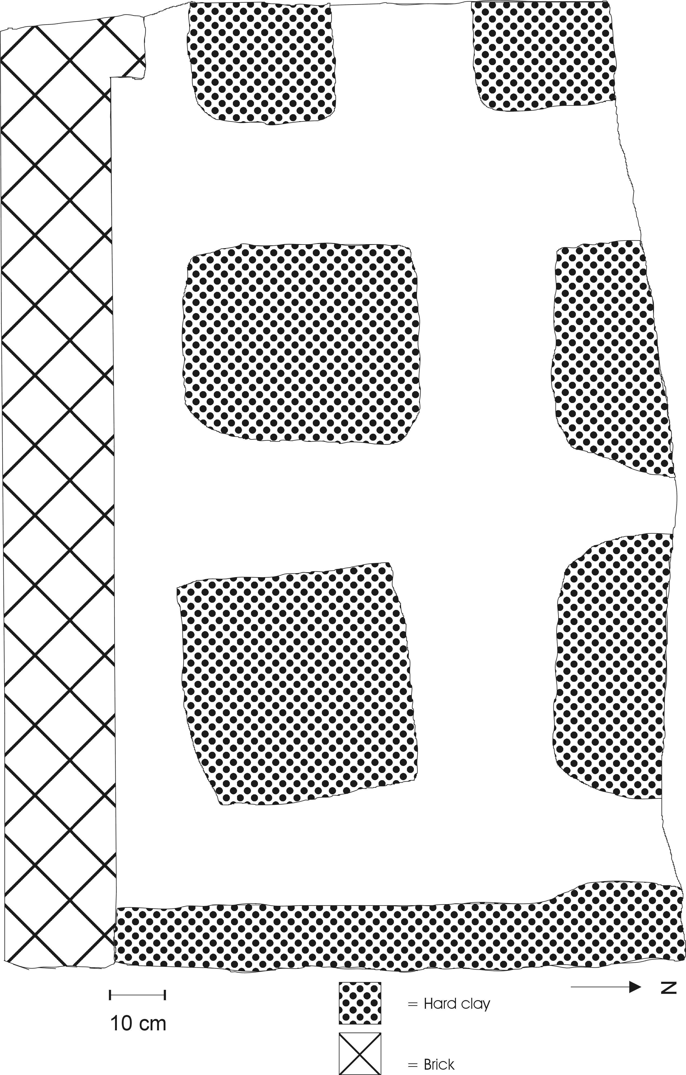
Figure 4.34 Plan drawing of the occupation surface of Room 9 (sectioned for excavation)

Stratum I (SU-2, Level 1) is a massive blackened deposit with a great deal of burned bone, ceramics, and brick pieces. Though the presence of brick fragments suggest some element of wall collapse, this deposit is probably more of a dump due to the scattered nature of the brick pieces and the overall black color and amount of bone and ceramics. Bone remains were fragmented with the majority unidentified; the only identified bone was a single hartebeest (Alcelaphus buselaphus) specimen.

During excavation of Stratum I three features were discovered and were excavated together as Stratum II (SU-3, Level 1). All three were composed in part of hard-packed clay and each was about 30-50cm across. Two of them had a single rock embedded in the center of each and consisted of clay in the center surrounded by yellow sand. The third had no rock and is composed of yellow sand in the center surrounded by clay. These were interpreted by Cagle (Cagle 2003) as some sort of column bases, perhaps for a light structure such as a lean-to. Similar short-term habitations were described by Giddy (Giddy 1987) at Ayn Asil in later deposits of abandoned structures.

Stratum III (SUs 4 and 5, Level 1) is composed of an upper layer of a mottled brown sandy sediment (SU-4) sitting on top of a much blacker sediment with patches of gray clay (SU-5). The mottles are assumed to be decomposed brick pieces and the excavators also described the upper layer as 'rubble fill'. This probably represents a dump deposit with some component of collapsed wall. The artifact contents are similar to other dump deposits with a relatively high ceramic density, several pig bones (N=8) and many unidentified fragments, and several lithics including two sickle blade fragments, a whole blade blank, a fragment of a flint chip, a faceted globular piece of flint (core?), five chunks of sandstone and one of slate (Cagle 2003: 85). Stratum IV (SU 6, Level 1) is similar and only differentiated from the overlying Stratum III as having a greater content of clay and a much harder surface, and a higher density of ceramics.

Strata V (SU-7, Level 3) and VI (SU-8, Level 3) are both wall collapse deposits composed of sandy brown matrix with few artifacts. The upper stratum is more decomposed with fewer visible brick pieces.

The excavator originally described Stratum VII (SU-9, Level 3) as consisting of softer clay in between areas of very hard clay. During excavation, however, it became apparent that the hard clay areas were square and laid out at regular intervals (see Figure 4.34). These may be column bases but they seem rather large and too close together to act as support structures that one could actually walk between. Artifact frequencies are low compared to other floor deposits. Excavation was halted at this point but it is apparently the basal deposit for this room.

Summary of Room 9 The upper strata of this room consist of dumps deposited later than the primary occupation of the room after a period of abandonment and wall collapse. The 'column bases' of Stratum II may represent a short period of occupation, perhaps a short-term occupation with a small roof supported on posts anchored by these de-posits.

Below the series of dumps (Strata I, III, and IV) lie two episodes of wall collapse, with the upper deposit (Stratum V) being relatively more decomposed than the unit underneath it (Stratum VI). The floor of this room is unusual and not seen in any other room excavated thus far. The plan drawing (Figure 4.34) is only half of the room as it was sectioned for excavation after Stratum III and consequently does not show the full relation of the rectangular clay features to the walls of the room. The features tend to be approximately 45-50 cm square and approximately 20 cm from the walls and from each other. No depressions or other attributes indicating whether some sort of posts were placed on these features was indicated by the excavator. The excavator also noted, though an examination of field notes and forms failed to uncover, that these features corresponded and were lined up with similar features in Room 4 to the west.

Room 10 (1212/1064)
The east profile drawing for Room 10 is provided in Figure 4.35. This room was excavated by Michael Kobusiewicz between 19 and 27 April, 1988.

Stratum I (SU-1, Level 1) is a hodgepodge of different materials apparently deposited during an extended period of wall collapse and fluvial infilling. The predominant sediment is a dark gray to black matrix with scattered charcoal fragments throughout. One area
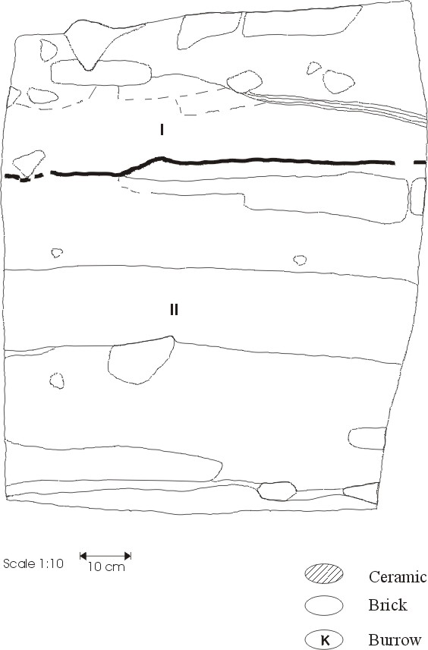
Figure 4.35 Room 10 (1212/1064) East profile
contained alternating sand and clay laminations apparently the result of fluvial activity. There were also two small depressions with coarse white sand in and around them.

Stratum II (SUs 2 and 3, Level 1) is a gray to light gray sediment with numerous lenses of darker sediment that appeared to contain more ash/charcoal, bone, and ceramics. These lenses tended to be roughly 40-80 cm in diameter and may either be periodic dumping episodes or infilling of naturally scoured depressions.

Summary of Room 10 As seen in the large plan map (Figure XX), this room is one small end of a larger room that was subsequently cut into by a later mud brick tomb (Room 15). Because of the construction of this later tomb the materials within these room deposits are not thought to be associated directly with the occupation of the larger room.

The upper deposit, Stratum I, contains wall collapse material and several lenses of apparently fluvial deposits. The artifacts therein are thought to represent objects occasionally washed in from elsewhere or included as part of the collapsed wall material. The lower deposit, Stratum II, is more laminated than Stratum I and contains more lenses with charred material that may represent intentional dumping of material rather than inwash. Both deposits probably represent wall collapse from both Room 15 and the larger room containing both, fluvial activity, and perhaps some minor dumping activity after the tomb was constructed.

Room 12 (1214/1062)
The east profile drawing for Room 12 is provided in Figure 4.36. This room was excavated by Anthony Cagle between 21 and 28 April, 1988.

Stratum I (SUs 1 and 3, Level 3) is composed of a sandy brown sediment with a large number of grinding stones, ceramics, and bone found right below the surface. Structurally, the stratum consists of two parts separated by a single-course brick partition: a northern portion (SU-1) that is rich in ceramics, and a southern portion that has fewer ceramics. Ceramic content is moderately high compared to all units and other dumps as is bone density. The identified bone consisted of majority pig (N=17) and two ovicaprid bones; the unidentified remains were predominantly medium skull fragments
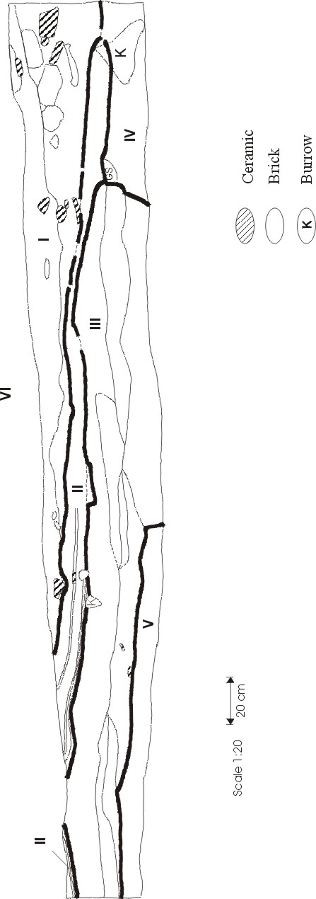
Figure 4.36 Room 12 (1214/1062) East profile
(N=38) and medium limb (N=55). Lithic density is high and the inventory for this unit contains several fragments and whole grinding stones, the majority of which are metates. It is unclear if this stratum may be regarded as an intact house floor or if the artifacts were dumped there later.

Stratum II (SUs 2 and 4, Level 3) is regarded as the true occupation surface of Room 12. It is a stratified layer of thin laminated clay and silt sediments, some of which clearly represent small fluvial deposits as they display a fining upwards sequence and contain only fine-grained sediments. The top layer, however, is dark black and contains a great deal of charcoal and small burned bones. All of this deposit went beneath the small brick partition in the north-central portion of the room and sloped towards the south where the majority of grinding stones in Stratum I were found. All artifact categories are much lower than those of Stratum I as well. It may be that both Strata I and II are floor deposits, with the upper stratum representing a slightly later occupation after the room was separated by the brick partition.

Stratum III (SUs 5 and 7, Level 4) is a complicated unit and appears to consist of several distinct episodes of wall collapse that subsequently decomposed. It covers the northern 2/3 of the room. The majority of the SU-5 portion largely consists of clean brown sand with few artifacts and is underlain by a greenish-gray material similarly devoid of much artifactual material. Also within SU-5 is a thin layer of black sediment which may have been a brief occupational layer or more likely a small dump of mostly burned organic material. SU-7 is more heterogeneous and consists of several slightly different materials: light brown sand in its southernmost extent, darker brown material in the center, and much darker brown in the north becoming thinner in this end as well. This thinning towards the north indicates a source wall in the south. A second course of bricks along the west side of the room and jutting out from the original wall may be the top portion of a room from an earlier occupation and part of the source material for these and the lower wall collapse deposits. Artifact densities are generally light with no identifiable bone and only a single lithic (a basalt chunk). This unit may represent collapsed and decomposed wall material originating in the south and undergoing several periods of collapse and slumping into the room.

Stratum IV (SU-6, Level 4) is a dark brown sandy sediment restricted to the south end of the room directly abutting Stratum III and continuing beneath the level of excavation. The lowest part of the south and west walls also ended right under the top surface of this stratum indicating that the walls and subsequent occupations were built on top of this deposit. Though no bricks were described by the excavator, the character of this deposit is similar to others interpreted as decomposed wall collapse. Artifact densities are somewhat greater than those of Stratum III and are moderate overall. Again, there is little identified bone (two pig bones) with the majority being unidentified limb fragments. The lithics (N=2) consisted of a single blade fragment and a globular chert nodule that was pink in color on one end (possibly heat treated).

Stratum V (SU-8, Level 4) is confined to the north end of the room and is differentiated from the overlying Stratum III by being a hard packed greenish sand. Bricks appeared in the lower north end of this unit and the unit is interpreted to be wall collapse. All artifact categories are low to moderate. This unit also went beneath the walls and is not part of the overlying occupation levels.

Summary of Room 12 This room contains four intact walls with the south wall shared with Room 13. The east wall is shared with the large structure that contains Rooms 10 and 15 with a doorway connecting Room 12 with this large structure.

The top two deposits, Strata I and II, may represent a single occupation surface. There was a great deal of artifactual material within Stratum I, including a number of metate fragments. This may indicate an intact house floor, since metates are generally heavy and not subject to transport; however, their fragmentary nature militates in favor of a dump rather than a floor. Stratum II is a more typical floor deposit, consisting of several layers of fine-grained laminated sediments. These layers all go underneath the brick 'partition' that divides the room width-wise into two areas. This partition may be from a later occupation that has since been destroyed.

These floor deposits are underlain by a complex series of what appear to be collapsed and decomposed walls – Strata III, IV, and V -- with a presumed source to the south of the unit. Stratum IV takes up the southern end of the room and the walls of Room 12 in this area are built directly on top of it. Strata V and VI are probably later than Stratum IV as they appear to cut into the latter's northern extent, though all extend underneath the room's walls.

Room 13 (1220/1064)
The south profile drawing for Room 13 is provided in Figure 4.37. This room was excavated by Alicia Wise between 26 April and 26 May, 1988.

Stratum I (SUs 1 and 2, Level 3) combines a small amount of UPL with general wall collapse. The upper portion (SU-1) is a black sandy matrix with tan mottles, along with thin lenses of tan sand. The latter indicates at least some fluvial deposition during the sequence of wall collapse. The lower portion (SU-2) is darker with more reddish-colored mottles and patches of gray clay with charcoal flecks suggesting some burning of bricks and dump material. An infant burial was also found within this deposit. Ceramic and bone density is fairly high, perhaps because of some dump material included. Most of the identified mammal remains are of pig (Sus scrofa, N=13) and ovicaprid (N=4), but two hartebeest specimens (Alcelaphus buselaphus) were also identified. There are several lithics present (N=18) and were distributed between three sickle blade fragments (two of which showed evidence of burning), four blade blanks, nine chunks (five of sandstone, 3 of limestone, one of slate), and a whole sandstone mano.

Stratum II (SU-3, Level 3) is a large unit (almost 4 m³) is differentiated from Stratum I by having a lighter tan color, more bricks, and fewer artifacts. Artifact densities are correspondingly lower, though it still contained nine lithics: one broken flint blade, six sandstone chunks, a single sand-stone flake, and a fragment of a sandstone metate.

The material comprising Stratum III (SU-5, Level 3) is inside of a semicircular brick structure (Figure 4.38) and consists of tumbled burned brick around the outside of the pit nearer the walls of the structure with unburned brick nearer the center. The sides of the bricks facing the interior of the structure were also burned. Ceramic concentration was noted by the excavator to be very high, consisting mostly of heavy, bread platter or bread mold wares (Types D and E, respectively). The overall character of the deposit suggests a dump with bricks from the collapsed pit structure. Bone density is only
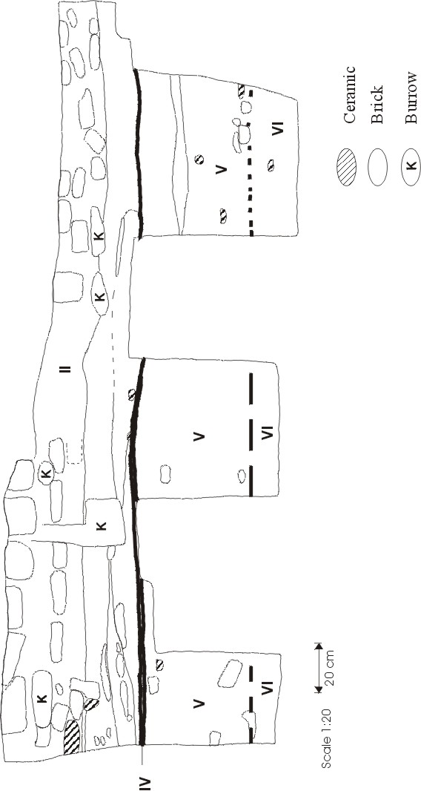
Figure 4.37 Room 13 (1220/1064) South profile
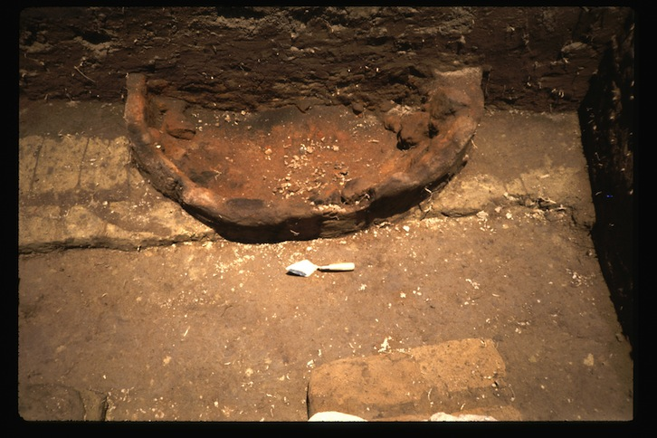
Figure 4.38 Room 13 Brick 'oven' feature
moderate, and consists of a single identifiable pig bone and numerous unidentifiable fragments. Lithic density is moderate with only a single sandstone flake present.

The overall structure, the character of the burning evident (on only one side of the bricks) and the presence of ceramics associated with bread baking suggest this was an oven. Though little archaeological evidence for baking facilities prior to New Kingdom times exists, it closely resembles the descriptions of later ovens given in (Samuel 2000).

Stratum IV (SU-4, Level 3) represents the occupation surface of the room as it occurs at the bottom of the walls. It is a brown layer with several lenses of rich black material throughout.

Stratum V (SU-6, Level 4) and the stratum immediately below it both occur beneath the walls making up the room and are not associated with the deposits above. Stratum V consists of a gray-brown mottled matrix with a few light brick patches and is interpreted as light brick fall or decomposed wall collapse. All artifact classes have moderate densities. Interestingly, the identified bone is distributed similarly to that of Stratum I with hartebeest, pig, and ovicaprid represented. Lithics are also similar to Stratum I, including a single sickle blade, a single blade fragment, and three chunks of limestone (N=2) and sandstone (N=1).

Stratum VI (SU-7, Level 4) is composed of heavy brick fall of large chunks of green and orange colored bricks. Several lenses of clay flecked with charcoal were also noted which are probably fluvially deposited.

Summary of Room 13 The excavated portion of this room contains two occupations. The upper occupation is associated with the visible outer room walls. The topmost deposits (Strata I and II) are predominantly wall collapse with a small amount of UPL contained in the top of Stratum I. This material covers the occupation surface (Stratum IV) and the "oven" (Stratum III).

Below the occupation surface and associated architecture are two, perhaps a single, episode of wall collapse from some as yet undetected structure(s). The boundaries between Strata V and VI are unclear in the profile and were noted by the excavator as being very gradual. This probably indicates that the upper stratum, V, is essentially the same deposit as Stratum VI with the bricks having been more gradually broken down and collapsing.

This room was sectioned so that only the southern portion was excavated; hence the relationship to the deposits in the adjacent Room 12 is not clear, though both rooms share a common wall and are assumed to be contemporaneous.

Room 14 (1224/1060)
There is no profile drawing for Room 14. This room was excavated by Paul Buck between 28 and 30 April, 1988.

Room 14 is a small circular mud brick feature to the southwest of the main block area and on the interior of the larger brick structure see Figure xx, main map). It was excavated in some detail because a large limestone block was noted in the center of the structure.

There are only two strata in this room. Stratum I (SU-1, Level 0) is typical UPL excavated to more fully expose the structure. Stratum II (SU-2, Level 3) contains a mixture of black sediment and fragments of brick and seems to be a mixture of some burned dump material and loosely compacted wall collapse. Below the tumbled brick and black material is a regular paving of brick laid on edge which may have encircled the limestone block (see Figure XX, should be a sheet of MK’s plan drawings; no photos are listed).

Summary of Room 14 The function of this structure in unclear. The deposits seem to represent a mixture of dump and wall collapse below the Stratum I UPL. Probably because of the dump material, Stratum II contains a great deal of ceramics and faunal remains. The identified mammal remains consist of ovicaprid (N=3), pig (Sus scrofa, N=1) and hartebeest specimens (Alcelaphus buselaphus, N=1) (Cagle 2003: 96). The limestone block is irregularly shaped and shows no inscriptions. It is possible that the block was used as a support for some temporary structure as seen in Room 9.

Room 15 (1214/1066)
There is no profile drawing for Room 15. This room was excavated by Anthony Cagle between 1 and 4 May, 1988. As seen in Figure XX (big plan map) this room is wholly contained within the larger structure containing Rooms 10 and 12.

Stratum I (SU-1, Level 0) is typical UPL but contains extraordinarily high densities of ceramics, lithics, and bone compared to other UPL deposits throughout the site.

Stratum II (SU-2, Level 2) has a matrix ranging from dark brown to tan and contains numerous small brick pieces and some ceramics. It rises in elevation to the south of the unit.

Stratum III (SU-3, Level 1) is a very black deposit containing abundant charcoal fragments, some ceramics, large pieces of bone, and a few scattered brick fragments. There are occasional patches with abundant burned bone and ash as well. The deposit was humped up along the eastern wall and tapered off down towards the corners of the room, implying that the material was dumped over the wall on this side. The identified faunal specimens (N=13) were about equally distributed between mammals (6 pig, 1 goat) and fish.

Stratum IV (SU-4, Level 2) is the deposit associated with the burial in Room 15. The majority consists of a light brown sandy sediment assumed to be the decomposed remains of collapsed wall material. Towards the bottom of the deposit were also the remains of the plaster coffin material above the burial. Ceramic densities were moderate but both bone and lithic densities were high. Again, the identified faunal specimens (N=26) were roughly equally divided between mammals (13 pig, 1 hartebeest) and fish/reptiles (11 fish, 1 turtle). A detailed description of the burial is found in Chapter XX).

Summary of Room 15 This room is a tomb built into a pre-existing structure that contains Room 10 directly north of Room 15. The tomb was probably constructed after the main occupation of the larger structure. After a period of decomposition in which the walls of the tomb and the coffin began to collapse creating Stratum IV, the dump material of Stratum III was deposited on top. From the structure of the deposit, it seems as though the Stratum III material was dumped over the eastern wall. Stratum III may consist of several episodes of dumping as there is a certain patchiness to the deposit. The presence of a great deal of burned bone and ash suggests hearth or oven refuse was being dumped here. After the dumping of Stratum III, the structure was allowed to collapse creating Stratum II capped by the ubiquitous UPL of Stratum I.

Room 16
There is no profile drawing for Room 16. This room was excavated by Paul Buck and Donald Ryan between 2 and 15 May, 1988. It is a series of six 2-meter units placed next to the southern edge of the large horseshoe-shaped enclosure see Big Plan Map). It was excavated to clarify the depth of this enclosure wall and to determine if any occupation surfaces were associated with it.

Only one stratum is defined here combining three SUs together; the remaining SUs are described individually.

1212/1058 SU-1 is a compact reddish brown sandy silt: typical UPL. Below it is SU-2, a slightly harder yellowish compact sand with some laminated black and brown layers within it. The excavator interpreted this deposit as apparent room fill with a possible floor surface.

Below SU-2 in 1212/1058 is Stratum I (Level 3) which consists of three separate SUs: 1212/1058 SU-3, 1214/1058 SU-4 (combined in Cagle (2003: 96) as DU-1) and a deposit covering portions of squares 1212/1058 and 1212/1052, designated at excavation as SU-2 (see Figure that has the squares and deposit marked). It is an amorphous dark layer, with gray and brown matrix mixed with charcoal and sherds throughout. It covers the entire surfaces of each square not part of the mud brick wall making up the circular structure.

1214/1058 SU-1 is a dark brown layer mixed with occasional sherds. SU-2 in this unit is a lighter sandy deposit with fewer sherds and evidence of collapsed brick near the wall. Below this is SU-3, a dark layer not highly distinguishable from the deposit below it (SU-4) but distinct in profile. Sherds and charcoal bits are found throughout SU-3 and several pieces of reddened brick are found adjacent to the wall.

No description is given for the deposit (SU-1) overlying SU-2 covering portions of 1212/1058 and 1212/1052.

Summary of Room 16 The deposits in these squares seem to be largely wall collapse deposits with some dumping of burned material and a few instances of either fluvial deposits or a floor surface (the laminations in Stratum I).

Room 17 (1156/1004) There is no profile drawing for Room 17. This room was excavated by Lech Krzyzaniak and Karla Kroeper between 8 and 26 May, 1988.

Stratum I (SUs 4 and 9, Level 3) occupies the northwest and eastern portions of the structure. The deposit as a whole is typical wall collapse with green and yellow brick pieces scattered throughout with a generally gray matrix. Ceramic density is low to moderate while bone and lithic densities are relatively high. Identified faunal remains consist of numerous ovicaprid (N=30) and pig (N=10) elements along with minor components of other species (Cagle 2003: 98).

Stratum II (SUs 5 and 10, Level 3) underlies Stratum I throughout its extent. It is differentiated from Stratum I by having a more brown to black matrix in the lower portions of the deposit, while the upper portion contains brick pieces similar to those in Stratum I. The excavators also noted the presence of more ceramics, though the density of ceramics is lower compared to Stratum I. There also appear to be more burned areas and lenses with abundant ash and charcoal, suggesting that some dump material may be incorporated into this largely wall collapse deposit. Bone density is only moderate for this deposit with the distribution of faunal remains similar to that in Stratum I. Lithic density is high and the objects consist of 2 bifacial knife fragments, nine sickle blade fragments, four flakes, a fragment of a ground stone, and fourteen blade fragments.

Stratum III (SU-1, Level 3) is a pit structure in the northwest corner of the structure. The pit itself is defined by a wall of burned red clay (photo here?). The deposit has a compact matrix and contained large and small sherd fragments and a few identifiable bones. It probably represents a hearth that was subsequently filled in with some refuse. Ceramic and bone densities are high but lithic density is low. Identified faunal remains are minimal with the majority of all bone consisting of small, unidentifiable pieces.

Stratum IV (SUs 2 and 3, Level 3) lies to the south of the above strata on the other side of a small wall. The deposit has a brown matrix and includes a heavy component of sherds and bone. All artifact categories have high densities and faunal remains are again similar to the preceding Strata I and II with the majority of identified specimens from ovicaprid and pig.

Stratum V (SU-6, Level 3) lies beneath Stratum V and was described by the excavators as one or two floors lying on thin layers of greenish bricks. The matrix is black but no mention was made of ash or charcoal remains. All artifact categories had high densities and lithic density was the highest of any other floor deposit. The lithics included numerous (N=26) flakes, seven blades or blade fragments, and 4 sickle blade fragments. The identified faunal remains were consistent with the other units in this room, predominantly ovicaprid and pig.

Stratum VI (SU-7, Level 4) is underneath the floor surface of Stratum V and is thought to represent an earlier occupation (Cagle 2003: 98). It is composed of brown-gray sand which has the appearance of decomposed brick. It contains a high density of ceramics and the sherds tended to be decomposed, indicating some time lapse before they were covered. Bone density is also high and the species distribution is similar to the other deposits in this room. The lithics consist of six blades or blade fragments, two limestone chunks, a single flake, and one fragment of an end scraper; perhaps notably absent are any sickle blades which were common in upper levels.

Stratum VII (SU-8, Level 4) is in a small area bounded by a rectangular brick structure to the north, walls to the east and south, and the Stratum VIII feature to the west. Only a small amount of sediment was removed from this unit, and it consisted of a dark matrix rich in charcoal and charred seeds. It had a high density of ceramic, but no macroscopic bone or lithic material.

Stratum VIII (SU-11, Level 4) is a pit structure similar to Stratum III: a sharply defined circular pit structure with walls of burned clay, presumably a hearth. It is full of rough ceramics and bone, also similar to Stratum III and contained a sickle blade and a blade fragment.

Summary of Room 17 This room contains two separate occupation areas, north and south, separated by a wall. The north half, containing strata 1, 2, and 3, has one hearth (Stratum III) and two episodes of wall collapse. The lower portion of Stratum III may, however, contain a dump or most likely the occupation surface associated with this room and was inadvertently excavated with the wall collapse above it. This would explain the unusually high artifact densities and black color of this unit.

The deposits to the south contain deposits contemporaneous with those in the north, and also some earlier ones. The upper deposits are composed of a dump (Stratum IV) and an occupation surface (Stratum V). Below these is another set of occupations defined by a complex series of room walls and smaller brick structures capped by collapsed walls (Stratum VI). A small dump (Stratum VII) was situated between two large walls and a smaller rectangular structure and bounded by another hearth (Stratum VIII). The faunal remains from all of these deposits are predominantly ovicaprid and pig, and together with the hearths suggests that this structure was related to food processing/preparation in both occupation levels.

Room 18 (1208/1068) The south section of the west profile drawing for Room 18 is shown in Figure 4.39. This room was excavated by A.C. D’Andrea, and Nancy D. Sharp between 8 and 24 May, 1988.

Stratum I (SU-2, Level 0) is a medium brown silty sand with abundant large pottery in its upper extent and yellowish brown silty sand with occasional brick fall in its lower portion. The north end contains some laminated structures of dark brown to black alternating with yellowish brown sand, presumably from fluvial deposition. All categories of artifacts are abundant. The majority of the bone is fragmentary, the only identified specimens being ovicaprid and pig; the remaining unidentified material is predominantly limb fragments. The lithics consist of a sickle blade fragment, two chunks of sand-stone, and a fragment of a sandstone metate. Overall, this deposit seems to be a dump with some wall collapse and perhaps some fluvial deposition.

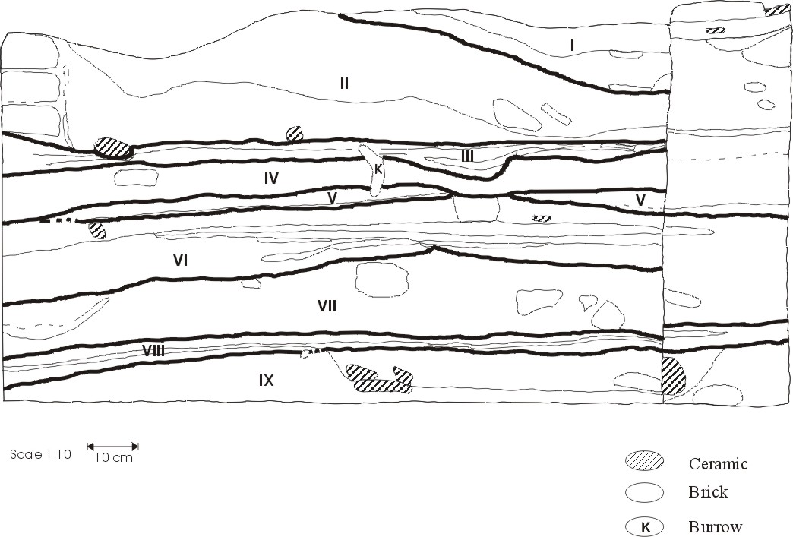
Figure 4.39 Room 18 (1208/1068) West portion of South profile
Stratum II (SUs 3 and 4, Level 3) is predominantly yellowish-brown sandy brick fall within a dark brown sandy silt matrix. Diffuse charcoal and ceramics charcoal were noted throughout but decreased in density toward the northern third of the room where a small thin lens of darker black material was excavated. Both ceramic and bone density are moderate, with the latter consisting of ovicaprids and the comparatively rare bovid remains (Cagle 2003:101).

Stratum III (SU-6, Level 3) is the occupational surface associated with this portion of the room. It is a clayey silt with diffuse charcoal flecks and fine black laminations, covered by a thin continuous layer of blackish clayey silt with diffuse black charcoal flecks throughout. Ceramic and bone remains are rare, but it has a sizable lithic component consisting of two sickle blade fragments, a blade fragment, and a chunk of unknown raw material (perhaps basalt).

Stratum IV (SU-7, Level 3) is a capping deposit sealing the lower layers from those above south of the unexcavated SU-5 wall uncovered during excavation of the upper layers. This wall (SU-5) lies closer to the north wall of the main room structure and may be a short occupation between those represented by the upper (north and east) walls and a lower and larger wall (SU-10, also not excavated). Stratum IV is a mottled yellowish brown brick fall with one lens of light tan sand within it. Artifactual materials were moderate.

Stratum V (SU-8, Level 4) was interpreted by the excavator as a floor but noted that the relation to any of the walls is unclear. It is certainly below the main (SU-1) walls of the upper level and the north profile shows it to be below the small SU-5 wall as well. However, in outline its eastern edge corresponds to that of the wall making up SU-10 which is slightly to the east of the main eastern wall of the room. Thus, this may be an occupation surface associated with these lower (SU-10) walls. It is gray to black which becomes very black and flecked with charcoal toward the southwest. Notes and profiles show this to be a discontinuous layer indicating a brief occupation. It contains moderate amounts of all artifact classes; the only lithic was a fragment of a sickle blade (Cagle 2003: 105).

Stratum VI (SUs 9, 12, 13, Level 4) occurs to the west of the SU-10 wall and is comprised of several slightly different strata, all containing some amount of brick fall, though not as much as the underlying Stratum VII material. The three main layers are an upper layer of yellowish brown silty sand with relatively few ceramics (SU-9), a darker layer containing more ceramics (SU-12), and a lower layer (SU-13) of mottled sediment with coarse sand pockets and a color similar to that of SU-9, but containing fewer ceramics.

Stratum VII (SU-14, Level 4) underlies Stratum VI and is differentiated from it by having a greater abundance of brick fragments relative to ceramics though both can be characterized as wall collapse deposits. Artifact densities are similar to Stratum VI but with a greater abundance of bone.

Stratum VIII (SUs 16, 17, 18, Level 4) consists of three areas of black, highly organic sediment rich in burned pottery fragments, some burned bone, and charcoal. SU-17 is a shallow basin filled with relatively more burned organic matter and pottery than the other SU's that make up this deposit. This is interpreted as a floor but is not clearly associated with visible walls; (Cagle 2003) placed it in a lower level (4) than most of the other deposits in this area.

Stratum IX (SU-15, Level 5) is a wall collapse deposit that underlies Stratum VIII and does not appear to be associated with the walls containing the that occupation. It consists of black to grayish-brown silty sand with brick fragments of tan to greenish color. This deposit was not completely excavated due to the encroaching water table.

Stratum X (SU11, Level 4) is the only excavated unit on the east side of the SU-10 wall. Stratum X directly contacts Stratum IV above it and is presumed to be of the same occupation level as those on the other side of the SU-10 wall. It is a very dark silty sand with a sticky consistency and is interpreted to be heavily decomposed wall collapse. The only artifactual material present was ceramics.

Summary of Room 18 This room has a complicated series of deposits that may represent several occupation levels. Stratum III is the uppermost floor surface and is associated with the upper room walls; it was assigned to Level 3 by (Cagle 2003) together with most of the deposits in this area. It is covered by the wall collapse of Stratum II and the dump of Stratum I. Stratum IV acts as a capping deposit above another set of occupational deposits, with a single wall running north-south (SU-10) as the only architectural unit visible hat is associated with these lower occupations. In addition, a very shallow wall (SU-5) splits the underlying room area into a northern and southern portion with approximately one third of the total area in the north, and two thirds in the south. This wall is only two courses deep and may be associated with the upper deposits rather than those below (Cagle 2003: 105). A floor (Stratum V) may be associated with this small wall, but both the profile drawings and the excavator's notes indicate that any relationship is unclear. Clearly, however, the Stratum V floor is not associated with the upper occupation, but is either intermediate or associated with the lower architectural units and is therefore associated with the lower occupations.

Below the Stratum V occupation lie two episodes of wall collapse, Strata VI and VII, the former having fewer whole bricks visible and probably representing a longer term period of slow collapse and disintegration of the bricks. Stratum VIII is the lowest occupation excavated and is not clearly associated with visible walls, though presumably it is part of or immediately adjacent to the SU-10 wall.

A final deposit, Stratum X, was excavated to the east of the SU-10 wall. This deposit is considered to be decomposed wall collapse and contemporary with the other deposits in this unit.

Room 20 (1160/1002) There is no profile drawing for Room 20. This room was excavated by Anthony Cagle on 24 May, 1988.

Room 20 is another small mud brick tomb contained within the confines of a later room, similar to Room 15. The deposits appeared to be heavily disturbed and so were taken out as a single deposit, Stratum I (Level 2). As seen in Figure XX, parts of both east and west walls were missing and the deposits in this portion were also the most heavily disturbed. Much of the deposit consisted of UPL, particularly the northern half which was UPL down to the lowest level of excavation. The southern portion was mostly intact and contained only a shallow layer of UPL, below which was collapsed wall and the burial itself. Coffin plaster was noted approximately 5 cm from the western wall and 10 cm from the eastern wall, which continued up to the southern wall of the tomb.

Summary of Room 20 This is a brick tomb similar to that of Room 15, but somewhat smaller. The northern half of the tomb was cut away by later occupations and/or sebakhin activity. Consequently, the upper half of the body above the 10th or 11th thoracic vertebrae was completely gone. The distal portion of the right humerus was present and articulated with the ulna upon excavation; a portion of the left humerus was also observed. All of the remaining ribs were broken midshaft. The body itself was lying on its left side facing east and was an adult male of apparently large, robust stature. The plaster surrounding the burial was mostly white with some red coloring in it. Due to the condition of the remains, the northern half of the tomb (containing most of the torso and head) was apparently cut through and completely removed sometime after burial, after which it was filled in with some wall collapse and UPL.

Room 22 (1210/788) The east profile drawing for Room 22 is shown in Figure 4.40. This room was excavated by Anthony Cagle between 26 and 30 May, 1988. This room, along with the adjacent Room 23, is located on the far western edge of the site (plan map KeH_AreaC). They were both chosen because mud brick architecture was visible near the surface and to provide a further sample of artifacts from a location far separate from the other excavated areas of the site.

Stratum I (SU-1, Level 3) is a dark brown, fairly compact sediment with some brick pieces around the wall borders and in the center of the room at the surface. Brick pieces cover the entire unit below 10 cm. Ceramic and bone are moderate to high and all of the identified faunal remains are ovicaprid and pig. Lithics include a sickle blade fragment, a fragment of a flint blade, three sandstone chunks, two limestone chunks, two globular chert nodules (cores?), and a fragment of a sandstone metate.

Stratum 2 (SUs 2 and 3, Level 3) is a deep unit and probably contains more than one floor surface separated by other deposits. The majority of the material is dark brown with few artifactual remains visible during excavation. The exceptions are two thin lenses covering a majority of the room surface that were much blacker and contained a great
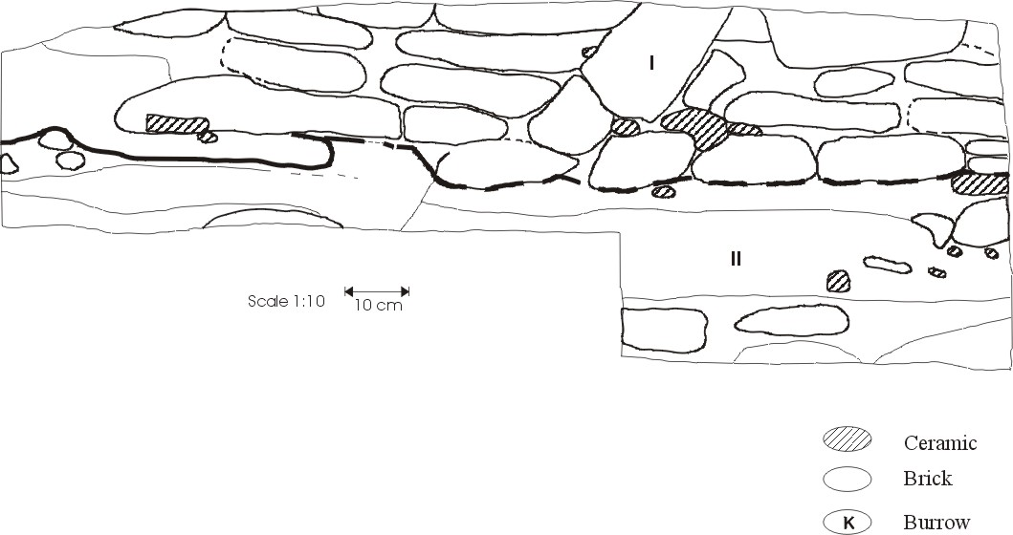
Figure 4.40 Room 22 (1210/788) East profile
deal of ash and burned bone. All categories of artifacts are moderate compared to other floor deposits. No identified faunal remains were present due to their burned and highly fragmentary nature.

Summary of Room 22 The deposits in Room 22 are separated from those in Room 23 by the brick wall at the south end of this unit (shared with Room 23). The sediments below Stratum II (unexcavated in this room) are equivalent to those in Room 23 (Strata III and IV). The upper layer of this room (Stratum I) is typical wall collapse while the lower unit, Stratum II, probably contains several distinct floor deposits along with other material separating them. The floor deposits are directly associated with the visible room walls and, based on ceramic content, were judged to be the same level (3) as the bulk of other excavated material (Cagle 2003).

Room 23 (1214/788) The north profile drawing for Room 23 is shown in Figure 4.41. This room was excavated by Anthony Cagle between 28 and 31 May, 1988. Room 23 lies directly north of Room 22 separated from it by the north wall of Room 23 (plan map KeH_AreaC).

Stratum I (SU-1, Level 3) is a dump deposit composed of brown fairly compact sediment with numerous ceramics and some bone and ash. A great deal of identified bone was recovered including hartebeest (N=6), ovicaprid, pig, equid (Equus asinus, N=1) and four bovid teeth. A variety of lithic material was also noted including a sickle and flint blade fragment, several chunks of limestone and sandstone, and a ground sandstone ‘pounder’ (Cagle 2003: 109).

Stratum II (SU-2, Level 3) in interpreted as the floor of the room and abuts the base of the walls making up the room. It is generally a dark brown to black sediment with faint to clear laminations visible, especially along the north wall adjacent to Room 22. The faunal remains are less varied than Stratum I; only ovicaprids are present along with two bovid teeth (Cagle 2003: 109). Several blade fragments are present along with two ground stone implements. This, along with Stratum I, are the only deposits in this room directly associated with the room walls.

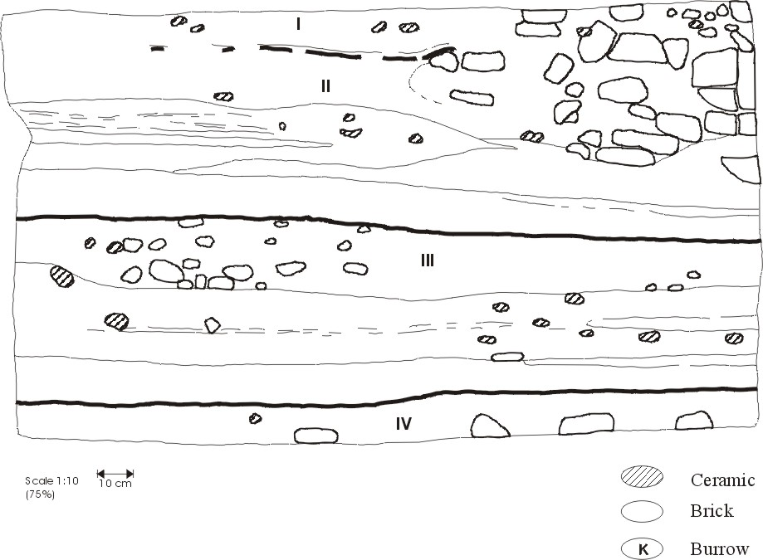
Figure 4.41 Room 23 (1214/788) North profile
Stratum III (SU-3, Level 4) lies beneath the room walls and was described as being identical to the (unexcavated) SU-4 deposit in Room 22. The majority of the material was dark brown with some brick pieces and several black lenses that may have been minor dumping episodes. There were also faint laminations visible throughout implying that the material was redeposited at least in part fluvially. Ovicaprid and pig are present in this room along with hartebeest (N=6).

Stratum IV (SU-4, Level 4) is composed of a light brown sandy sediment with a few large brick pieces and is interpreted as heavily decomposed wall collapse.

Summary of Room 23 Two sets of deposits are present in Room 23, an upper set associated with the room walls and a lower set. The top set consists of a dump (Stratum I) underlain by a floor (Stratum II). The boundary between Strata I and II is not shown clearly in profile. This may be indicative of disturbance from the collapsed wall to the east of the room as shown in the profile. Stratum II ends at the base of the northern wall; below this, the deposits in Rooms 22 and 23 are equivalent, though only those in Room 23 were excavated.

The lower deposits, Strata III and IV, are both collapsed wall deposits. Stratum III shows signs of having been redeposited, in part, by running water because of the laminations present. Stratum IV, the basal deposit excavated, has few brick pieces through most of its extent, but a few show up in the bottom of the unit, perhaps indicating the top portions of a lower set of occupations.

